Puteți să vă creați propriile resurse, filme sau jocuri la:

http://www.opensign.eu

FILM TEMATIC : RECICLAREA 1: CE ESTE GUNOIUL?

Vârsta: 8-12 ani
Autori: Média’Pi
France
Urmăriți filmele noastre tematice la:
http://opensign.eu/thematic_topics/89 și http://opensign.eu/thematic_topics/88

Competențe :
- Înțelege noțiunea de gunoi și impactul acestuia asupra mediului și sănătății

- Dă exemple de poluare

- Adoptă o atitudine critică față de consum
Competențe conform curriculumului european:

https://eur-lex.europa.eu/legal-content/EN/TXT/?uri=uriserv%3 AOJ.C_.2018.189.01.0001.01.ENG&toc=OJ%3AC%3A2018%3A189%3ATOC

Evaluare formativă:

- Explică ce înseamnă risipa
- Face diferența dintre obiecte și deșeuri
- Explică consecințele deversării deșeurilor în natură
- Dă exemple despre cum se acumulează deșeurile și care sunt consecințele
- Explică natura nocivă a deșeurilor și legătura dintre natură, hrană și sănătate.

Evaluare sumativă:
- Definește conceptul de gunoi și cum putem să ne analizăm propriile deșeuri menajere

Vocabular specific/Cuvinte-cheie:

Deșeuri, gunoaie, sticle, pe zi, pe an, de persoană, natură, toxice, periculoase

Schema lecției:

În primul rând, urmăriți videoclipul cu pauze, puneți întrebări despre limbajul mimico-gestual folosit și despre vocabular și concepte. Reveniți la începutul videoclipului. Apoi, urmăriți videoclipul a doua oară fără să vă opriți.

Materiale necesare : computer, videoproiector, exemple de deșeuri și ambalaje

Utilizarea limbajului mimico-gestual:
Aveți grijă să vă exprimați corect cu privire la numele materialelor și obiectelor.

1. Încercuiește cu roșu ce poate fi pus în coșul de gunoi
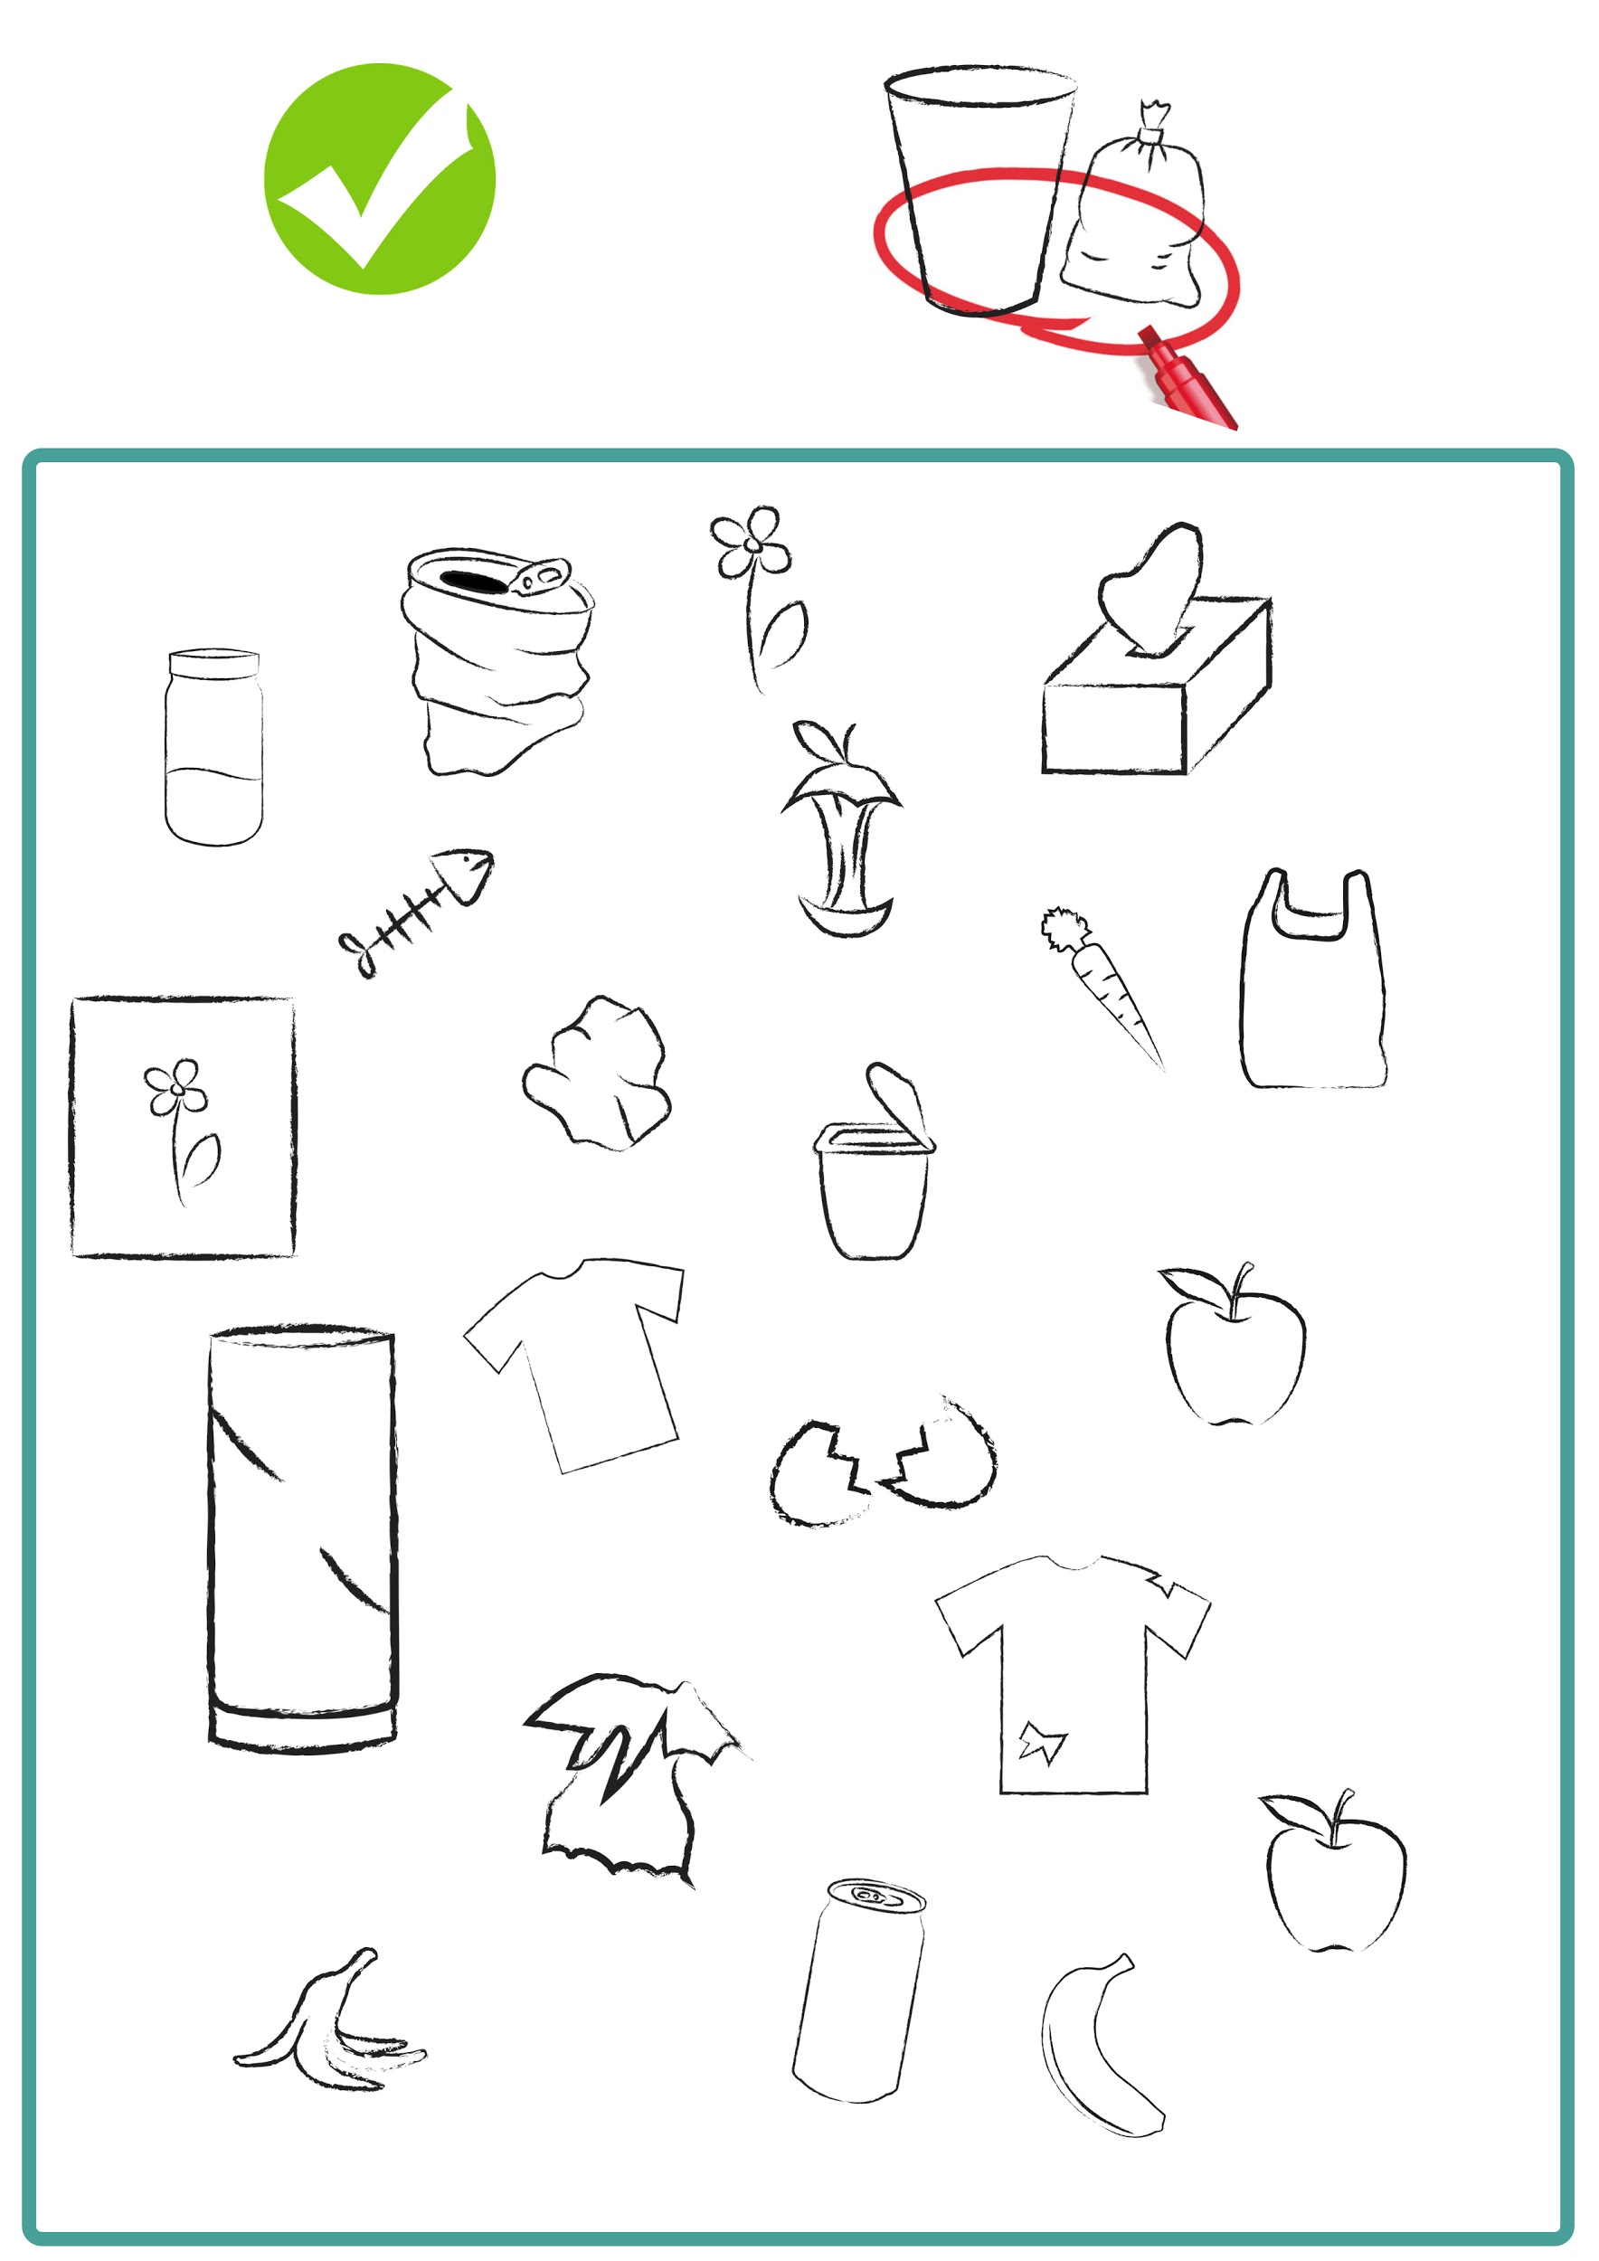

2. De ce pare îngrijorat acest băiat?

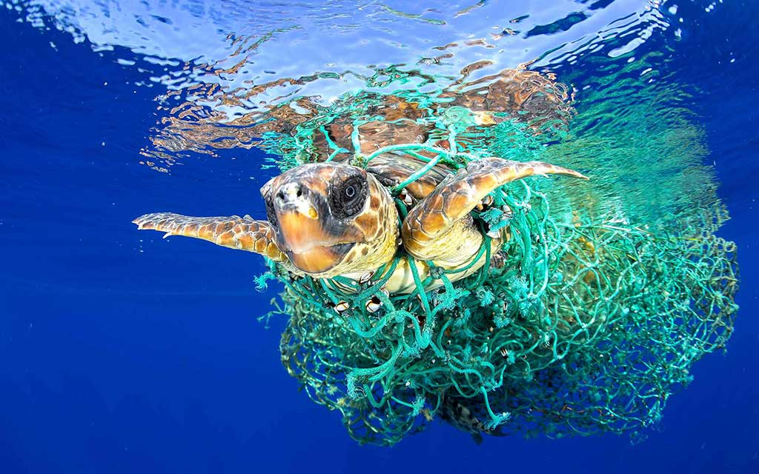
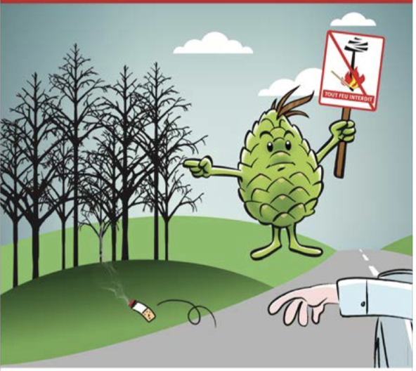
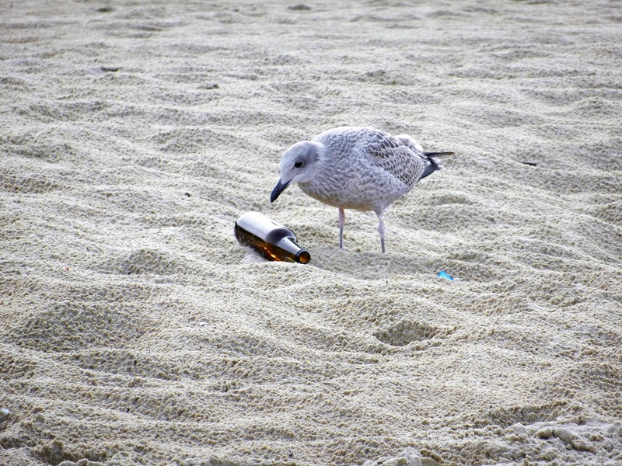
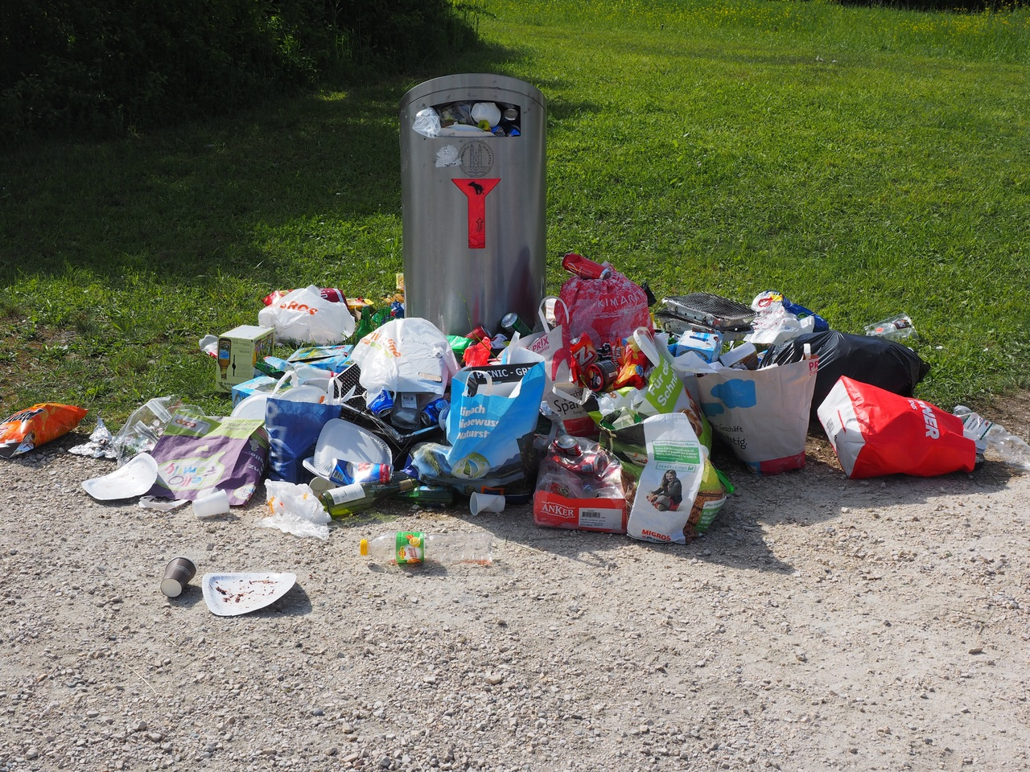

3. Cum se realizează compostul?

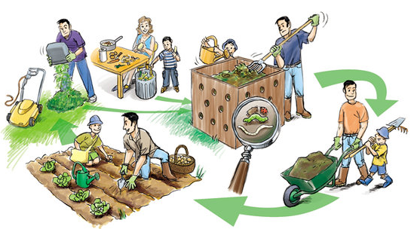
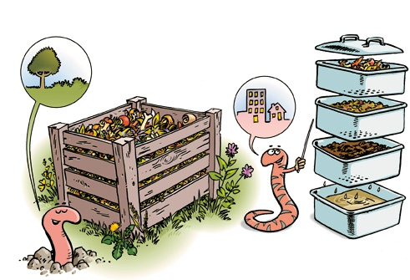
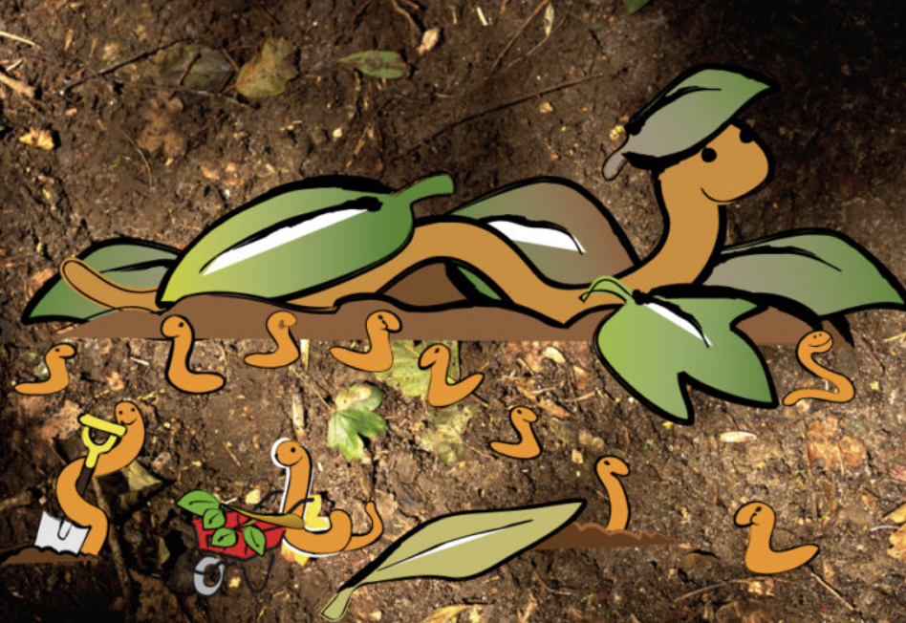
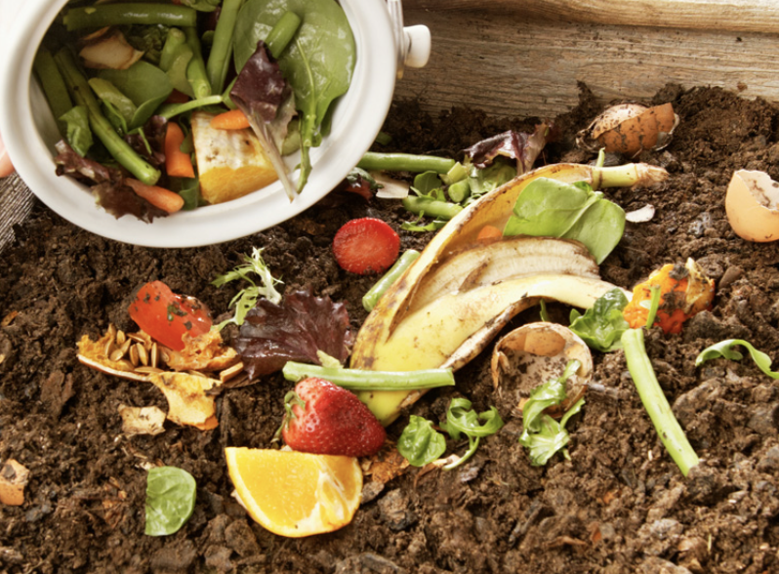
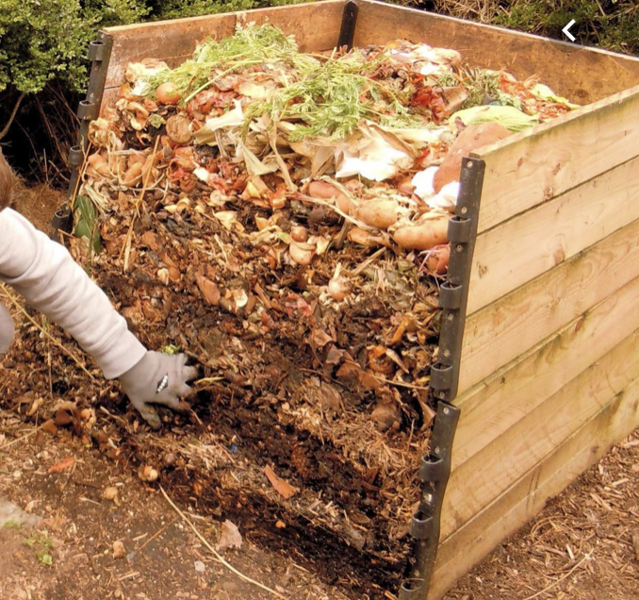

Resurse/Link-uri web cu alte instrumente digitale:

1. Cum să ținem plasticul deperte de ocean? / National Geographic
https://www.youtube.com/watch?v=HQTUWK7CM-Y

Acest proiect nr 2017-1-FR01-KA201-037433 a fost finanțat cu sprijinul Comisiei Europene. Această publicație și autorul ei deține responsabilitatea exclusivă Comisia nu poate fi considerată responsabilă pentru nicio utilizare a informațiilor conținute de aceasta.

