Title: SUGAR

Age category: 6 -12 years old

Authors: Istituto dei Sordi di Torino www.istitutosorditorino.org

Competences:
- Learning about the dangers of excessive sugar consumption is very important if we want to have an healthy lifestyle.
- Students will be provided with information on sugar and advice on how to choose healthier, low-sugar options.
- Students will become aware of the potential consequences of over consumption is very important.

Competences according to European curriculum:
http://eur-lex.europa.eu/legal-content/EN/TXT/?uri=LEGISSUM%3Ac11090

Formative assessment:
• describe the importance of eating the right amounts of different types of food
• identify and classify drinks like coke, orange juice, tea, and understand their properties

Summative Assessment:
- Communicate personal thoughts, impressions, creativity and exploratory competences.
- Stimulate awareness of what we drink.

Specific vocabulary list/Keywords:
- Different types of drinks (coke, orange juice, tea…), pan, kitchen, to boil, sugar, energy, to drink, to weight.

Short description of the educational context/scenario:
In the following activity, pupils become drink detectives and find out all about sugar. Fun games and practical experiments get them thinking about everyday drinks and foods and better understand of the amount of sugar they assimilate.
The teacher will discuss with them about their drinking habits and about their knowledge of sugar and food in general. The teacher will analyse with them the labels on each drink can and will then propose the activity as shown in the video “Sugar” and repeat the activity.
The teacher will always assist the students

Learning objectives
By the end of these activities, pupils will be able to:
• identify different drinks: understand and compare the sugar content in a variety of food and drink products
• recall the new recommended daily maximum sugar intake for their age range
• explain why water is an important part of a healthy diet
• select lower-sugar alternatives to high-sugar products

Materials needed/Technical requirements:
- Different types of drinks (coke, orange juice, tea…) in a can, a pan.

Focus on sign language:
- Sign the new vocabulary, articulate and justify answers, arguments and opinions
- give well-structured descriptions, explanations and narratives for different purposes.

1. How much sugar do these products have?

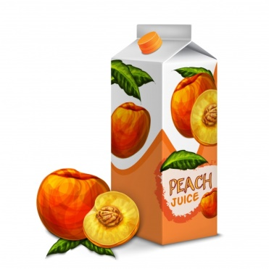
2. Draw what you usually drink and eat at breakfast, lunch and dinner.

 | I EAT… | I DRINK…
BREAKFAST
LUNCH
DINNER

3. What’s your favorite drink? Draw it and explain why?

_____________________________________________________

_____________________________________________________

_____________________________________________________

_____________________________________________________

_____________________________________________________

4. Circle the fruit.

5. Each category its name! Chose from the list : DRINKS, SWEETS, FRUIT, VEGETABLES.

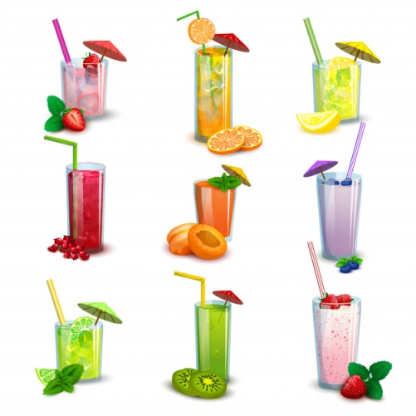
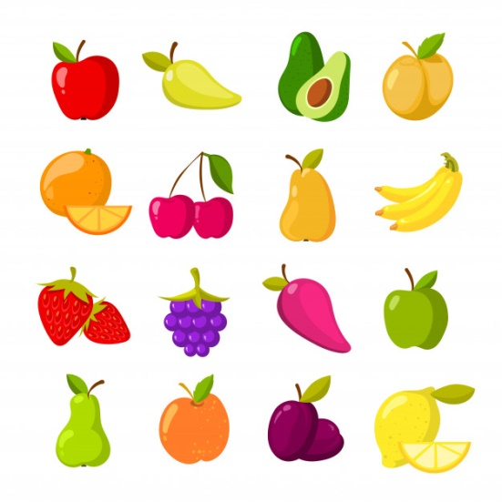
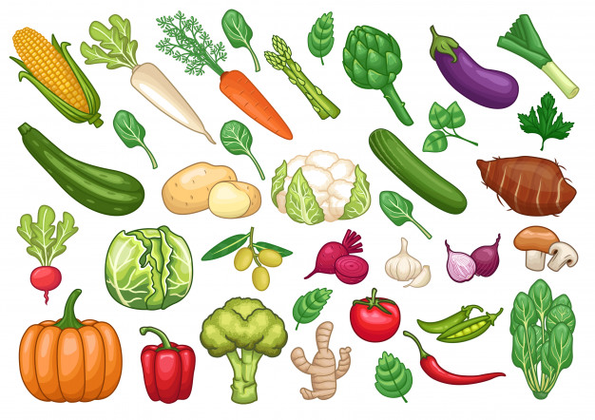
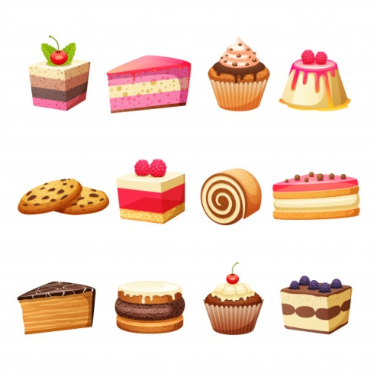
Extend / Enrichment / Prolongations Web links with others digital tools:

- http://www.actiononsugar.org/resources/education-materials/
- https://www.youtube.com/watch?v=lEXBxijQREo

