Title: RECYCLING TRAIN

Age category: 6 -12 years old

Authors: Istituto dei Sordi di Torino www.istitutosorditorino.org

Competences :
- The students will use their creativity in order to use again recycled material.
- The students will know that different materials have to be divided, not to throw away everything together.
- The students will know to use their manual dexterity.

Competences according to European curriculum:
http://eur-lex.europa.eu/legal-content/EN/TXT/?uri=LEGISSUM%3Ac11090

Formative assessment:
- Identify the materials
- Explain the actions to do on the materials: what to do first and the different phases
- Explain the creativity: what they what to create and use, what they see in the basic materials they have

Summative Assessment:
- Communicate personal thoughts, impressions, creativity and manual competences.
- Stimulate creativity.

Specific vocabulary list/Keywords:
- Recycling, paper, plastic, material, colours, imagination, creativity, new objects.

Short description of the educational context/scenario:
The teacher and the children will collect materials to throw away, but still in good conditions as paper boxes or plastic boxes, caps, cardstocks…
The teacher will explain that it is important to re-use materials still in good condition because if we always throw away everything that is old, we create pollution and create bad environment for us and for all living creatures. In order to make that explanation more clear, the teacher can show the video created by yomma on the thematic topic “Recycling”.
The teacher can teach new vocabulary about the different materials and can ask what the child could do or create with these objects and how he can manage that with everyday school stationery. The teacher can help him/her in both actions, the creative one and the practical one.
The teacher will always assist the students.

Materials needed/Technical requirements:
- Scissors, colors, colored pencils, liquid glow, recycling material such as plastic boxes or stoppers.
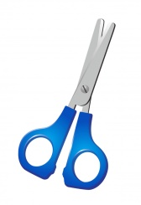
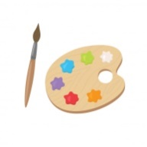

Focus on sign language:
- Sign the new vocabulary, sign the old materials that usually are thrown away and show that they are needed in order to create new objects.

- Each object has its place!

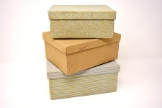
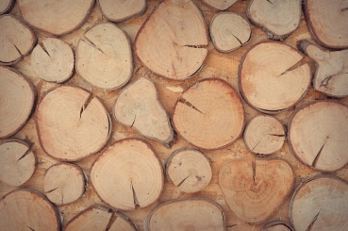
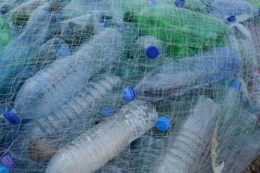
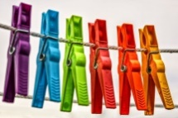
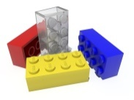
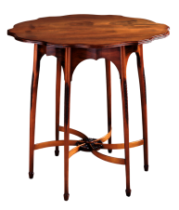
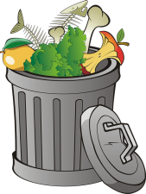
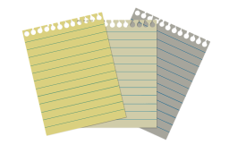
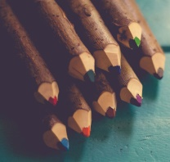

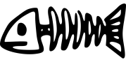

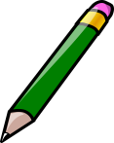
- Help our friends to collect all the trash they find on the floor and throw it away!

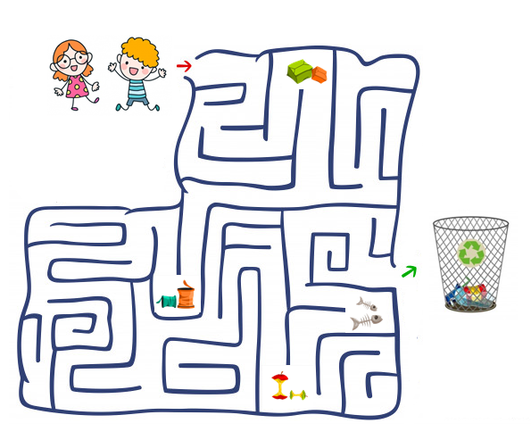

- What do you need to make a recycling train?

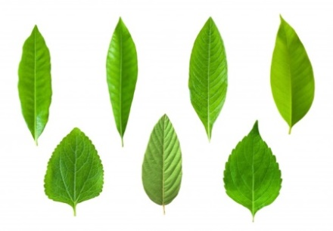
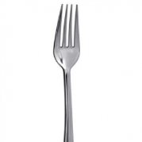
- Imagine what you can produce from this materials, like in the example:

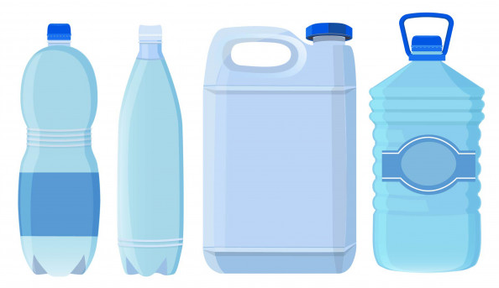
- Imagine an object you’d like exist, draw it and explain of what materials it is made of.

Extend / Enrichment / Prolongations Web links with others digital tools:

- https://www.youtube.com/watch?v=0xTyKc6LGdY
- https://www.youtube.com/watch?v=7UuUeoyYmxI
- https://www.youtube.com/watch?v=6jQ7y_qQYUA

