Title: RECYCLING PAPERS BECOME FISH!

Age category: 6 -12 years old

Authors: Istituto dei Sordi di Torino www.istitutosorditorino.org

Competences :
- The students will use their creativity in order to use again recycled paper instead of throw it away.
- The students will know to use their manual dexterity.

Competences according to European curriculum:
http://eur-lex.europa.eu/legal-content/EN/TXT/?uri=LEGISSUM%3Ac11090

Formative assessment:
- Identify the materials
- Explain the actions to do on the materials: what to do first and the different phases
- Explain the creativity: what they what to create with the material they have, what they want to do.

Summative Assessment:
- Communicate personal thoughts, impressions, creativity and manual competences.
- Stimulate creativity.

Specific vocabulary list/Keywords:
- Recycling, paper, material, imagination, creativity, new objects, new drawings.

Short description of the educational context/scenario:
The teacher and the children will collect papers to throw away, but still in good conditions.
The teacher will explain that it is important to re-use materials still in good condition because if we always throw away everything that is old, we create pollution and create bad environment for us and for all living creatures. In order to make that explanation more clear, the teacher can show two videos : “Recycling” and “Big fish, little fish”.
The teacher can teach new vocabulary about recycling activity and about the way to describe the environment that has different shapes as the papers that we can use. What can we do with big and little pieces of paper? The teacher can help the pupils in both actions, the creative one and the practical one.
The teacher will always assist the students.

Materials needed/Technical requirements:
- Scissors, liquid glow, used papers or recycling papers.

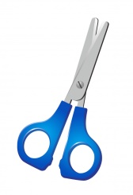

Focus on sign language:
- Sign the new vocabulary, sign the paper materials that usually are thrown away and show that they are needed in order to create something new, show how can be the shape of the hand in order to sign different sizes.

- What is paper? Collect only it in the bin.

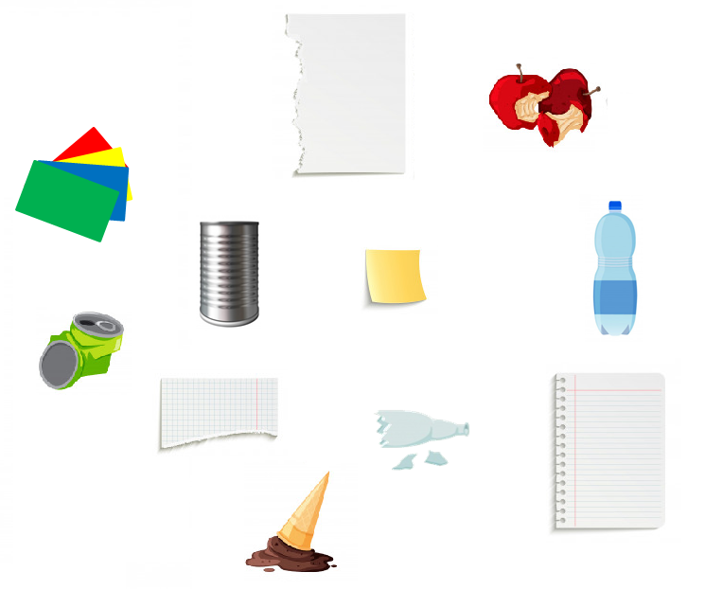
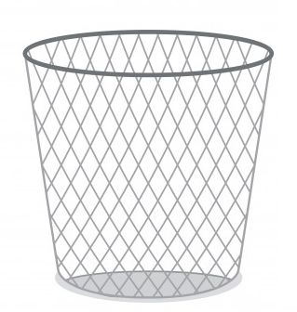
- Order the steps for paper processing!
1 2 3 …

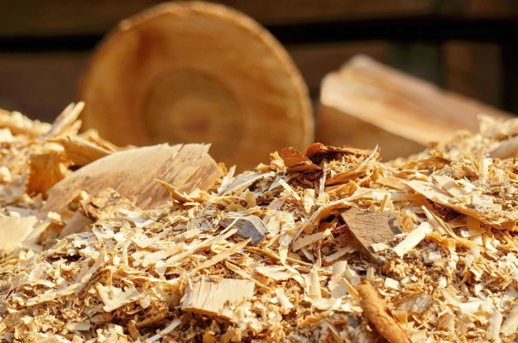

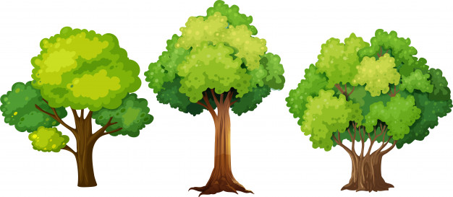
- Re-make the fish! Cut each part and paste them on another sheet.
- Big fishes and little fishes. Circle only the little ones!

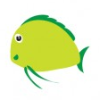

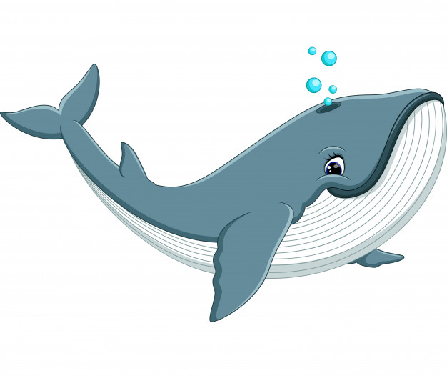

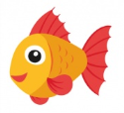

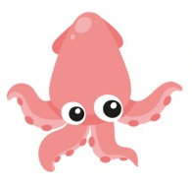
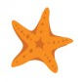
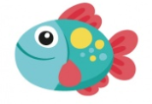
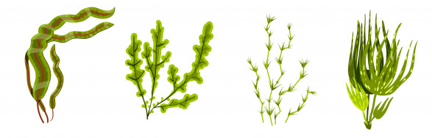
- Each fish its name!

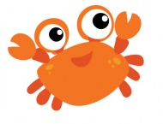

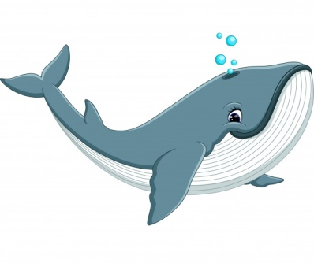

WHALE

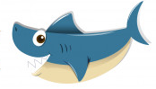

JELLYFISH

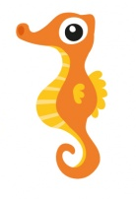

SHRIMP

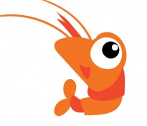

SEAHORSE

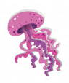

SHARK

Extend / Enrichment / Prolongations Web links with others digital tools:

- https://www.youtube.com/watch?v=7IP0Ch1Va44
- https://www.youtube.com/watch?v=jmgMdDH14sE
- https://www.youtube.com/watch?v=jAqVxsEgWIM
- https://www.youtube.com/watch?v=Oxw6FoUNeT4

