You can create your own resources, videos and games at:

http://www.opensign.eu

GAME : Landfills

Age: 8 to 12 years
Creator : Média’Pi

Competences :
- Put a link between waste and it’s effect on the environment at landfill sites

- Follow the logical, chronological order of the situation

- Identifies logical cues within the discourse in the video

European Competences
https://eur-lex.europa.eu/legal-content/EN/TXT/?uri=uriserv%3AOJ.C_.2018.189.01.0001.01.ENG&toc=OJ%3AC%3A2018%3A189%3ATOC

Specific vocabulary / keywords :
landfill, rain, river, environment, pollution, fish, food, toxic products.

Lesson outline:
After viewing and sharing the “Why recycle?” video at: http://opensign.eu/thematic_topics/88
This game can be played at: http://opensign.eu/sequence/76

Resources:
A computer and an internet connection.
Focus on sign language:
Have the various parts of the videos reformulated in the country’s sign language, taking care to identify the logical signs that coordinate the links between the videos.

Ce projet n ° 2017-1-FR01-KA201-037433 a été financé avec le soutien de la Commission européenne. Cette publication n'engage que son auteur et la Commission ne peut être tenue responsable de l'usage qui pourrait être fait des informations qui y figurent.

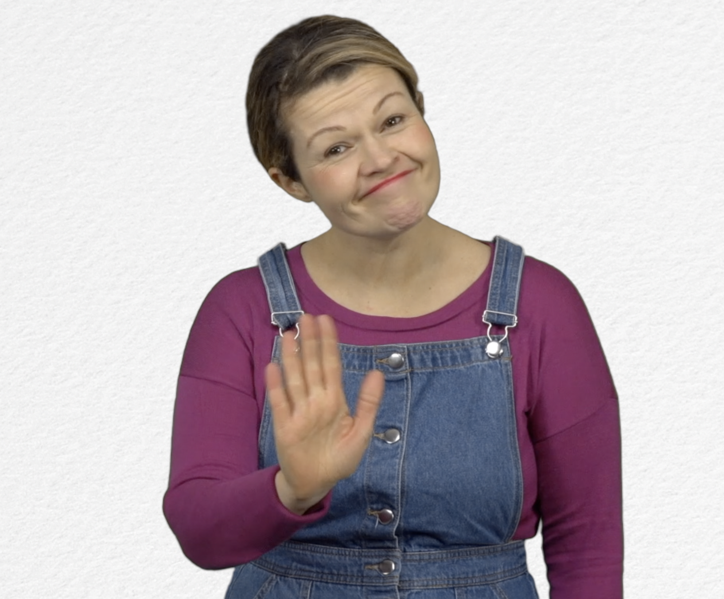
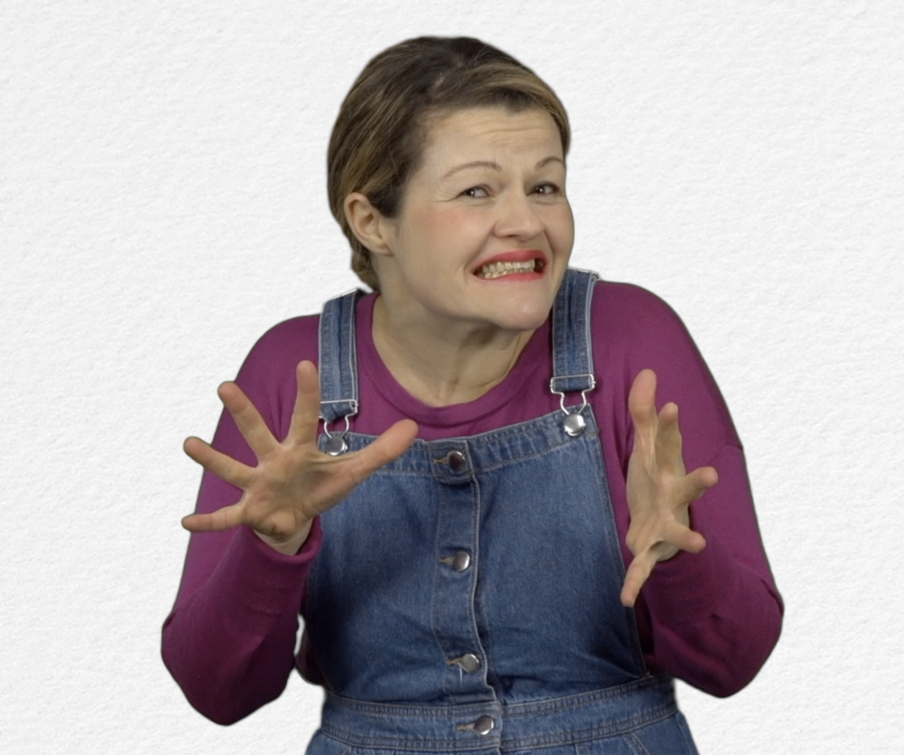
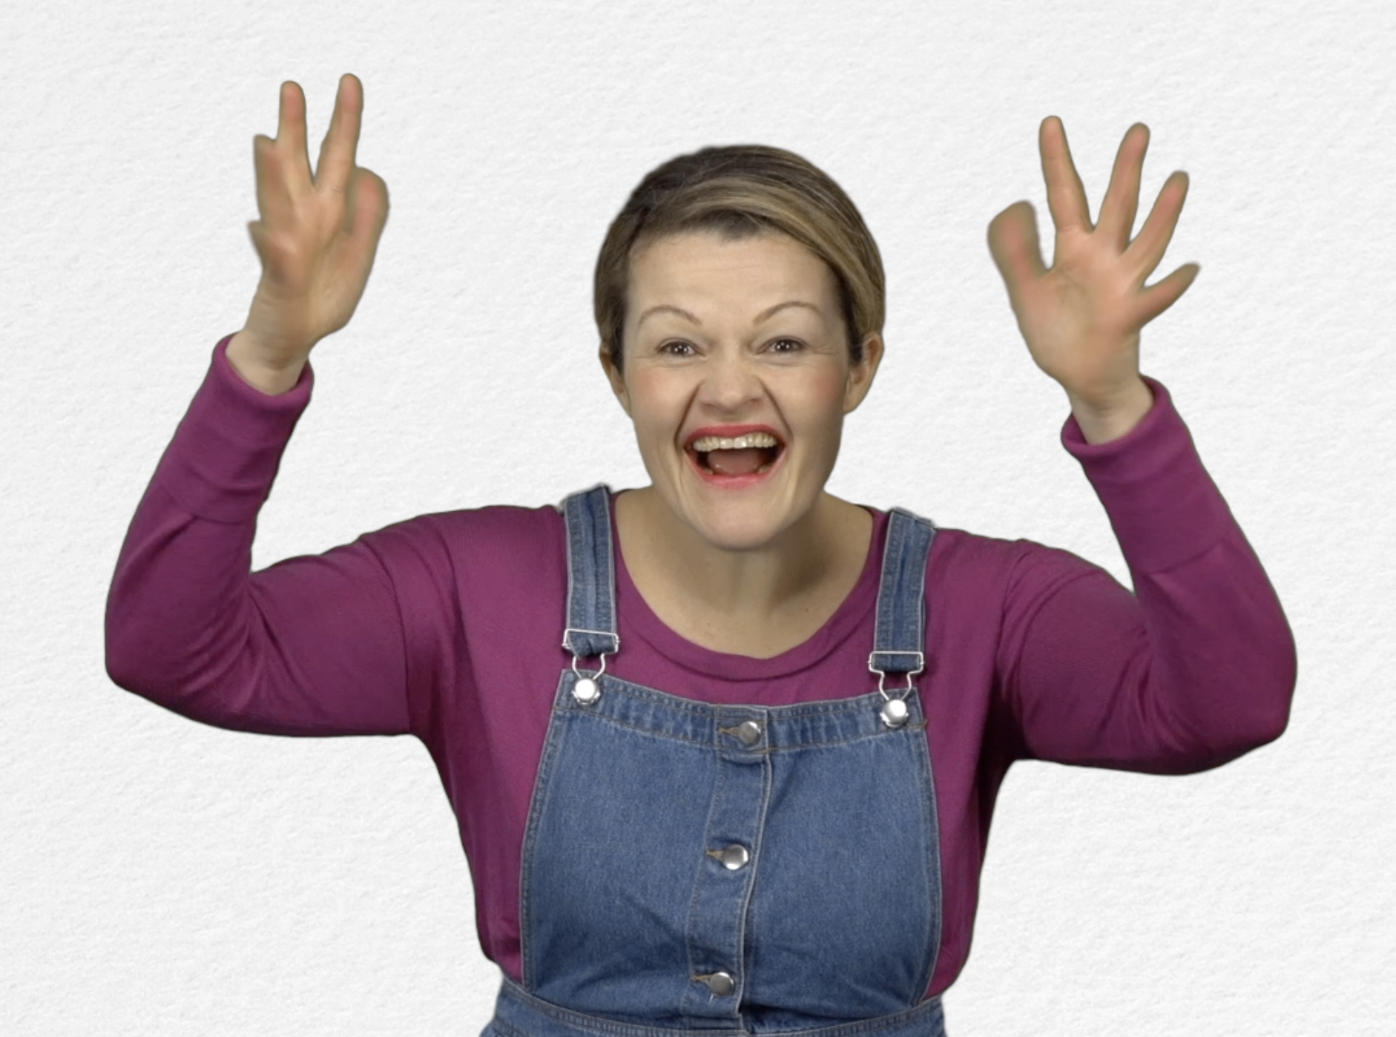
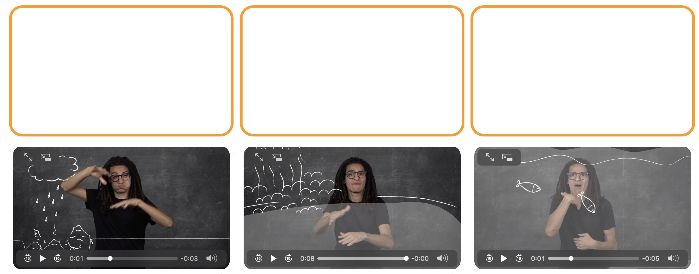
- Game : Landfills : http://opensign.eu/sequence/76
Tick the box if you have succeeded on the first try or note the number of tries.

- Extend / Enrichment / Prolongation Web links with other digital tools :

- Thematic video: Why recycle? http://opensign.eu/thematic_topics/88
- Thematic video: Recycling- how? http://opensign.eu/thematic_topics/89
- Memory Game : Recyclable objects 1: http://opensign.eu/memory_game/51
- Memory Game : Recyclable objects 2: http://opensign.eu/memory_game/75
- Quiz: Recyclable ? : http://opensign.eu/multiplechoice/77

