You can create your own resources, videos and games at:

http://www.opensign.eu

GAME : Stress

Age: 7 to 12 years
Creator : Média’Pi

Competences :
- Determine that one of the most effective ways of combatting stress is to focus on breathing

- Select the correct videos

- Take the time to watch everything before choosing your answers(s)

European Competences
https://eur-lex.europa.eu/legal-content/EN/TXT/?uri=uriserv%3AOJ.C_.2018.189.01.0001.01.ENG&toc=OJ%3AC%3A2018%3A189%3ATOC

Specific vocabulary / keywords : explode, hide or breathe, control your breathing.

Lesson outline;
After viewing and sharing the « How to manage your emotions » video at:
http://opensign.eu/thematic_topics/59
Place questions to your students while playing game: http://opensign.eu/multiplechoice/81

Resources:
A computer and an internet connection.
Focus on sign language:
Find key vocabulary in the language of your country to name the 3 actions of the character.
Facial expression is also an important input of information and can be worked upon in this lesson.

Ce projet n ° 2017-1-FR01-KA201-037433 a été financé avec le soutien de la Commission européenne. Cette publication n'engage que son auteur et la Commission ne peut être tenue responsable de l'usage qui pourrait être fait des informations qui y figurent.

- Game: Stress: http://opensign.eu/multiplechoice/81
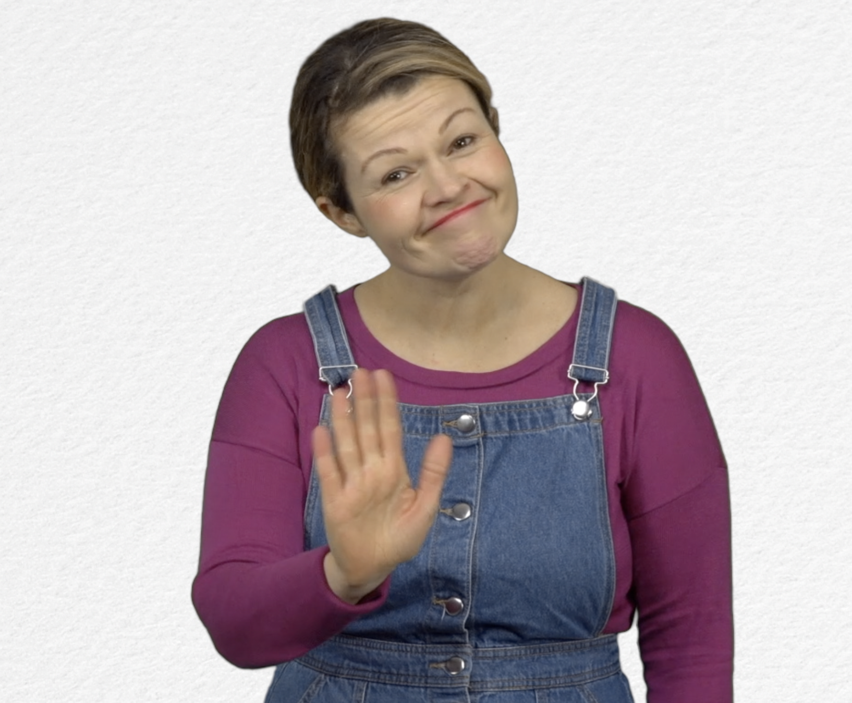
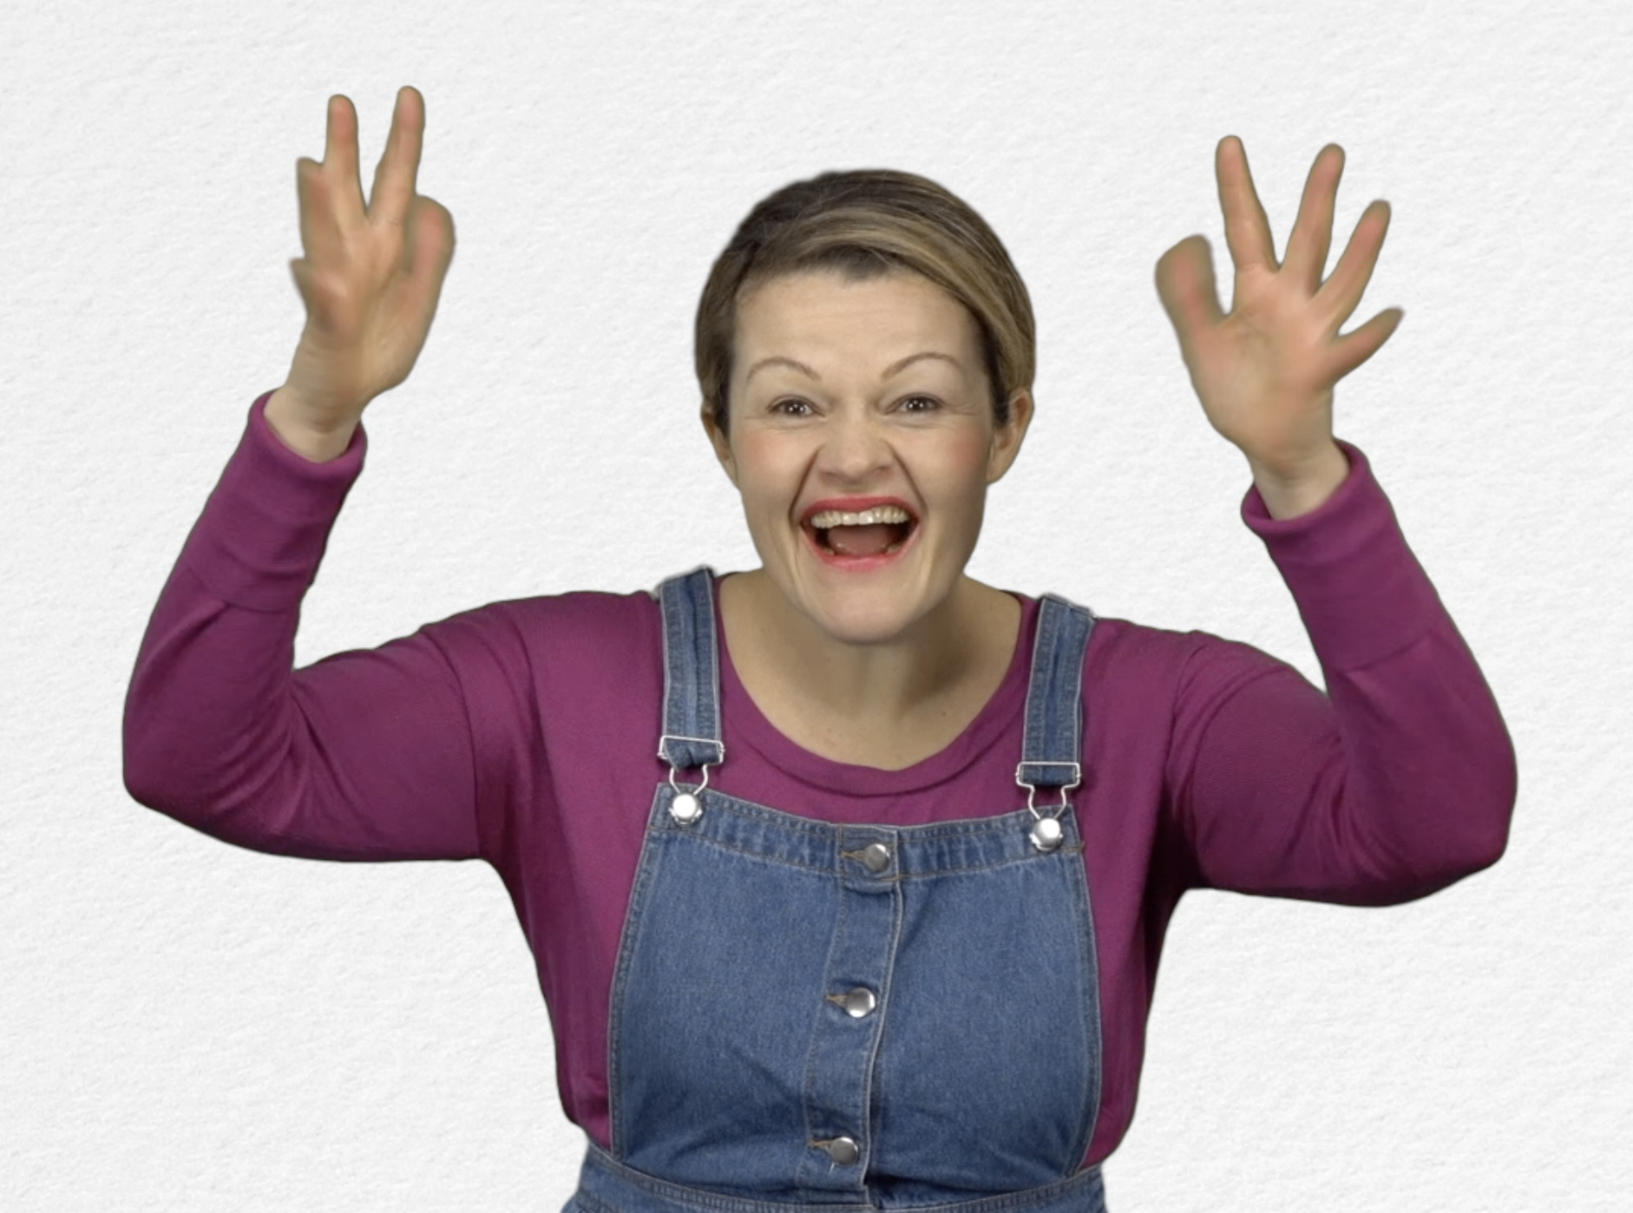
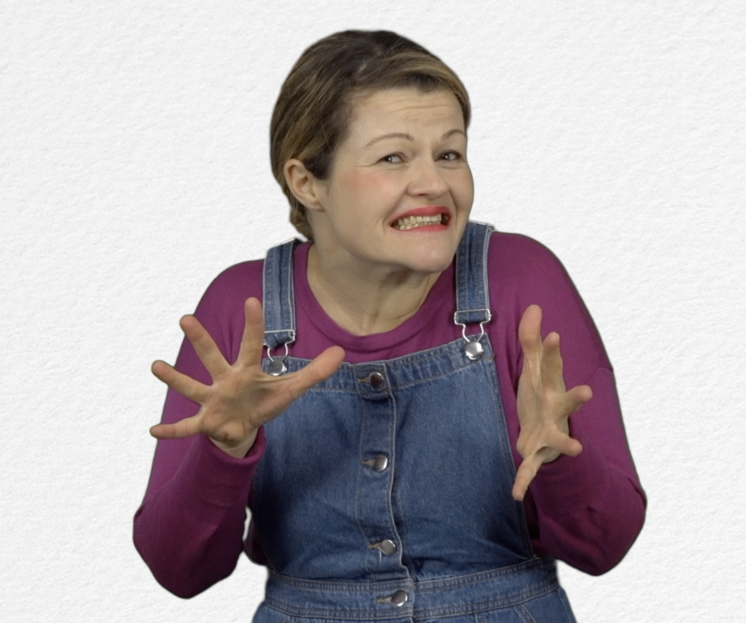
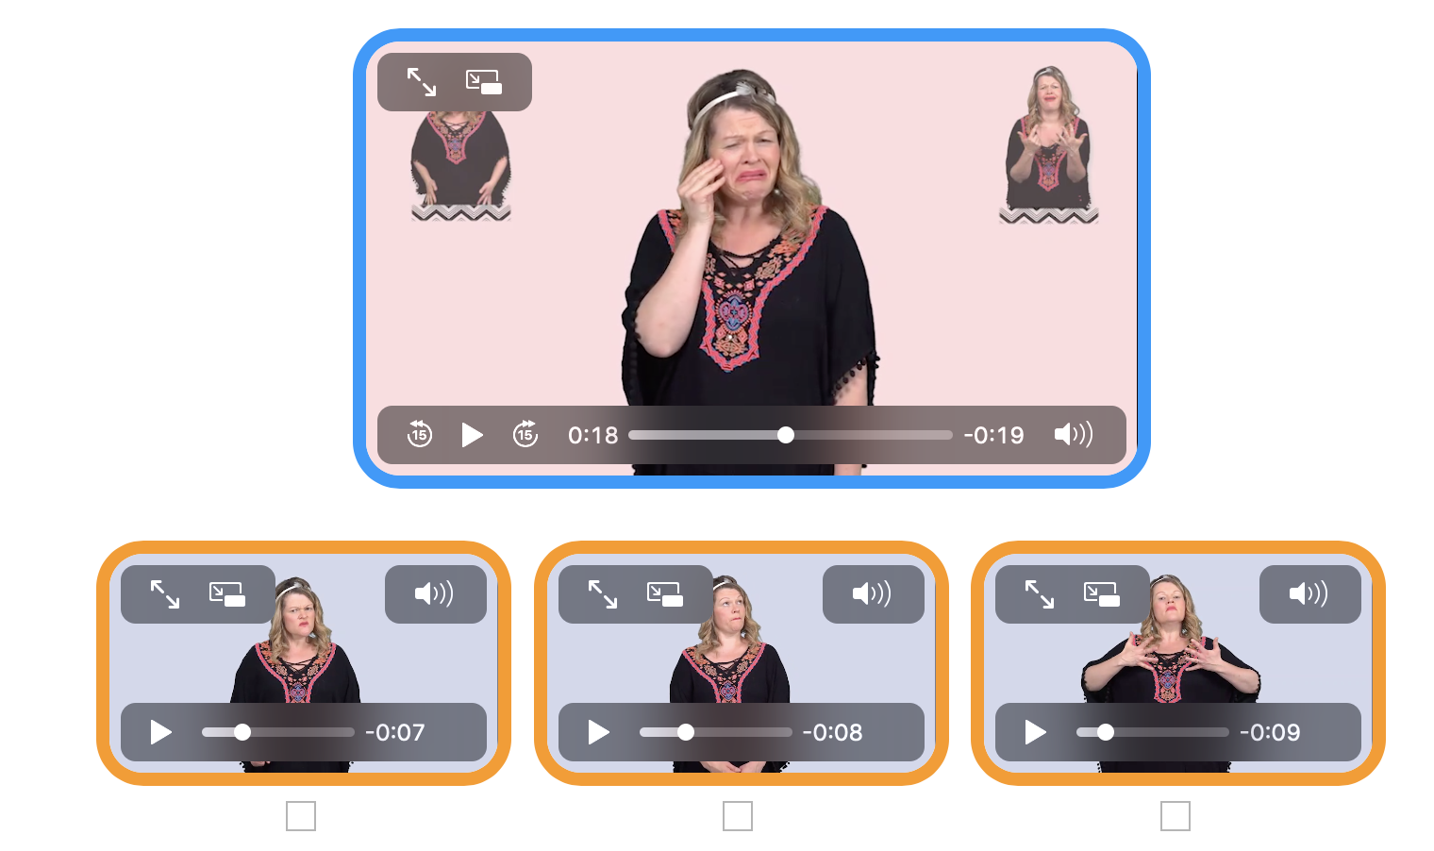
Tick the box if you have succeeded on the first try or note the number of tries.

- Extend / Enrichment / Prolongation Web links with other digital tools :

- Vidéo: « How to manage our Emotions » : http://opensign.eu/thematic_topics/59
- Game : Stop the stress ! : http://opensign.eu/sequence/82
- Game : Stress : http://opensign.eu/multiplechoice/81
- DIY Open sign: http://www.opensign.eu/manual_activities_videos
- Film Vice et versa : https://fr.wikipedia.org/wiki/Vice-versa_(film,_2015)

