You can create your own resources, videos and games at:

http://www.opensign.eu
Thematic video: Sugar

Age : 9 to 12 years
Creators: Media’Pi
Watch our thematic video at: http://opensign.eu/thematic_topics/56

Competences:

- Know the different types of natural or refined (added) sugars present in our diet and the conséquences of our consumption choices

- Limit personal sugar intake based on body needs

- Be vigilant and adopt a critical attitude towards industrial products and label reading
European Key Competences :
https://eur-lex.europa.eu/legal-content/EN/TXT/?uri=uriserv%3AOJ.C_.2018.189.01.0001.01.ENG&toc=OJ%3AC%3A2018%3A189%3ATOC

Formative Evaluation :
- Be able to differentiate hidden sugars into 2 categories: natural or refined
- Be able to link industrial products with the amount of refined sugars they contain such as soda cans or tomato sauce
- Be able to count the total amount of refined sugars in one’s own diet and compare it to the daily quantity sufficient to our needs.

Summative evaluation:
Read labels of industrial products and adopt a healthy diet commensurate with their needs.

Specific vocabulary/keywords
- natural sugar/ refined sugar/ processed foods/ industrial products/ daily requirements

Lesson outline
Present a package of powdered sugar and a package of sugar in cubes
Define sugar. Present a package of sweets, fruits, vegetables, tomato sauce and other industrial products. Which ones contain sugar?

Resources required : computer, video projector, examples of waste and packaging

Focus on sign language: Watch our video about Sugar at: http://opensign.eu/thematic_topics/56 and discuss

- Exercises, games and evaluation

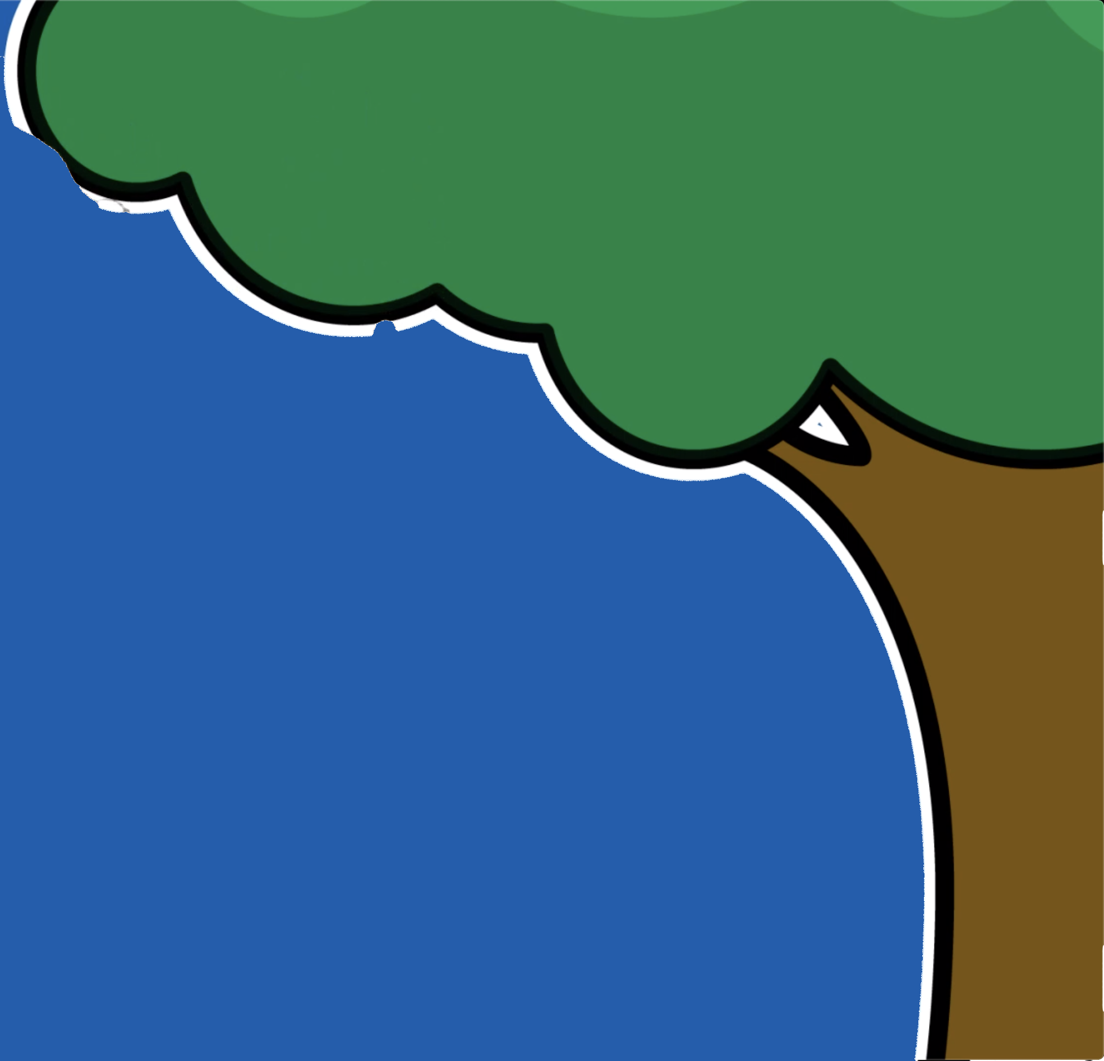
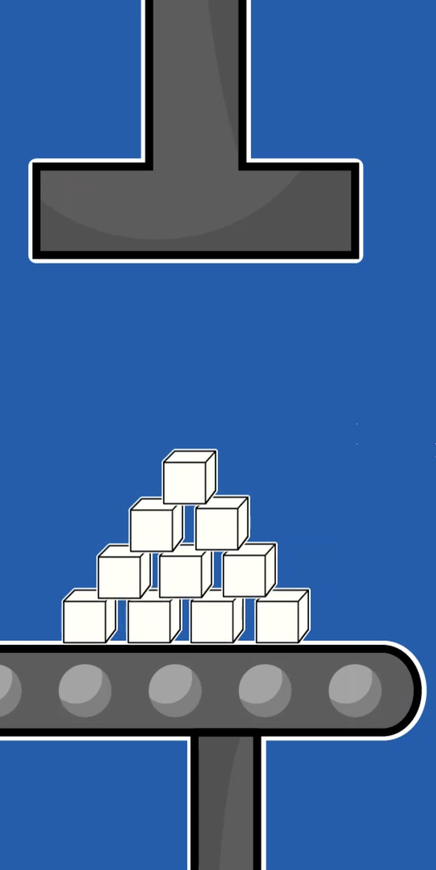
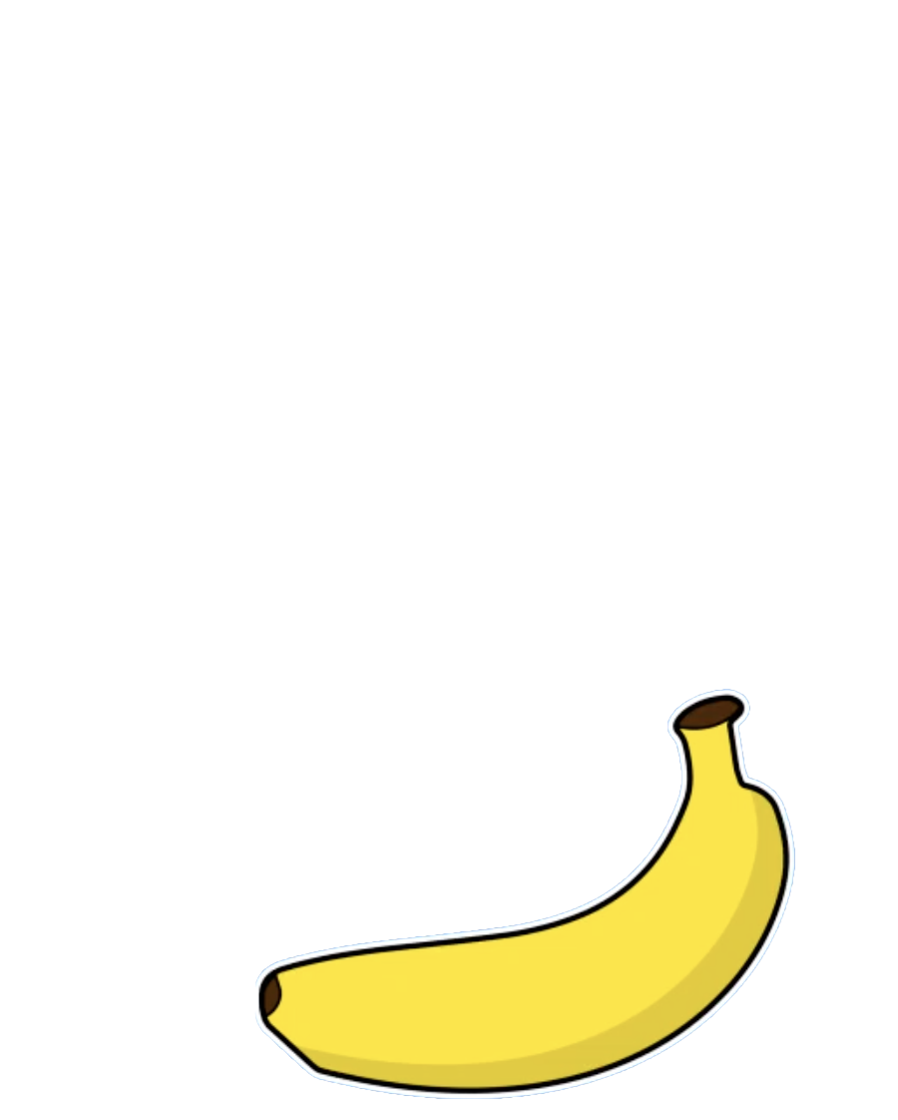
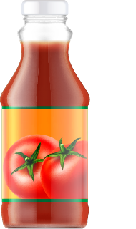
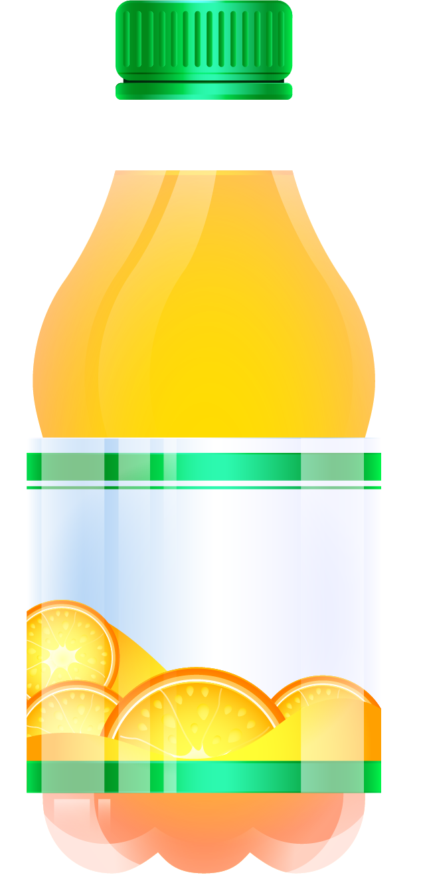
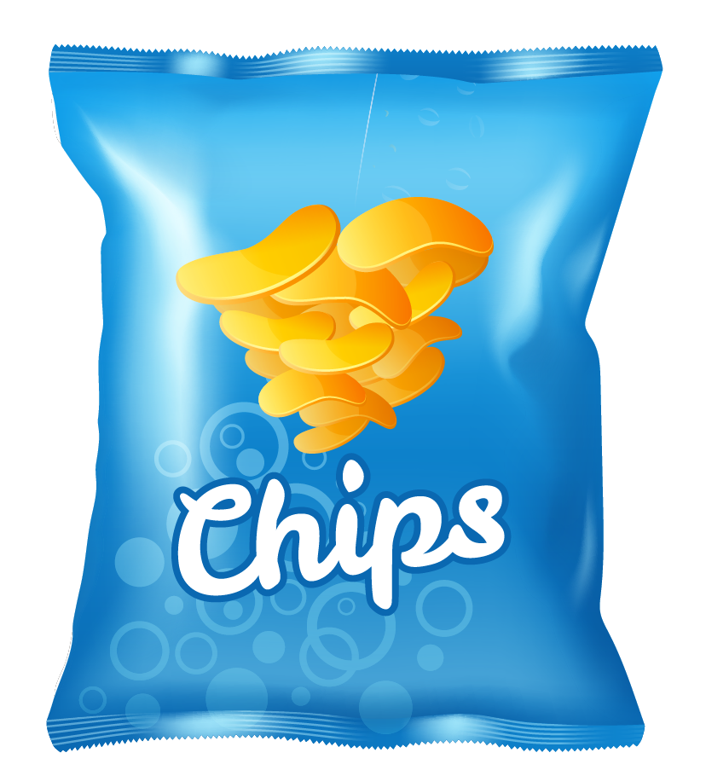
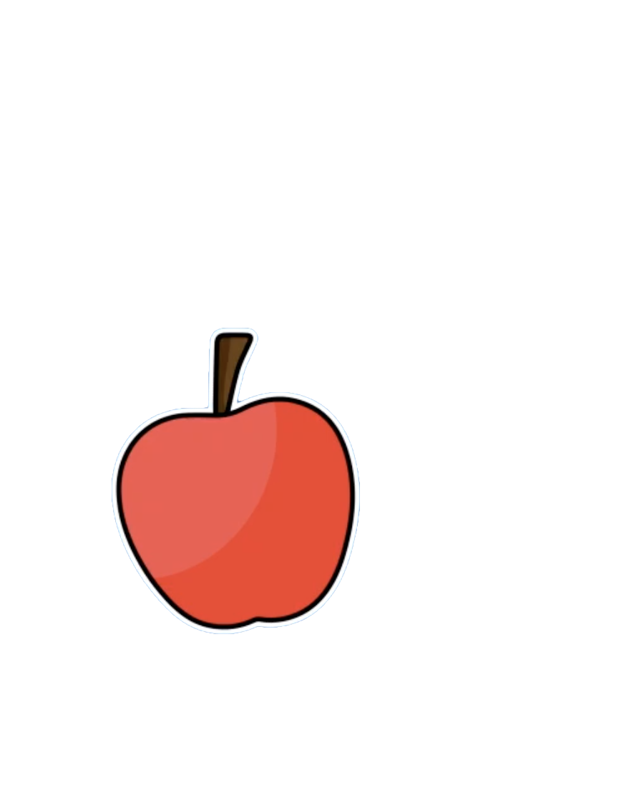
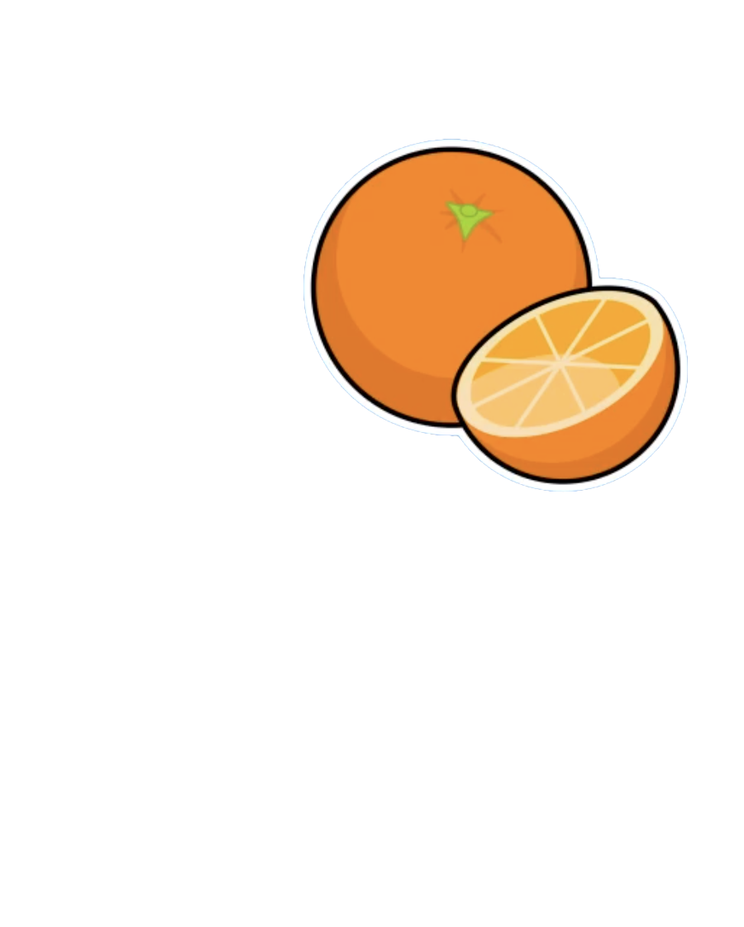
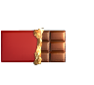
1- Circle in green the products that contain natural sugar, in purple the products with industrial sugar.

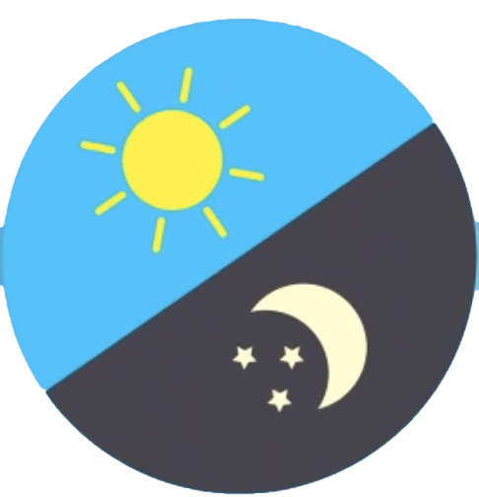
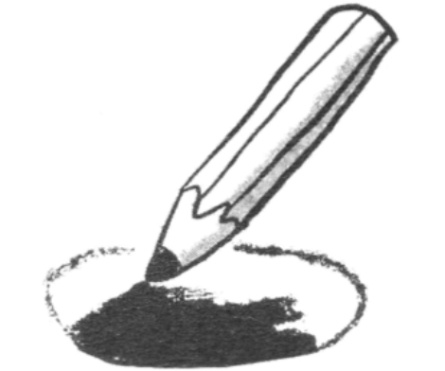
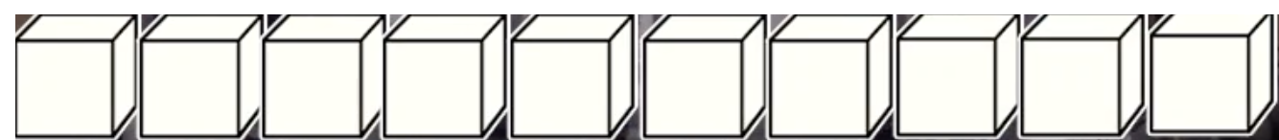
2. Colour the number of sugars in each food:

3.

100 %

80 %

?
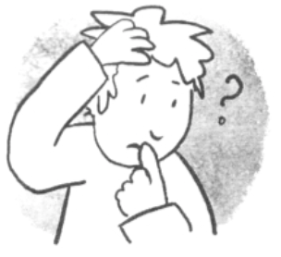
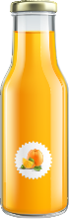
Explain the difference between these two bottles of juice
How can I be sure?

- Extend / Enrichment / Prolongation Web links with others digital tools:

1. Understanding the evolution of human food:
https://www.1jour1actu.com/info-animee/alimentation/
2. How is cane sugar made? :
https://www.youtube.com/watch?v=f16TnqmfS0w
3. How does one make sugar from beetroot - a documentary:
https://youtu.be/zAzLW9R5R7Y
4. How to have a balanced diet
https://www.youtube.com/watch?v=YimuIdEZSNY

Ce projet n ° 2017-1-FR01-KA201-037433 a été financé avec le soutien de la Commission européenne. Cette publication n'engage que son auteur et la Commission ne peut être tenue responsable de l'usage qui pourrait être fait des informations qui y figurent.

