You can create your own resources, videos and games at:

http://www.opensign.eu

GAME : Energy Levels

Age: 7 to 12 years
Creator : Média’Pi

Competences :
- Explain the impact of sugar consumption on body energy

- Read a graph / chart

- Take the time to listen to the 3 answers and choose your answer wisely

European Competences
https://eur-lex.europa.eu/legal-content/EN/TXT/?uri=uriserv%3AOJ.C_.2018.189.01.0001.01.ENG&toc=OJ%3AC%3A2018%3A189%3ATOC

Specific vocabulary / keywords : Energy Levels

Lesson outline
After viewing the video « Sugar » at http://opensign.eu/thematic_topics/56,
playing this game will allow an evaluation of comprehension of the video :
http://www.open-sign.eu/multiplechoice/80

Resources:
A computer and an internet connection.
Focus on sign language:
Do not hesitate to ask the player to replay the question and answers , reformulating them in the sign language of the country. You can ask the player about his or her choice.

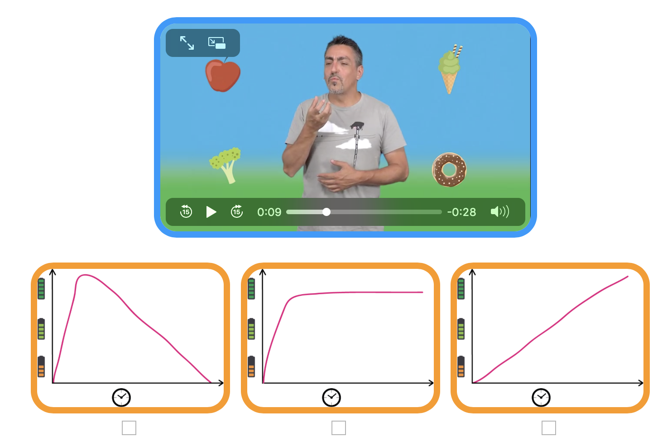
- GAME: Energy levels
- Extend / Enrichment / Prolongation Web links with other digital tools :

1. Thematic video : http://www.open-sign.eu/thematic_topics/56
2. Game: Eating Sugar : http://www.open-sign.eu/multiplechoice/62
3. Memory Game : Hidden Sugar (Level 1) http://www.opensign.eu/memory_game/78

