Title: LIKE AN INDIAN

Age category: 6 -12 years old

Authors: Istituto dei Sordi di Torino www.istitutosorditorino.org

Competences :
- The students will know that there can be different reasons for an habit and a tradition that they can see.
- The students will use their creativity in order to create something to wear from objects collected from the nature (leaves) in this case or recycling materials. The students will use their manual dexterity.
- The students will be aware of cultural ways of expression.

Competences according to European curriculum:
http://eur-lex.europa.eu/legal-content/EN/TXT/?uri=LEGISSUM%3Ac11090

Formative assessment:
- Identify the materials
- Identify the cultural traditions and explain why, the meaning of this object in the population
- Ask what they what to create and need as material

Summative Assessment:
- Communicate personal thoughts, impressions, creativity while making a new object and have fun because .

Specific vocabulary list/Keywords:
- Culture, history, imagination, cultural aspects, identity, tradition, dresses.

Short description of the educational context/scenario:
The teacher and the children will prepare and collect the materials they need: a thick cardboard strip with corrugated sheets, the stapler and some different leaves.
The teacher will explain that we can re-use some materials still in good condition in order to create new object for a game, in this case to create an headgear like the ones Indians used to have. We can also be really creative and choose different ways to create it: different leaves as feathers or draw the feathers on papers and cut out them.
The teacher can teach who Indians people were and their history. New vocabulary about the different materials and the different populations and cultures nowadays and in history. The teacher can ask how in child’s opinion they really used to build such objects and why, if for religious or social reasons…
The teacher will assist the students during the creation of the headgear and will combine the playtime with the teaching.

Materials needed/Technical requirements:
- Scissors, thick cardboard strip with corrugated sheets, stapler, leaves.

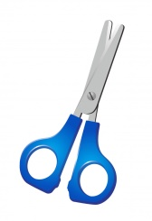
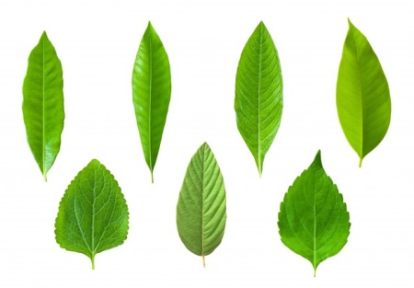
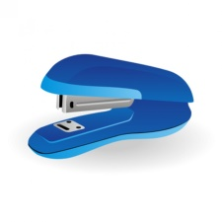

Focus on sign language:
- Sign the new vocabulary, sign the materials needed to make the headgear, sign the steps to take in order to create this new object.

- Where people usually use these headgears?

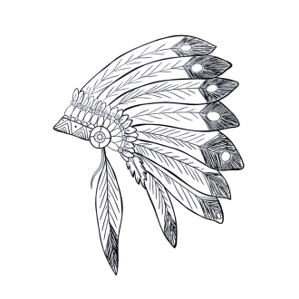
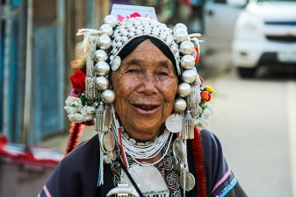
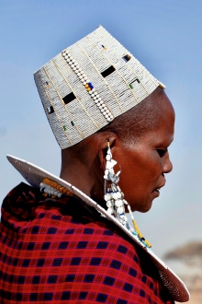
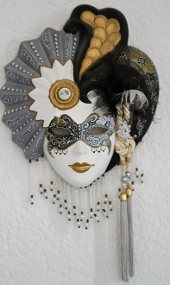

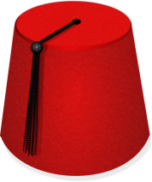
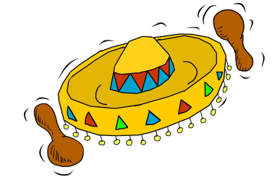

- HEADGEARS IN SPORT
- write the name of the sports you know.
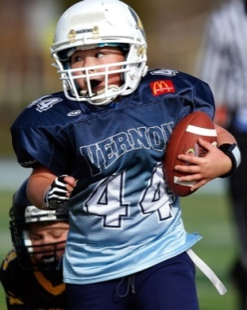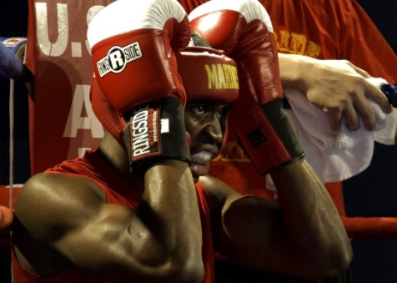

_____________________________ ________________________________

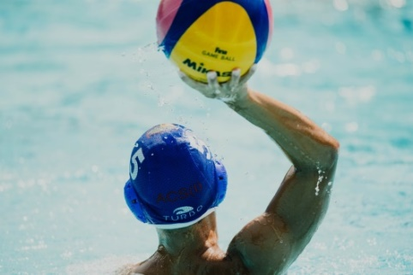

________________________________ __________________________________

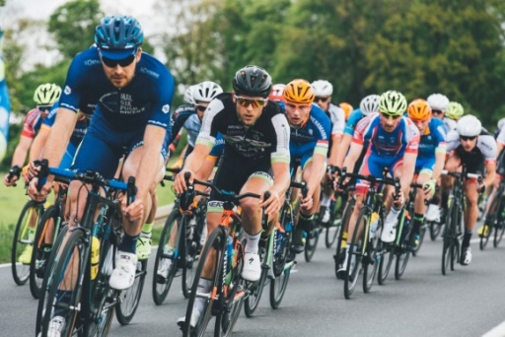

________________________________ __________________________________

- And on workplaces? Do we need particular headgears and clothes? Why?

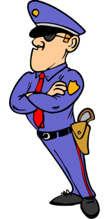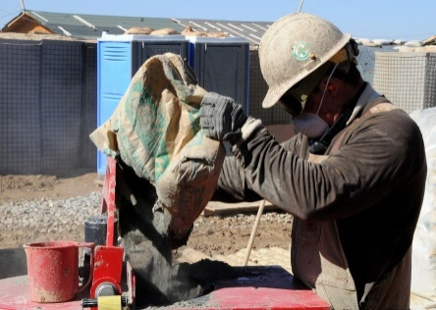

- why we use them?
______________________________________________________________________________________________
______________________________________________________________________________________________
______________________________________________________________________________________________

- do you know other sport / works?
______________________________________________________________________________________________
______________________________________________________________________________________________
______________________________________________________________________________________________

- do you do sport?
______________________________________________________________________________________________
______________________________________________________________________________________________
______________________________________________________________________________________________

- Help the two children to reach their friend and his Indian House!

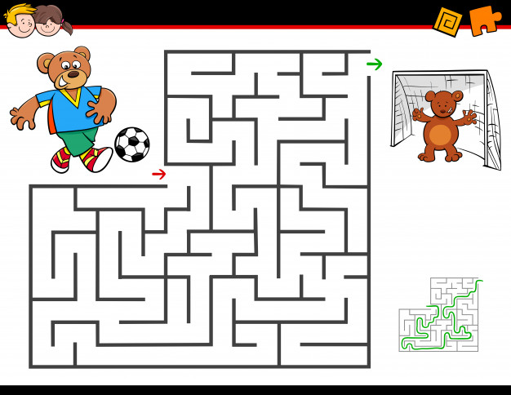

- Cut the images and make the puzzle.

Extend / Enrichment / Prolongations Web links with others digital tools:

- https://www.youtube.com/watch?v=LURNRjtiEkM
- https://www.youtube.com/watch?v=pqtOnhb_BI0
- https://www.youtube.com/watch?v=-W0pi_PsYgI

