Title: FLYING A KITE

Age category: 06 -12 years old

Authors: Istituto dei Sordi di Torino www.istitutosorditorino.org

Competences :
- After this activity, students should be able to build a kite with the help of an adult.
- The students will know to explain how to make a kite.

Competences according to European curriculum:
- http://eur-lex.europa.eu/legal-content/EN/TXT/?uri=LEGISSUM%3Ac11090

Formative assessment:
- Explain the steps for building a kite and a little bit of the history and science of flight
- Define the words: kite, cloth, wire, fly...
- Identify the tools needed to make a kite

Summative Assessment:
- Communicate the steps to take in order to make a new game, impressions, creativity while making a new object.

Specific vocabulary list/Keywords:
- Kite, history, science, air, force, physics.

Short description of the educational context/scenario:
The teacher will propose to create a kite and will ask how they think these games can fly. The teacher will explain the phases for the creation of a kite. During this activity teacher and students can discuss about the history of the objects that fly and about the animals that can fly.
The teacher can teach new vocabulary about physics and flight.
The teacher will assist the students in each phase.

Materials needed/Technical requirements:
- sticks, fabric, cords, scissors, glue, wool

Focus on sign language:
- Sign the new vocabulary, sign the materials needed to make the kite, sign the steps to take in order to create this new object.

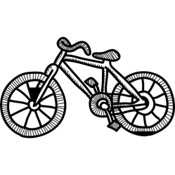
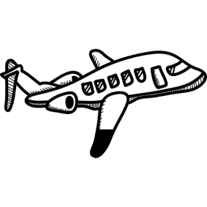
- Circle the objects that can fly.

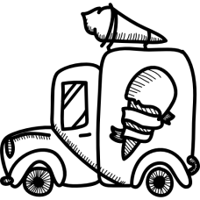

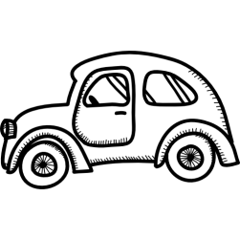

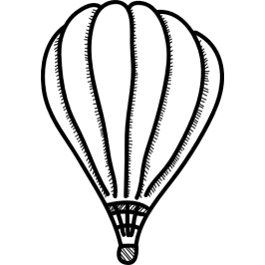
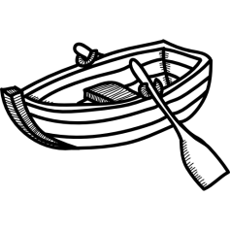

- Circle the animals that can fly.
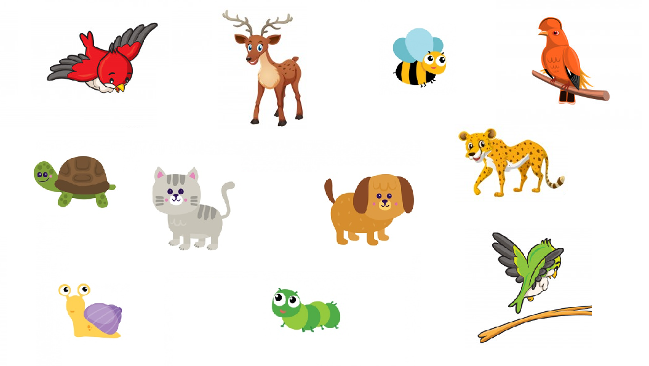

- What do you need to build a kite?

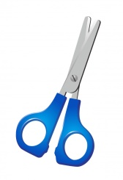
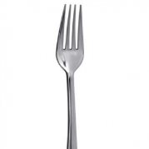
- Kite and geometry!
Which is the shape of the kite? ________________________________________

- This girl has a kite, but she is without cord. Can you help her?
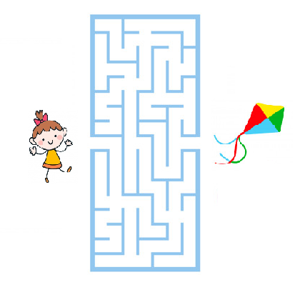

Extend / Enrichment / Prolongations Web links with others digital tools:

- https://www.youtube.com/watch?v=Oiz6K6TVTMA&feature=youtu.be

