Title: HOW DO YOU FEEL?

Age category: 6 -12 years old

Authors: Istituto dei Sordi di Torino www.istitutosorditorino.org

Competences :
- The students will learn feelings and facial expressions associated.
- The students will know to use their facial expression in order to communicate something they feel.

Competences according to European curriculum:
http://eur-lex.europa.eu/legal-content/EN/TXT/?uri=LEGISSUM%3Ac11090

Formative assessment:
- Define how we can associate facial expressions to feelings and communicate something we want to express.

Summative Assessment:
- Use facial expressions (one of the component of sign languages and non-verbal communication) and show one’s own feelings.
- Make the students more aware of the components of the communication and of the meaning of some feelings.

Specific vocabulary list/Keywords:
- Facial expressions, feelings, meaning, behaviors.

Short description of the educational context/scenario:
The video shows some feelings and the facial expression associated.
The teacher and the children will shortly look at the video and discuss with them about facial expressions, sign language components and feelings, then the teacher will propose an activity.
After the discussion with them, the teacher will propose to prepare some images with facial expressions and feelings, cut them and put them in a bag. Then, one by one the students have to draw out a card and repeat the feeling: the other students have to guess the feeling.
The teacher can help the children in each phase.

Materials needed/Technical requirements:
- Photos or drawing of facial expressions showing some feelings.

Focus on sign language:
- Sign the feelings, discuss about communication with students and about how we can express feeling in sign language.

- Which are the feelings shown from these faces?

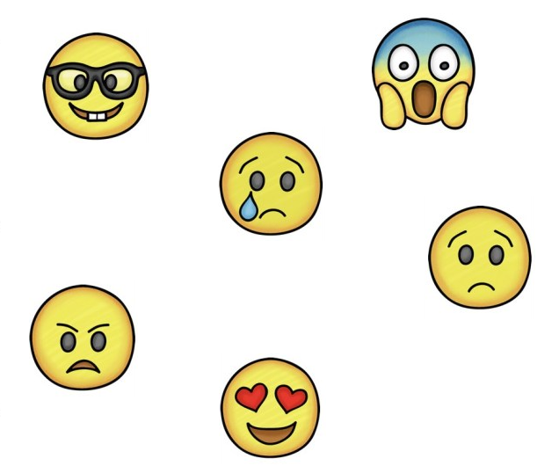

- IN LOVE
- WORRIED
- SAD
- HAPPY
- ANGRY
- SCARED

- How do you feel today? Draw yourself and write why you feel in this way.

______________________________________________________________________________________________________________________________________________________________________________________
- Match the feelings with the probably reasons, like in the example.

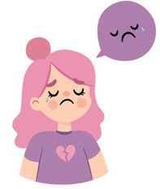
…today it’s raining and it’s impossible to go out.
....today it’s her birthday.
....today the breakfast was bad and she is still hungry.
SHE IS SAD BECAUSE…
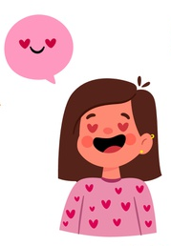
…today the bus didn’t pass on time and she arrived late.
....today it’s her birthday and her best friend forgot about it.
SHE IS HAPPY BECAUSE…
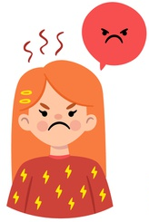
....today she visited her friends.
…today she has to go to the dentist.
....today at school she attended her favorite lesson.
SHE IS ANGRY BECAUSE…

- Draw the facial expressions written.

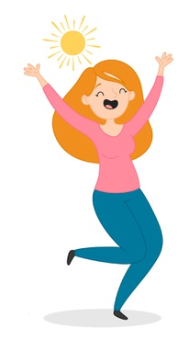
I feel happy when…
____________________________________________________________________________________________________________

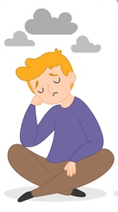
I feel sad when…
____________________________________________________________________________________________________________

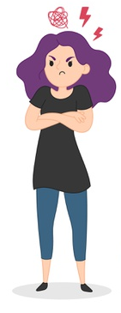
I feel sad when…
____________________________________________________________________________________________________________
- Why is the man scared? Find the reason of his fear!

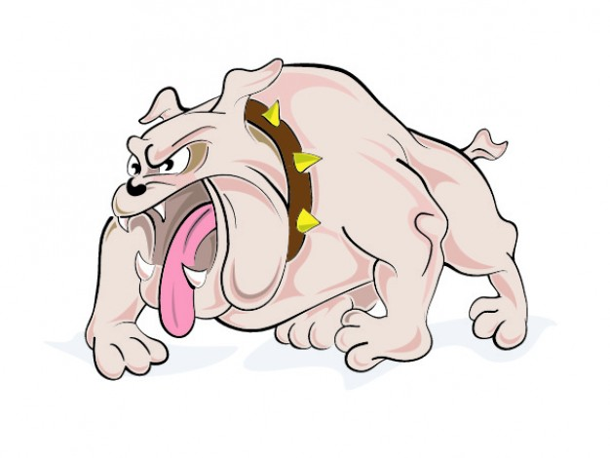
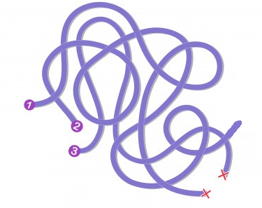
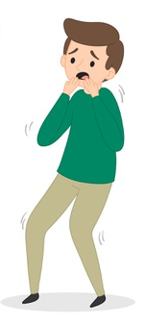

Extend / Enrichment / Prolongations Web links with others digital tools:

- https://www.youtube.com/watch?v=gh1oZrHRmZc
- https://www.youtube.com/watch?v=IBnM1Sz3fNw

