Title: HOMEMADE MODELLING PASTA

Age category: 6 -12 years old

Authors: Istituto dei Sordi di Torino www.istitutosorditorino.org

Competences :
- The students will use their creativity in order to create an object by modelling a paste.
- The students will know that materials can have a different consistency at the beginning and at the end.
- The students will know to use their manual dexterity.

Competences according to European curriculum:
http://eur-lex.europa.eu/legal-content/EN/TXT/?uri=LEGISSUM%3Ac11090

Formative assessment:
- Identify the materials
- Explain the actions to do on the materials: what to do first and the different phases
- Explain the creativity: what they what to create and use, what they think can be practically useful to have as object

Summative Assessment:
- Communicate personal ideas, impressions, creativity and manual competences (assess if they are aware of their level of competences).

Specific vocabulary list/Keywords:
- Imagination, creativity, shapes, ingredients.

Short description of the educational context/scenario:
The teacher will propose to the children to become a sculptor, but not by hitting stones, but by modelling a special paste made with simple ingredients: flour, salt and water.
The teacher will ask some questions about what children think about these materials: how their particular consistency (we can say “dusty”) can change, why the water, and so on.
The teacher will explain the phases of this activity and will ask what they’d like to create and make as little sculpture.
The teacher can teach new vocabulary about the different materials used and can ask what the children could do with these new objects, for example a photo frame or a penholder.
The teacher will assist the students during the whole activity and will combine the playtime with the teaching.

Materials needed/Technical requirements:
- Flour, salt, water, tempera colors, paintbrushes. If necessary, depending on what you what to do, cookie cutters and wires.

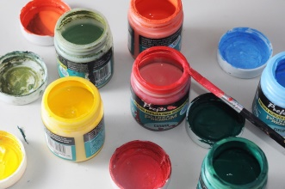

Focus on sign language:
- Sign the new vocabulary, sign the materials needed and the steps to take in order to make this paste.

- Creative jobs: what do they do?

______________________ ________________________ _______________________

______________________ ________________________ _______________________

- Which tools does the sculptor need in his work?

- Match the imagine with the correct word.

FLOUR

WATER

SALT

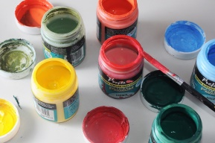
TEMPERA COLORS

SCULPTOR

PAINTER

DANCER

- Draw your hand, cut it and re-cut it on a modelling paste layer.

Extend / Enrichment / Prolongations Web links with others digital tools:

- https://www.youtube.com/watch?v=VWsUnC7JG7I
- https://www.youtube.com/watch?v=7sAZZTMdg9U

