Title: GREEK SALAD

Age category: 6 -12 years old

Authors: Istituto dei Sordi di Torino www.istitutosorditorino.org

Competences :
- The students will learn that they can always use their creativity and have fun in every activity.
- The students will learn to make an healthy dish at home and the reason why healthy habits are important .
- The students will know to use their manual dexterity with food.

Competences according to European curriculum:
http://eur-lex.europa.eu/legal-content/EN/TXT/?uri=LEGISSUM%3Ac11090

Formative assessment:
- Identify the food
- Explain the actions to do on the food: how to manage it
- Explain why healthy habits are important
- Explain that in different countries we can find different foods and cooking traditions

Summative Assessment:
- Communicate personal daily routine about food, impressions, favorite tastes and food traditions they know.

Specific vocabulary list/Keywords:
- Healthy habits, geographical production of food, vegetables and food signs (cucumber, oil, feta cheese, salt, tomatoes, olives).

Short description of the educational context/scenario:
The teacher will propose to prepare an healthy and fresh dish with vegetables and cheese, the Greek salad. It is important to underline that cooking and eating can be funny activities, and also vegetables are good.
The teacher will explain that it is important to eat healthy food in order to have a strong body, avoid illnesses and do many things. The teacher can also explain that eating habits are different in each country because it depends on the weather and on the food production.
The teacher can teach new vocabulary about the food and can ask what the child prefer as dish and his/her healthy habits.
The teacher can help him/her in both actions, the theory one about correct healthy habit and the practical one about the preparation of the dish.
The teacher will assist the students.

Materials needed/Technical requirements:
Cucumber, oil, feta cheese, salt, tomatoes, olives, bowl, knives.
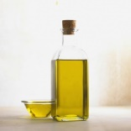

Focus on sign language:
- Sign the new vocabulary; sign the food needed to make the dish; sign the steps to take; explain the culture behind this dish.

- Which vegetables do you need to make the Greek salad?
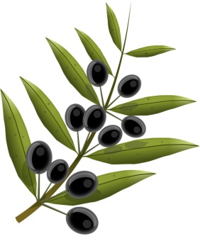
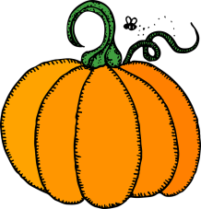
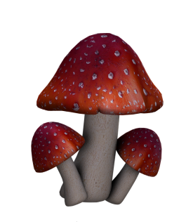
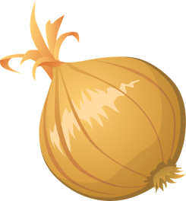
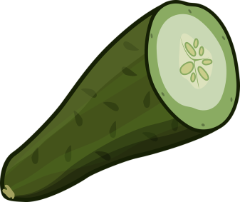
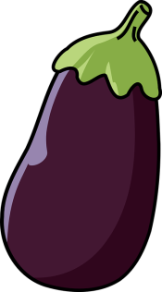
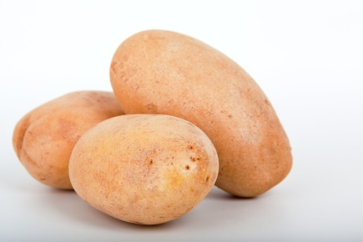
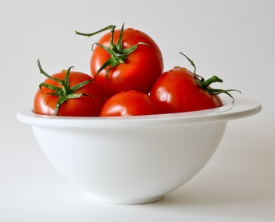
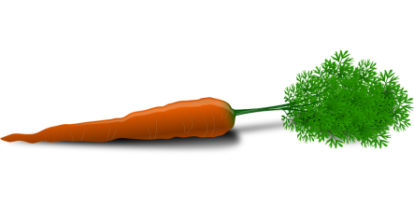

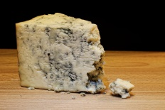
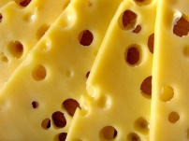
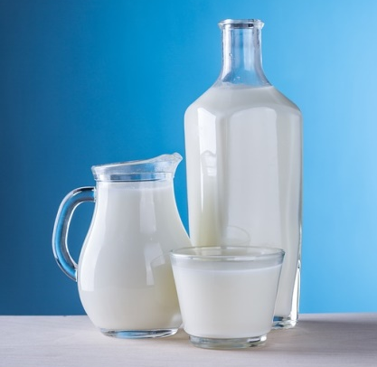
- What can we produce from milk?

With what can we produce oil?
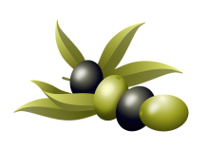
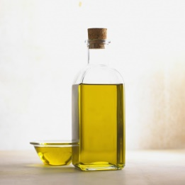

- Match the imagine with the correct word.

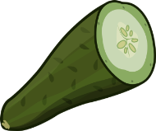

TOMATO

OLIVES

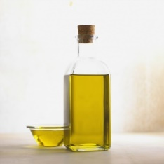

GREEK SALAD

CUCUMBER

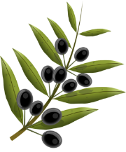

OIL

SALT

- Each country its tipical dish.

- Circle the tools you need when cooking.

- Extend / Enrichment / Prolongations Web links with others digital tools:

- https://www.youtube.com/watch?v=Htp4SSacqYk
- https://www.youtube.com/watch?v=VGLNqbgGYlg
- https://www.youtube.com/watch?v=XKsEJEwXrxM

