Title: FAST TIRAMISU

Age category: 6 -12 years old

Authors: Istituto dei Sordi di Torino www.istitutosorditorino.org

Competences :
- The students will learn to make an healthy snack at home
- The students will learn the importance of the correct actions order to take in the kitchen (for example, they can’t dip the biscuit in the coconut flour before spreading mascarpone cream) .
- The students will know that different ingredients can come from the same raw material.

Competences according to European curriculum:
http://eur-lex.europa.eu/legal-content/EN/TXT/?uri=LEGISSUM%3Ac11090

Formative assessment:
- Identify the materials.
- Explain the actions to do: what to do first and the different phases .
- Prepare the setting in order to work well.
- Explain why different ingredients come from the same raw materials.

Summative Assessment:
- Communicate that some actions have to be done in a fix order (for example, when cooking), but we can be creative and find new receipts and/or solutions.

Specific vocabulary list/Keywords:
- Cooking, snack, healthy nutrition, milk, coconut, hazelnut, cocoa, biscuits.

Short description of the educational context/scenario:
The teacher will propose to create a sweet together for a break, a fast snack to share with the friends.
They can collect the ingredients in different way: the teacher can buy everything and directly make the sweets or the teacher can ask the child to decide for how many people prepare this snack and make some mathematics calculations. It depends on the aim of the activity.
The teacher will explain the phases for the creation of the “Fast Tiramisu” and ask the child from where the ingredients come and what is part of the same type, for example cream and mascarpone come from milk.
The teacher can teach new vocabulary about the ingredients we usually use for cooking sweets and cakes and can ask the child to be creative and think of other ingredients to use or replace.
The teacher will assist the students in each phase.

Materials needed/Technical requirements:
- Milk, coconut flour, biscuits, sweet cocoa powder, hazelnut cream, a spoon, mascarpone cheese.

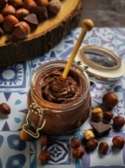
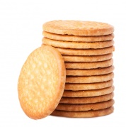
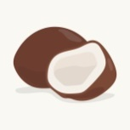
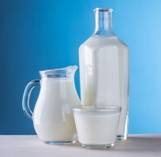
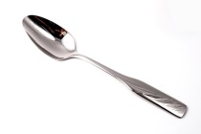

Focus on sign language:
- Sign the new vocabulary, sign the materials needed to make the sweet, sign the steps to take in order to make this sweet.

- Choose which food is sweet and which is salty.

SALT
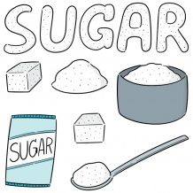

- Color the cake corresponding to the month of your birthday.

JANUARY FEBRUARY MARCH

APRIL MAY JUNE

JULY AUGUST SEPTEMBER

OCTOBER NOVEMBER DECEMBER
- Each food has its place!

FISH
MEAT
VEGETABLES
FRUIT
- Draw your favorite food and explain why you like it:

- Origins: from where comes each of this food?

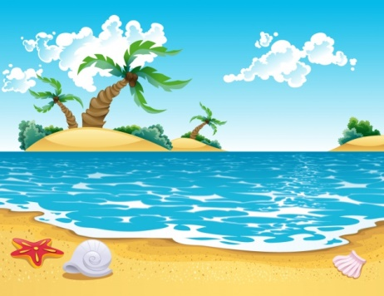
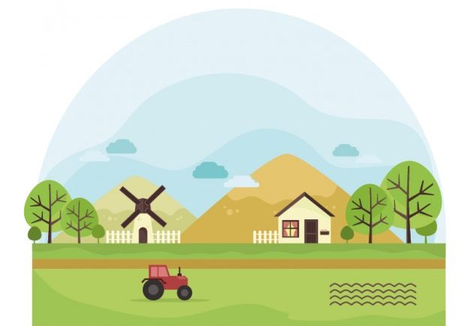

Extend / Enrichment / Prolongations Web links with others digital tools:
SEASIDE
COUNTRYSIDE

- https://www.youtube.com/watch?v=Dsgl8Luv8mw
- https://www.youtube.com/watch?v=pOeic7W8_Yc

