Title: my ancient EGYPTIAN papyrus

Age category: 6 -12 years old

Authors: Istituto dei Sordi di Torino www.istitutosorditorino.org

Competences :
- The students will learn by doing and by having fun.
- The students will learn that ancient civilizations used another writing and had other daily traditions.
- The students will learn not only about Egyptian people, but also about other “civilizations of the rivers”: the Sumerians, the Babylonians and the Assyrians.
- The students will know to use their manual dexterity and act properly in relation to the objects and different shapes in order to create something new.

Competences according to European curriculum:
http://eur-lex.europa.eu/legal-content/EN/TXT/?uri=LEGISSUM%3Ac11090

Formative assessment:
- Identify the tools
- Explain the actions to do on the materials: what to do first and the different phases
- Define new terms and what do they mean: civilization, “ancient civilizations of the rivers”, alphabet, communication, papyrus…

Summative Assessment:
- Learn that in order to arrive at today’s human alphabet and language we had many phases starting from drawings.

Specific vocabulary list/Keywords:
- Egyptian civilization, papyrus, writing, drawing, pyramid, social classes , history.

Short description of the educational context/scenario:
The teacher will collect the materials needed in order to create a papyrus: cardboard, gauze, glue , paintbrush, a dish, a fork, scissors, wax crayons and cocoa.
The teacher will ask to the children if they know where ancient civilizations used to write and in which language (here starts the presentation and the research of images about Egyptian writing).
After discussion with them, the teacher will propose to make a game: create with art material a papyrus, then draw and write on it as they wish.
The teacher can help the children in both actions, the practical one about the manual activity and the imaginative one about what to draw and the symbols to write.
The teacher will assist the students.

Materials needed/Technical requirements:
- Cardboard, gauze, glue , paintbrush, a dish, a fork, scissors, wax crayons and cocoa.

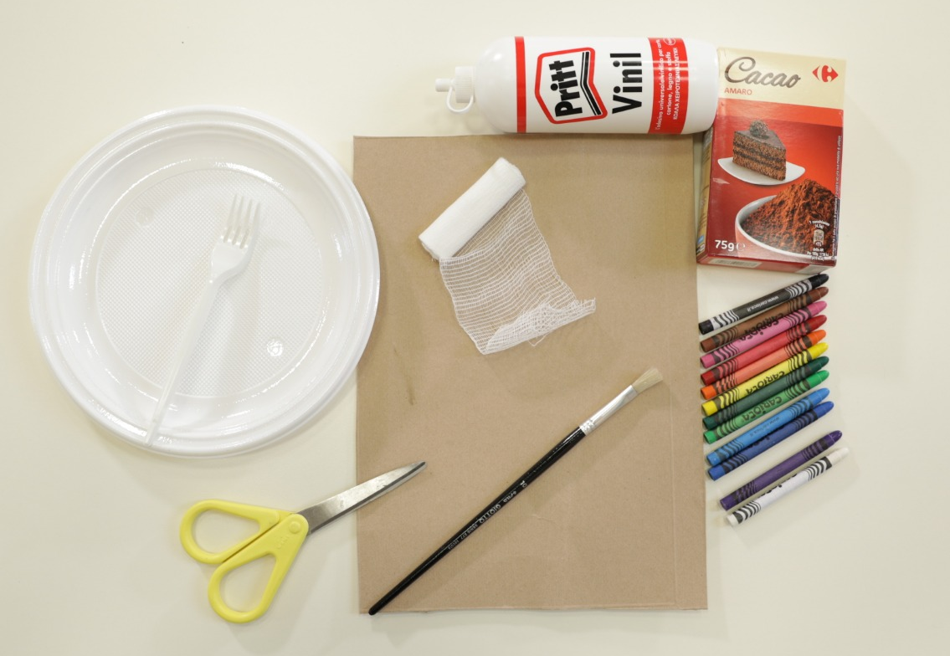

Focus on sign language:
- Sign the new vocabulary, sign the materials needed to make the papyrus, sign the steps to take.

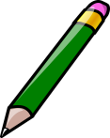
- Circle the famous characteristics of Egyptian civilizations.

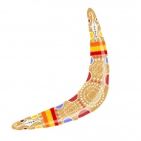
- Write your name using the Egyptian alphabet.

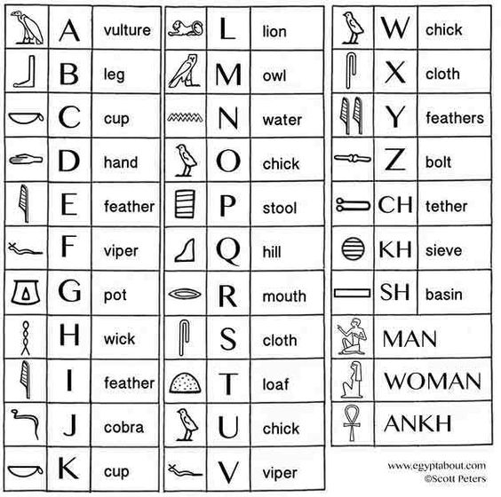

MY NAME IS…

______________________________________________________________________________
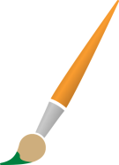
- Where is Egypt? Colour the correct country.

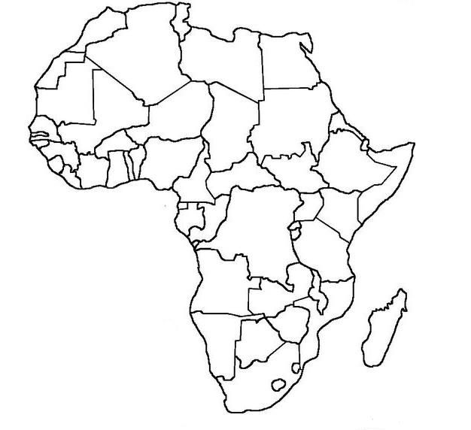

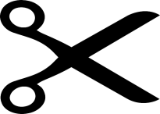
- What are their names?
5. DROMEDARY
6. PIRAMIDI
7. MUMMY
- PHARAOH
- OBELISK
- SPHINX
- PAPYRUS
- Help the mummy to come back to his pyramid!
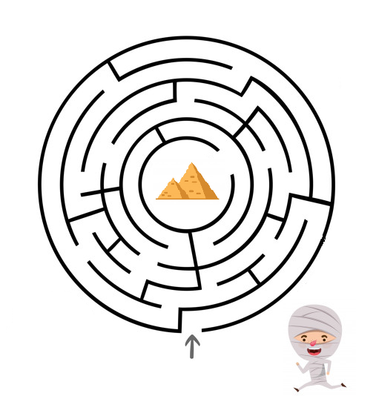

Extend / Enrichment / Prolongations Web links with others digital tools:

- https://www.youtube.com/watch?v=8_Tbv7anqXk
- https://www.youtube.com/watch?v=hO1tzmi1V5g
- https://www.youtube.com/watch?v=lBYmOuajdC8

