Title: CLOTHES DESCRIPTION

Age category: 6 -12 years old

Authors: Istituto dei Sordi di Torino www.istitutosorditorino.org

Competences :
- The students will learn some basic components of sign language in order to describe a person and tell how is dressed and what are the characteristics.
- The students will learn that facial expressions and some hand shapes are the one that allow to describe at the best a clothes or the shape of an object.
- The students will know to use their manual dexterity and body movements.

Competences according to European curriculum:
http://eur-lex.europa.eu/legal-content/EN/TXT/?uri=LEGISSUM%3Ac11090

Formative assessment:
- Discuss together how we can explain an object through signs and gestures.
- Define how we can associate mime, facial expressions and hand shape with what we want to describe.
- Discuss together the components of sign languages.

Summative Assessment:
- Use facial expressions, hand shape and non-verbal communication in order to describe external objects.
- Make the students more aware of the components of the communication.

Specific vocabulary list/Keywords:
- Sign language components, manual components, hand shape, facial expressions, external characteristics of the objects.

Short description of the educational context/scenario:
The teacher will ask the students of what components sign languages are made and how do they communicate with hearing people that don’t know sign language or have never met a deaf person. The discussion can be really useful in order to improve communicative skills and think together about how important languages are in human communication.
After discussion with them, the teacher will propose to make a video or to prepare some photos of a topic chosen by the group (clothes, buildings, uniforms, places…) and describe them using mime, signs and hand shape.
The teacher can help the children in each phase.

Materials needed/Technical requirements:
- Photos of clothes or other themes/subjects/topics that can be shown through hand shape, facial expression and sign language components.

Focus on sign language:
- Sign the new vocabulary, discuss about communication with students and about which components sign languages are composed.

- How do you describe in signs these clothes and objects? For who are them?
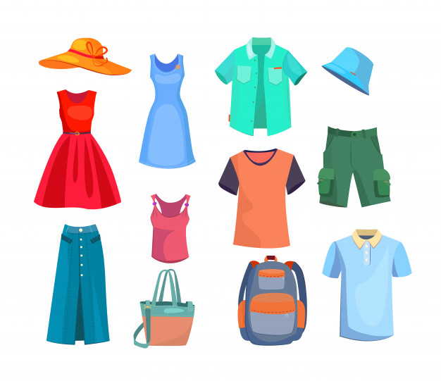

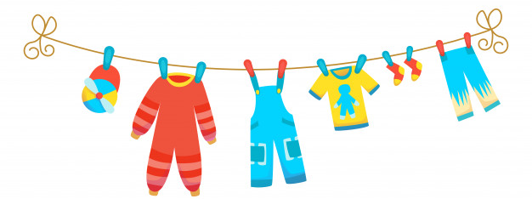
- Associate the hand shape you use in order to describe these characters?
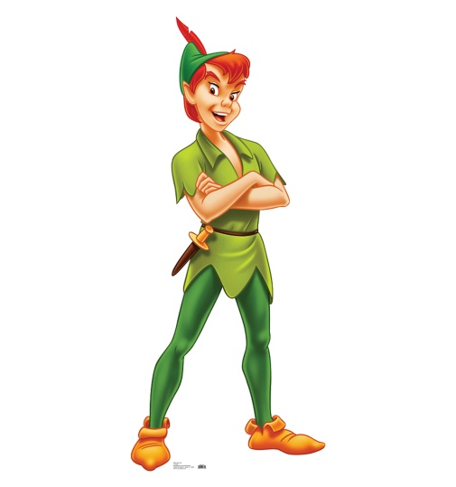

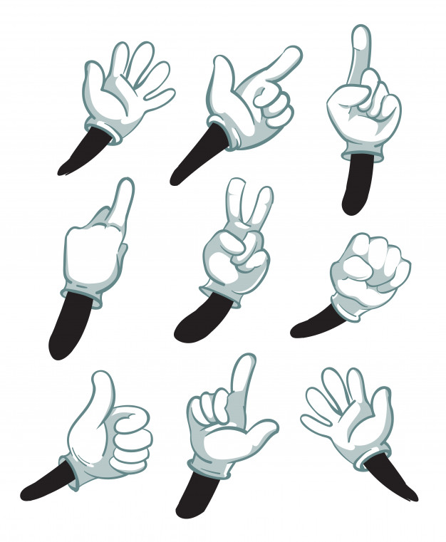

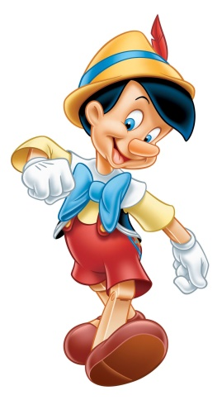

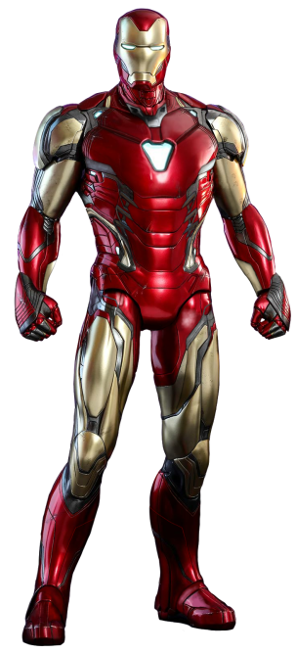
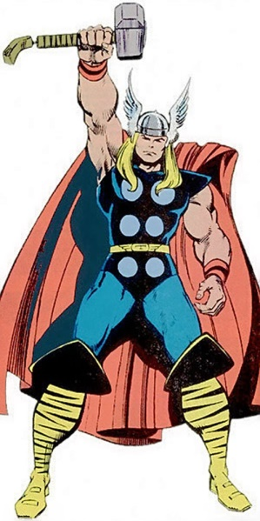

- Which is your main physical characteristic? Draw yourself and write what and why it’s particular.

- Which is your favourite character? Draw it and explain why?

Extend / Enrichment / Prolongations Web links with others digital tools:

- https://www.youtube.com/watch?v=_-f1My_8OFE

