Title: ANIMALS AND EXPRESSIONS

Age category: 6 -12 years old

Authors: Istituto dei Sordi di Torino www.istitutosorditorino.org

Competences :
- The students will learn facial expressions associated to a topic in order toimprove the way to communicate.
- The students will know that facial expressions can express feelings and characteristics.
- The students will know to use their manual dexterity and movement.

Competences according to European curriculum:
http://eur-lex.europa.eu/legal-content/EN/TXT/?uri=LEGISSUM%3Ac11090

Formative assessment:
- Discuss together how we can explain soothing through signs and gestures.
- Define how we can associate mime and facial expressions.
- Discuss together the feelings that facial expressions can clearly show.

Summative Assessment:
- Use facial expressions (one of the component of sign languages and non-verbal communication) and show feelings and characteristics.
- Make the students more aware of the components of the communication.

Specific vocabulary list/Keywords:
- Facial expressions, feelings, animals, characteristics, external characteristics and internal ideas and feelings.

Short description of the educational context/scenario:
The teacher will ask the students of what components sign languages are made and how do they communicate with hearing people that don’t know sign language or have never met a deaf person. The discussion can be really useful in order to develop identity concept and think together about how important languages are in human communication.
After discussion with them, the teacher will propose to make a video or to prepare some photos of a topic chosen by the group (animals, family’s members, feelings, jobs…) and describe them using mime, signs and facial expressions.
The teacher can help the children in each phase.

Materials needed/Technical requirements:
- Photos of animals or other themes/subjects/topics that can be shown through facial expressions and sign language components.

Focus on sign language:
- Sign the new vocabulary, discuss about communication with students and about which components sign languages are composed.

- How does this man feel?

HAPPY

BORED

SURPRISED

SAD
ANGRY
- What is this child doing? How does he feel?

___________________________________________________________________________________________________________________________________

___________________________________________________________________________________________________________________________________

___________________________________________________________________________________________________________________________________

___________________________________________________________________________________________________________________________________
- Can you explain the differences?

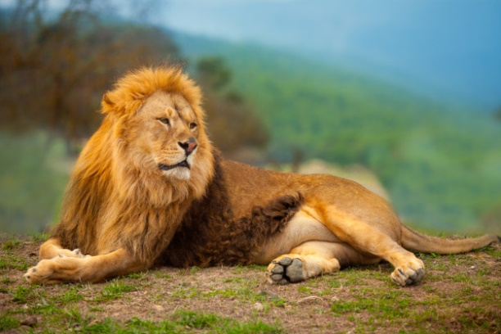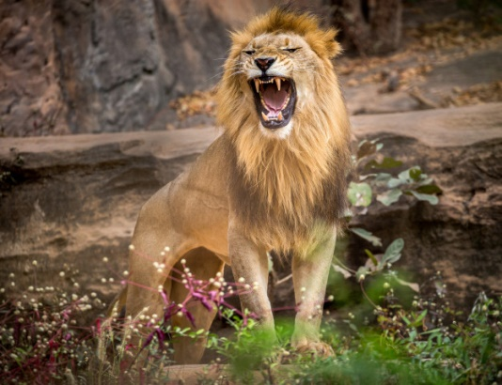

___________________________________________________________________________________________________________________________________________________________________________________________________________________________________________________________________________

___________________________________________________________________________________________________________________________________________________________________________________________________________________________________________________________________________

- Draw the facial expressions written.

TIRED HAPPY

WORRIED IN LOVE

ENTHUSIASTIC ANGRY
- Cut the images and make the puzzle .

Extend / Enrichment / Prolongations Web links with others digital tools:

- https://www.youtube.com/watch?v=37w9JjUWN30
- https://www.youtube.com/watch?v=Q9JJyfnbY6g

