THE VERY HUNGRY CATERPILLAR

Age category: 6-12

Authors: IOANA LETITIA SERBAN; OVIDIA MONICA MORARU

Competences:
- The students will learn the life cycle of the butterfly
- The students will know the characteristics of a caterpillar
- The students will learn to monitor the steps of a lifecycle

Competences according to European curriculum:
http://eur-lex.europa.eu/legal-content/EN/TXT/?uri=LEGISSUM%3Ac11090

Formative assessment:
- Present the book, the illustrations and the materials
- Define and recognize the caterpillar and the butterfly
- Identifying the steps in the lifecycle of a butterfly through the story

Summative Assessment:
- Telling the story from beginning to the end

Specific vocabulary list/Keywords:

- Caterpillar, butterfly, storytelling

Short description of the educational context/scenario:

The teacher and the children will watch the video” The very hungry caterpillar”. The teacher will ask questions about the story presented in the video. The teacher will use sign language and will explain the new vocabulary and the concepts of the story. The children will sign the new vocabulary and will tell the story as they understood it. They will watch the video again. The children will play the story individually. The teacher will give the educational sheet to the children. The children will complete the educational sheet. The teacher will assist the students.

Materials needed/Technical requirements:
Computer, tablet, internet, papers, toys, pencils, sheets.

Focus on sign language:
Signing the new vocabulary, signing the story from the beginning to the end.

- Circle the caterpillars:

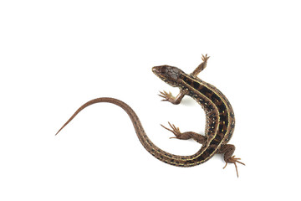
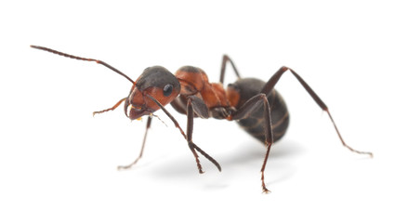
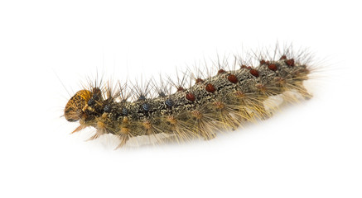
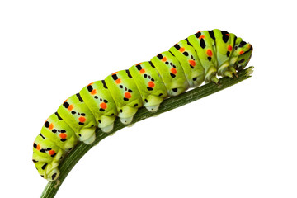

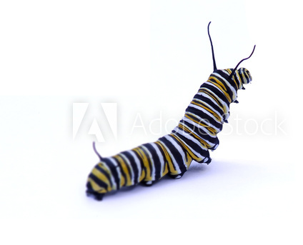

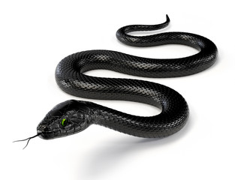

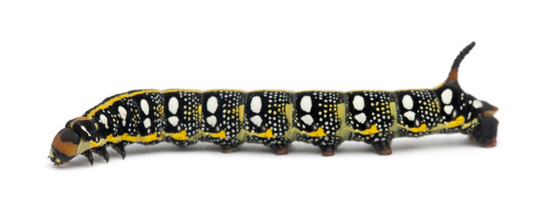

- Count the steps of the butterfly’s life cycle shown in the picture below:

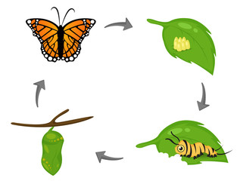

- Color the caterpillar and the butterfly:
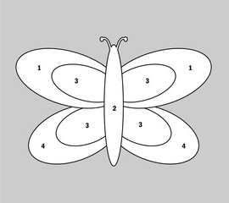

Colour by numbers:

1 – blue
2 – orange
3 – yellow
4 – green

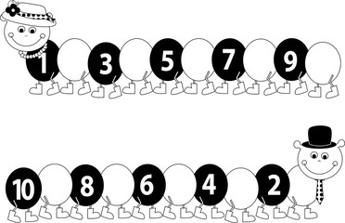
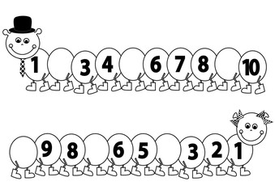
- Fill in the missing numbers:

- What does a caterpillar eat? Match the images:

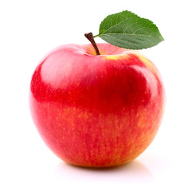

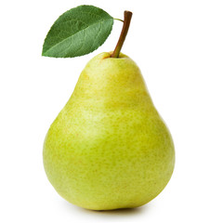

- Match the words with the pictures:

 | CATERPILLAR
 | EGGS
 | PEAR
 | BUTTERFLY
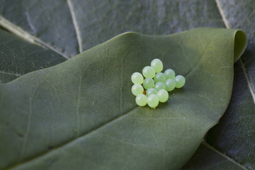 | LEAF
 | WINGS
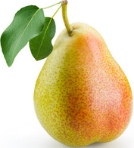 | APPLE

- Arrange the images from the story in the right order:

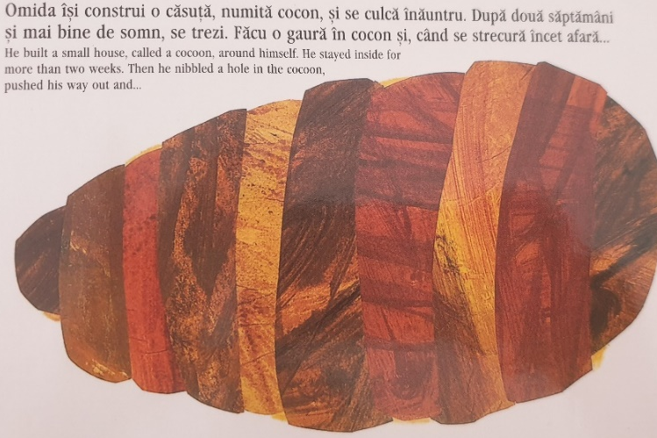

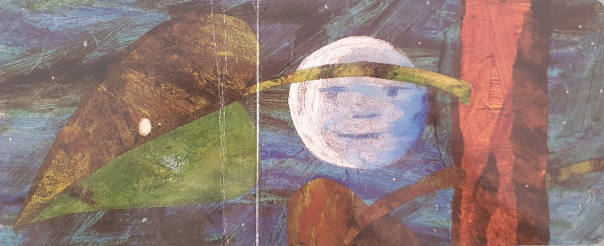
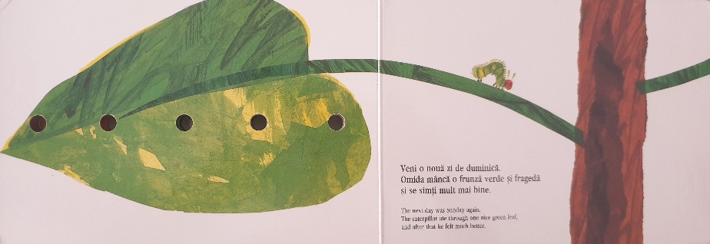
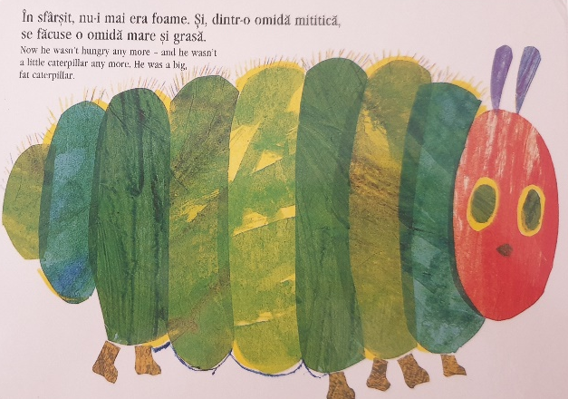

- Complete the sentences:

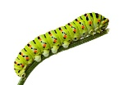

A small ………….. came out of the egg.

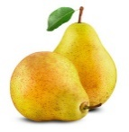

The caterpillar ate through two ………… but he was still hungry.

The caterpillar ate through one green …….. .

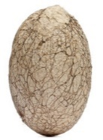

The caterpillar built a small house around himself, called a ………..

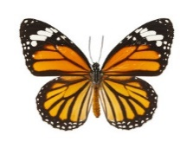

When the caterpillar pushed his way out he was a beautiful …………….. .

Extend / Enrichment / Prolongations Web links with others digital tools:

1. www.freepik.com
2. www.pixabay.com
3. www.pdclipart.org
4. The Very Hungry Caterpillar - Animated Film
https://www.youtube.com/watch?v=75NQK-Sm1YY

