You can create your own resources, videos and games at:

http://www.opensign.eu

Thematic Topic: A Pyramid in Ancient Egypt

Age: 7 to 12 years
Creator: Média’Pi

Competences :
- To learn about the construction of the pyramids and understand the technical feats used for these ancient buildings
- Describe and explain several Egyptian construction techniques
- Be curious!

European Competences
https://eur-lex.europa.eu/legal-content/EN/TXT/?uri=uriserv%3AOJ.C_.2018.189.01.0001.01.ENG&toc=OJ%3AC%3A2018%3A189%3ATOC

Formative Evaluation
Place the period of pyramid construction on a chronological timeline before the year 0.
List some of the building techniques designed by Egyptian architects.

Summative Evaluation
Explain the difficulties encountered by the Egyptians and the technical skill achieved.

Specific vocabulary / keywords
Ancient Egypt/ the Pharaoh and characteristics / the workers/ the Nile/ a pyramid/ sand/ water/ a block of stone/ technique

Lesson outline
- Watch the video called « Ancient Egypt » on our website
http://opensign.eu/thematic_topics/57.
- During the first viewing, pause to have a discussion about the content and give essential vocabulary.
- Replay the video and rephrase the content
Resources required : computer, video projector, examples of waste and packaging

- Written trace of the lesson
- Images / Vocabulary

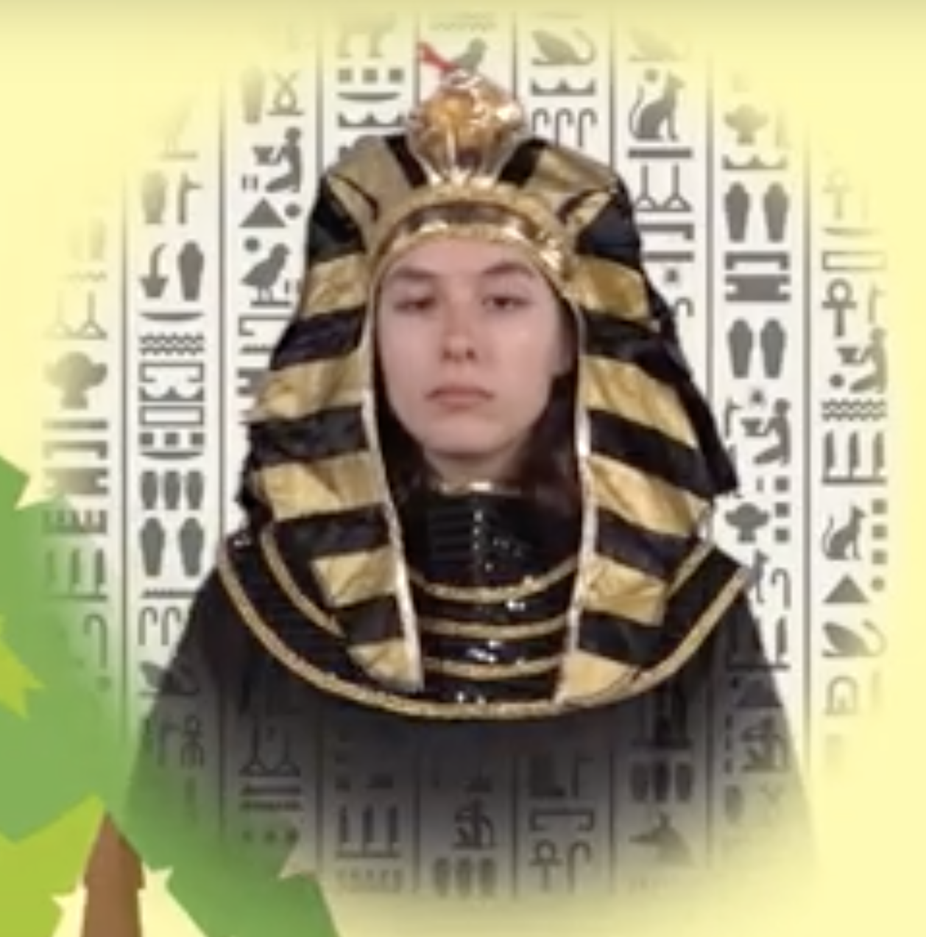

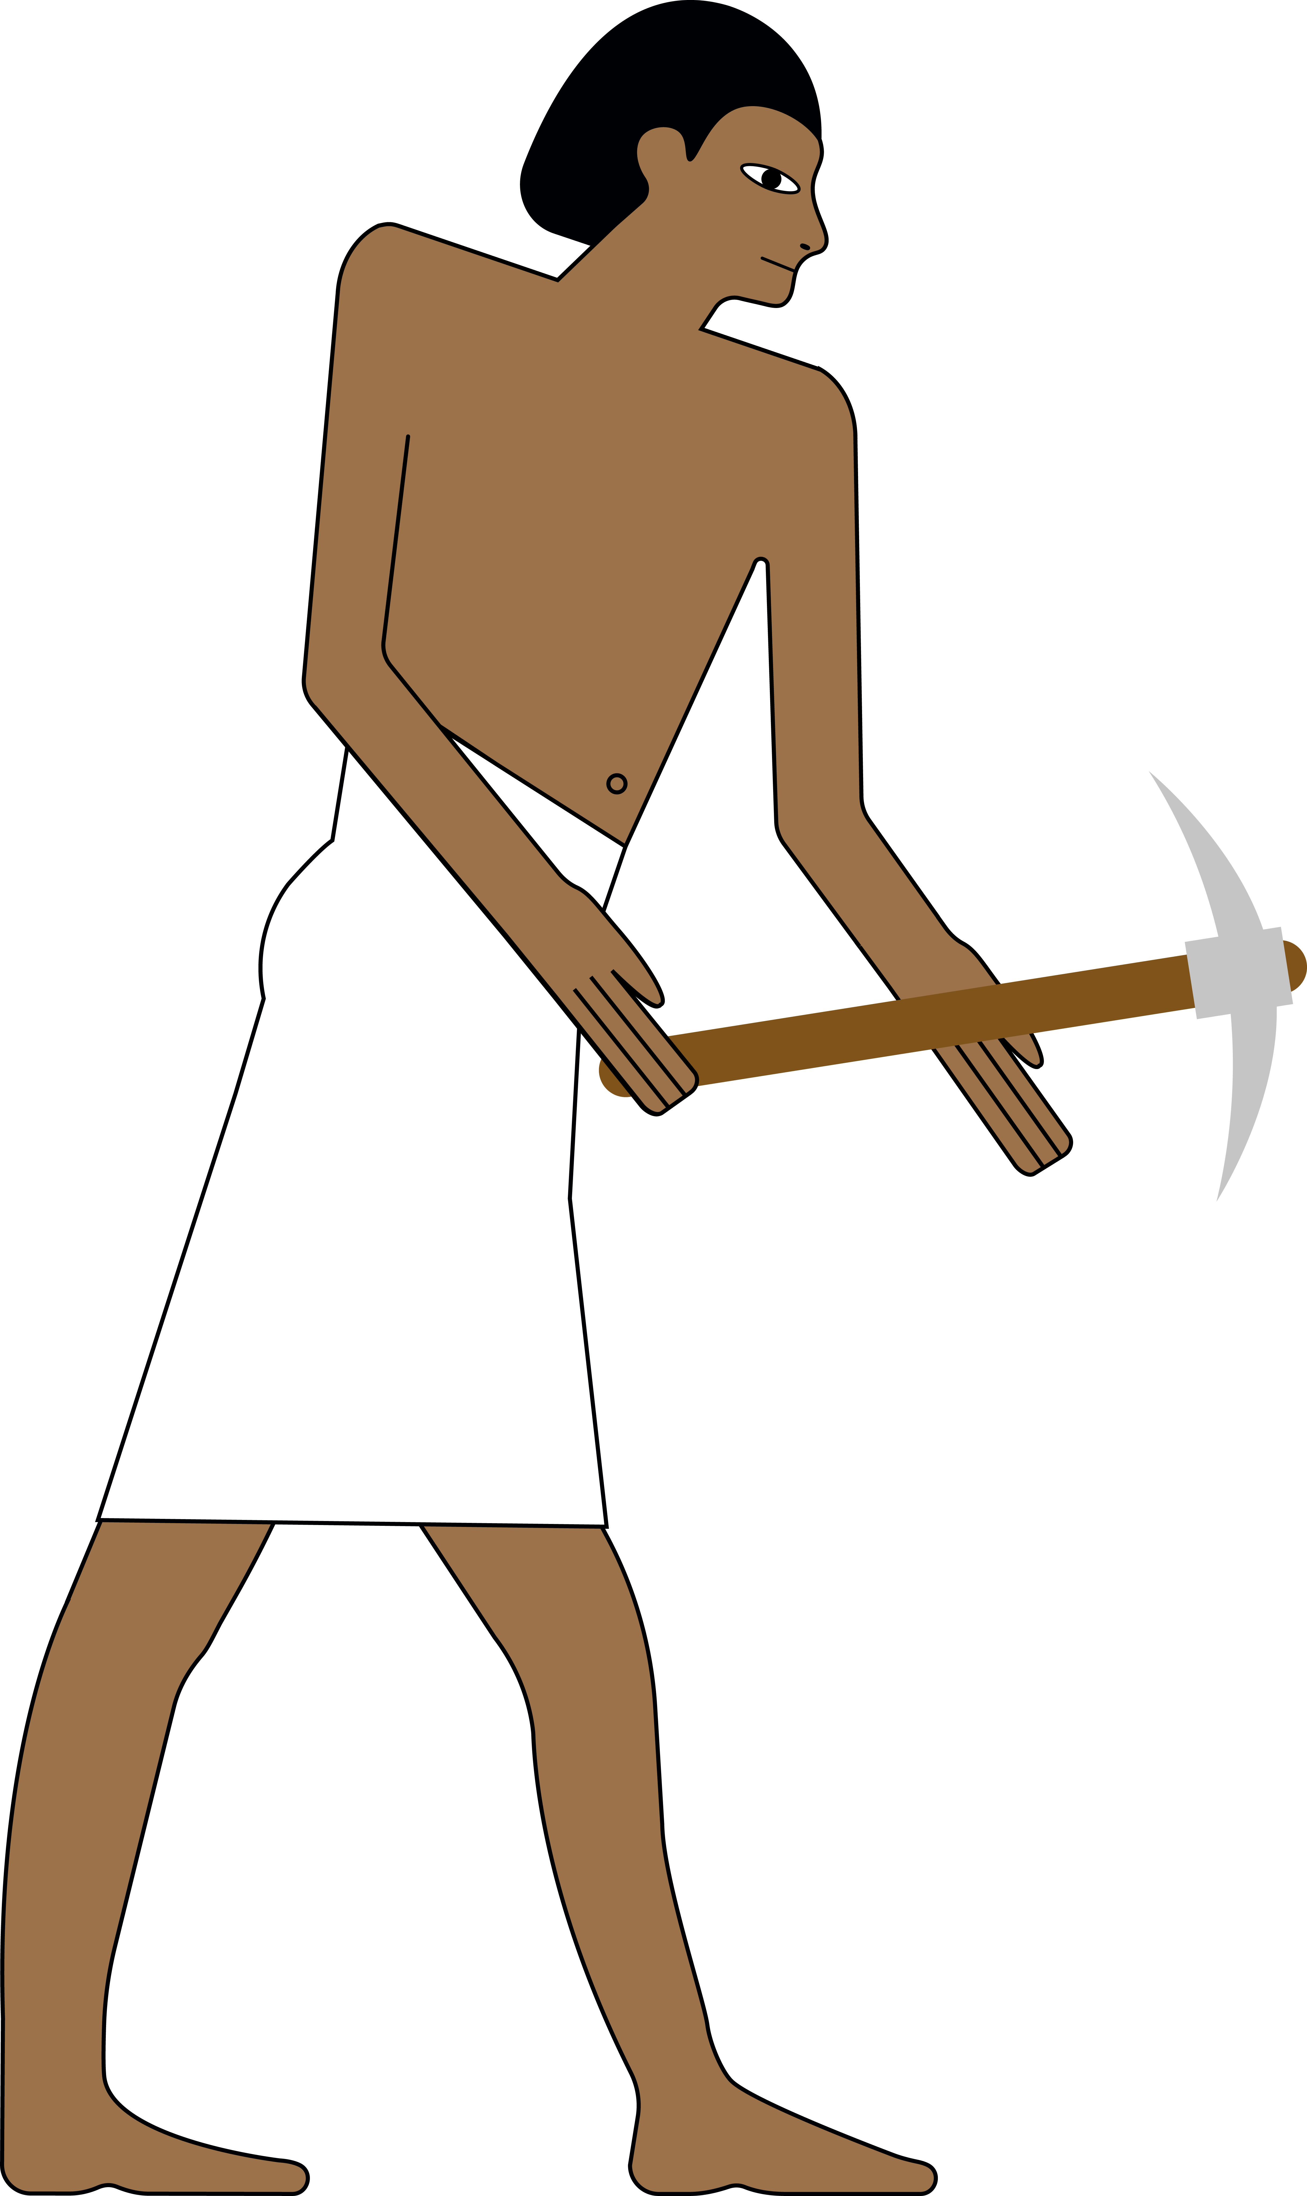

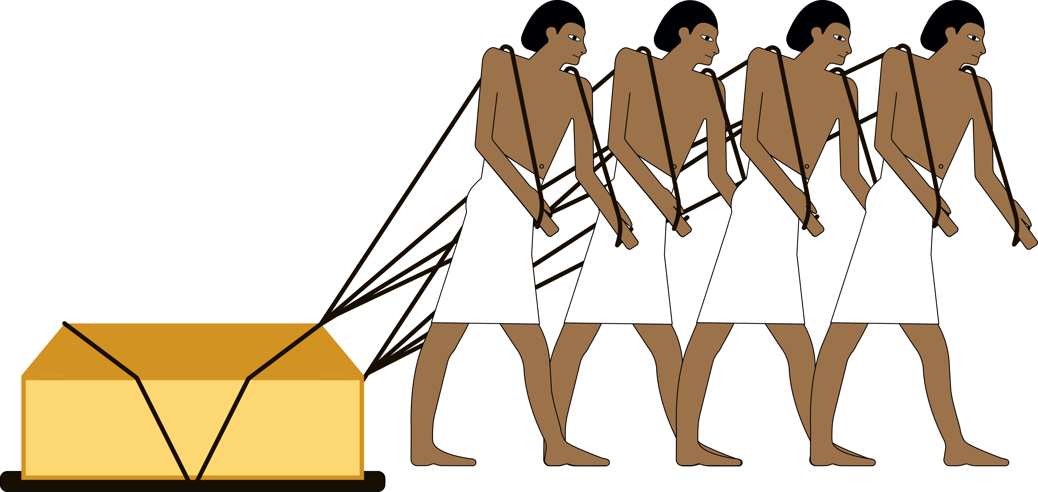
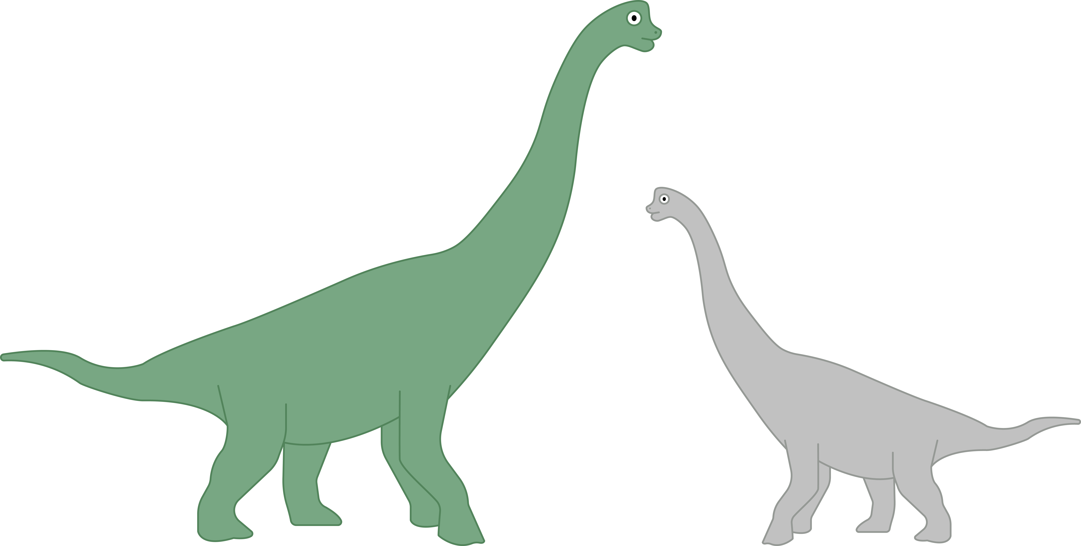
- Timeline

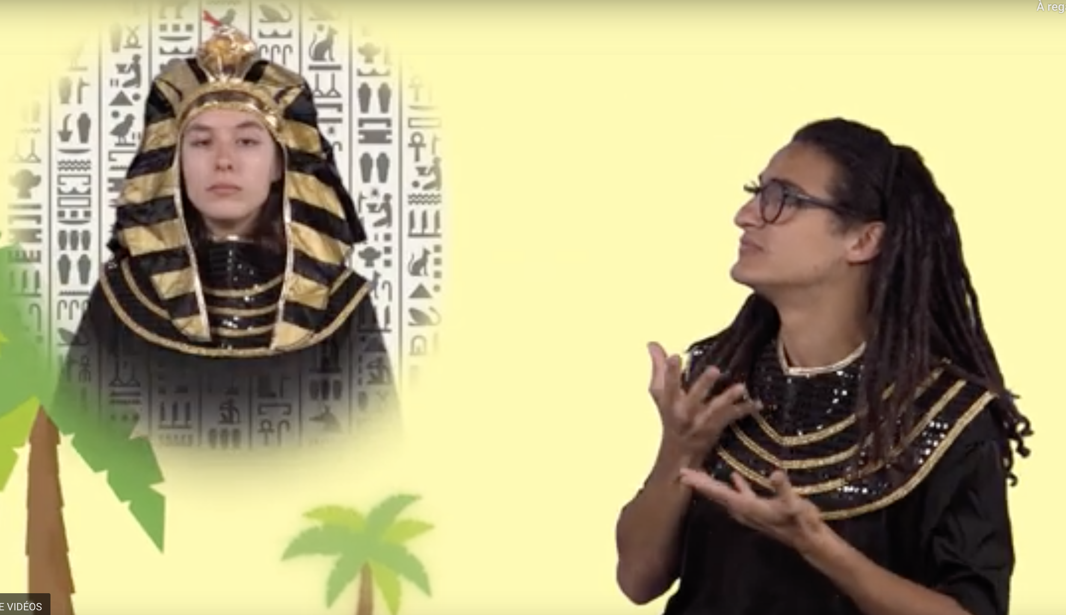

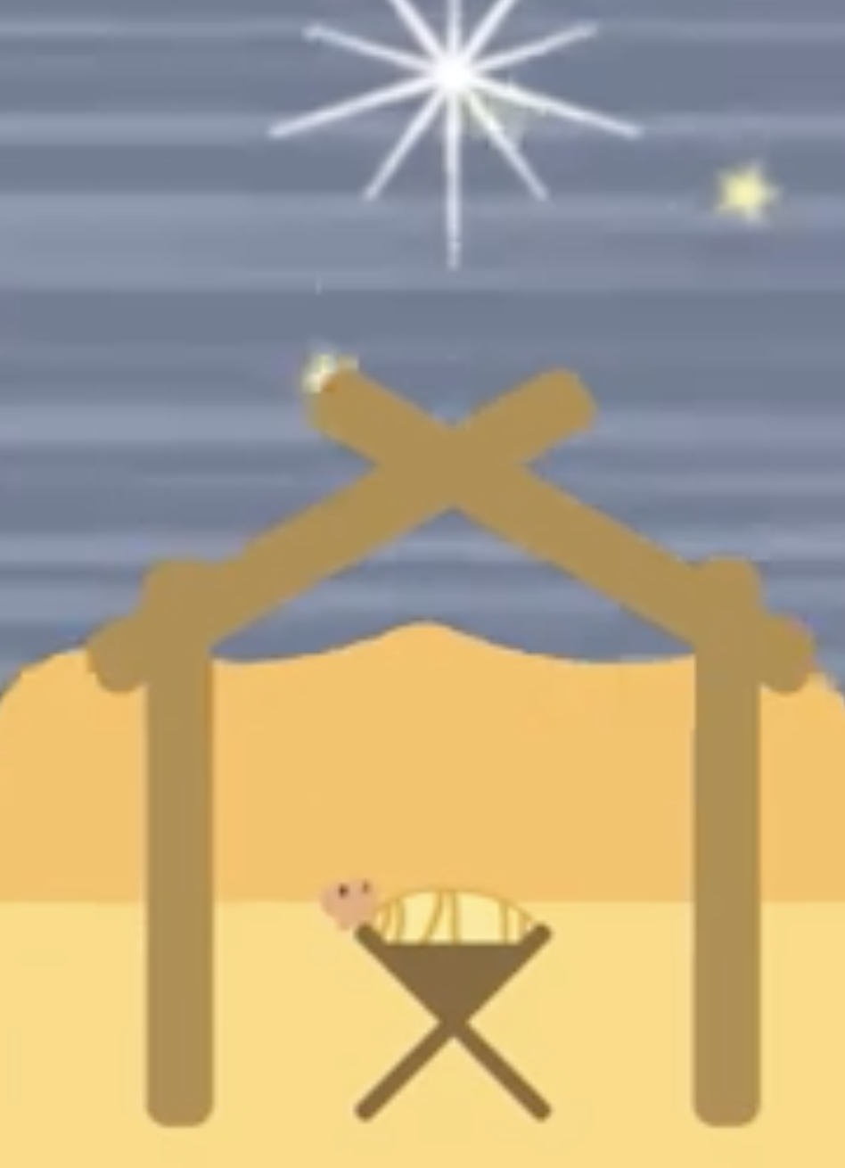
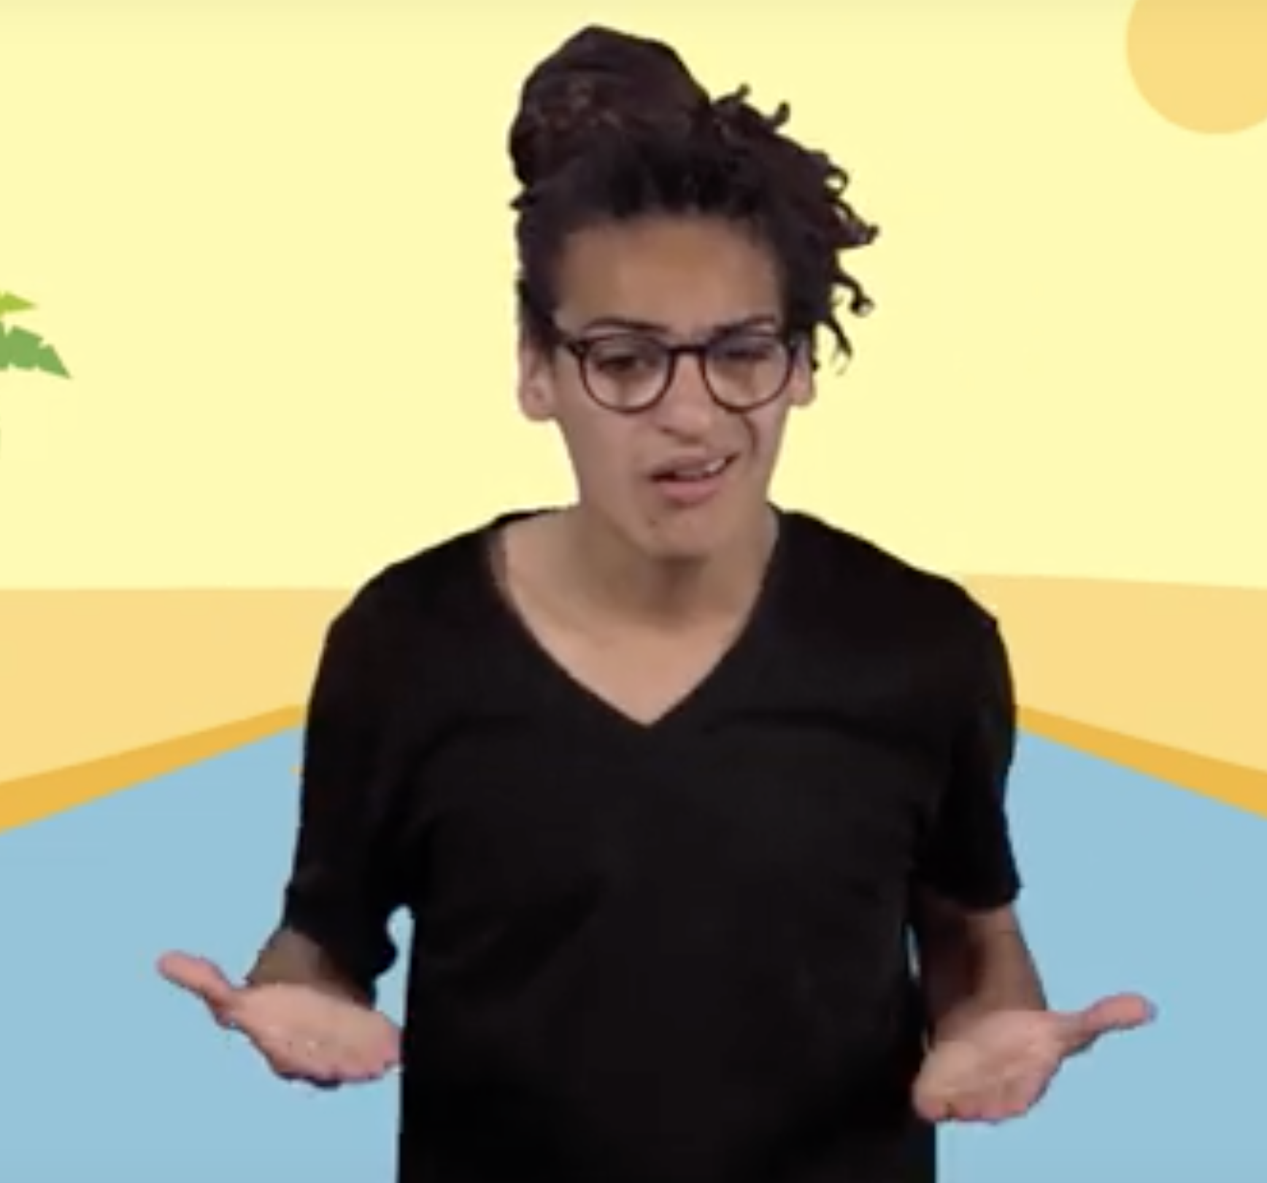
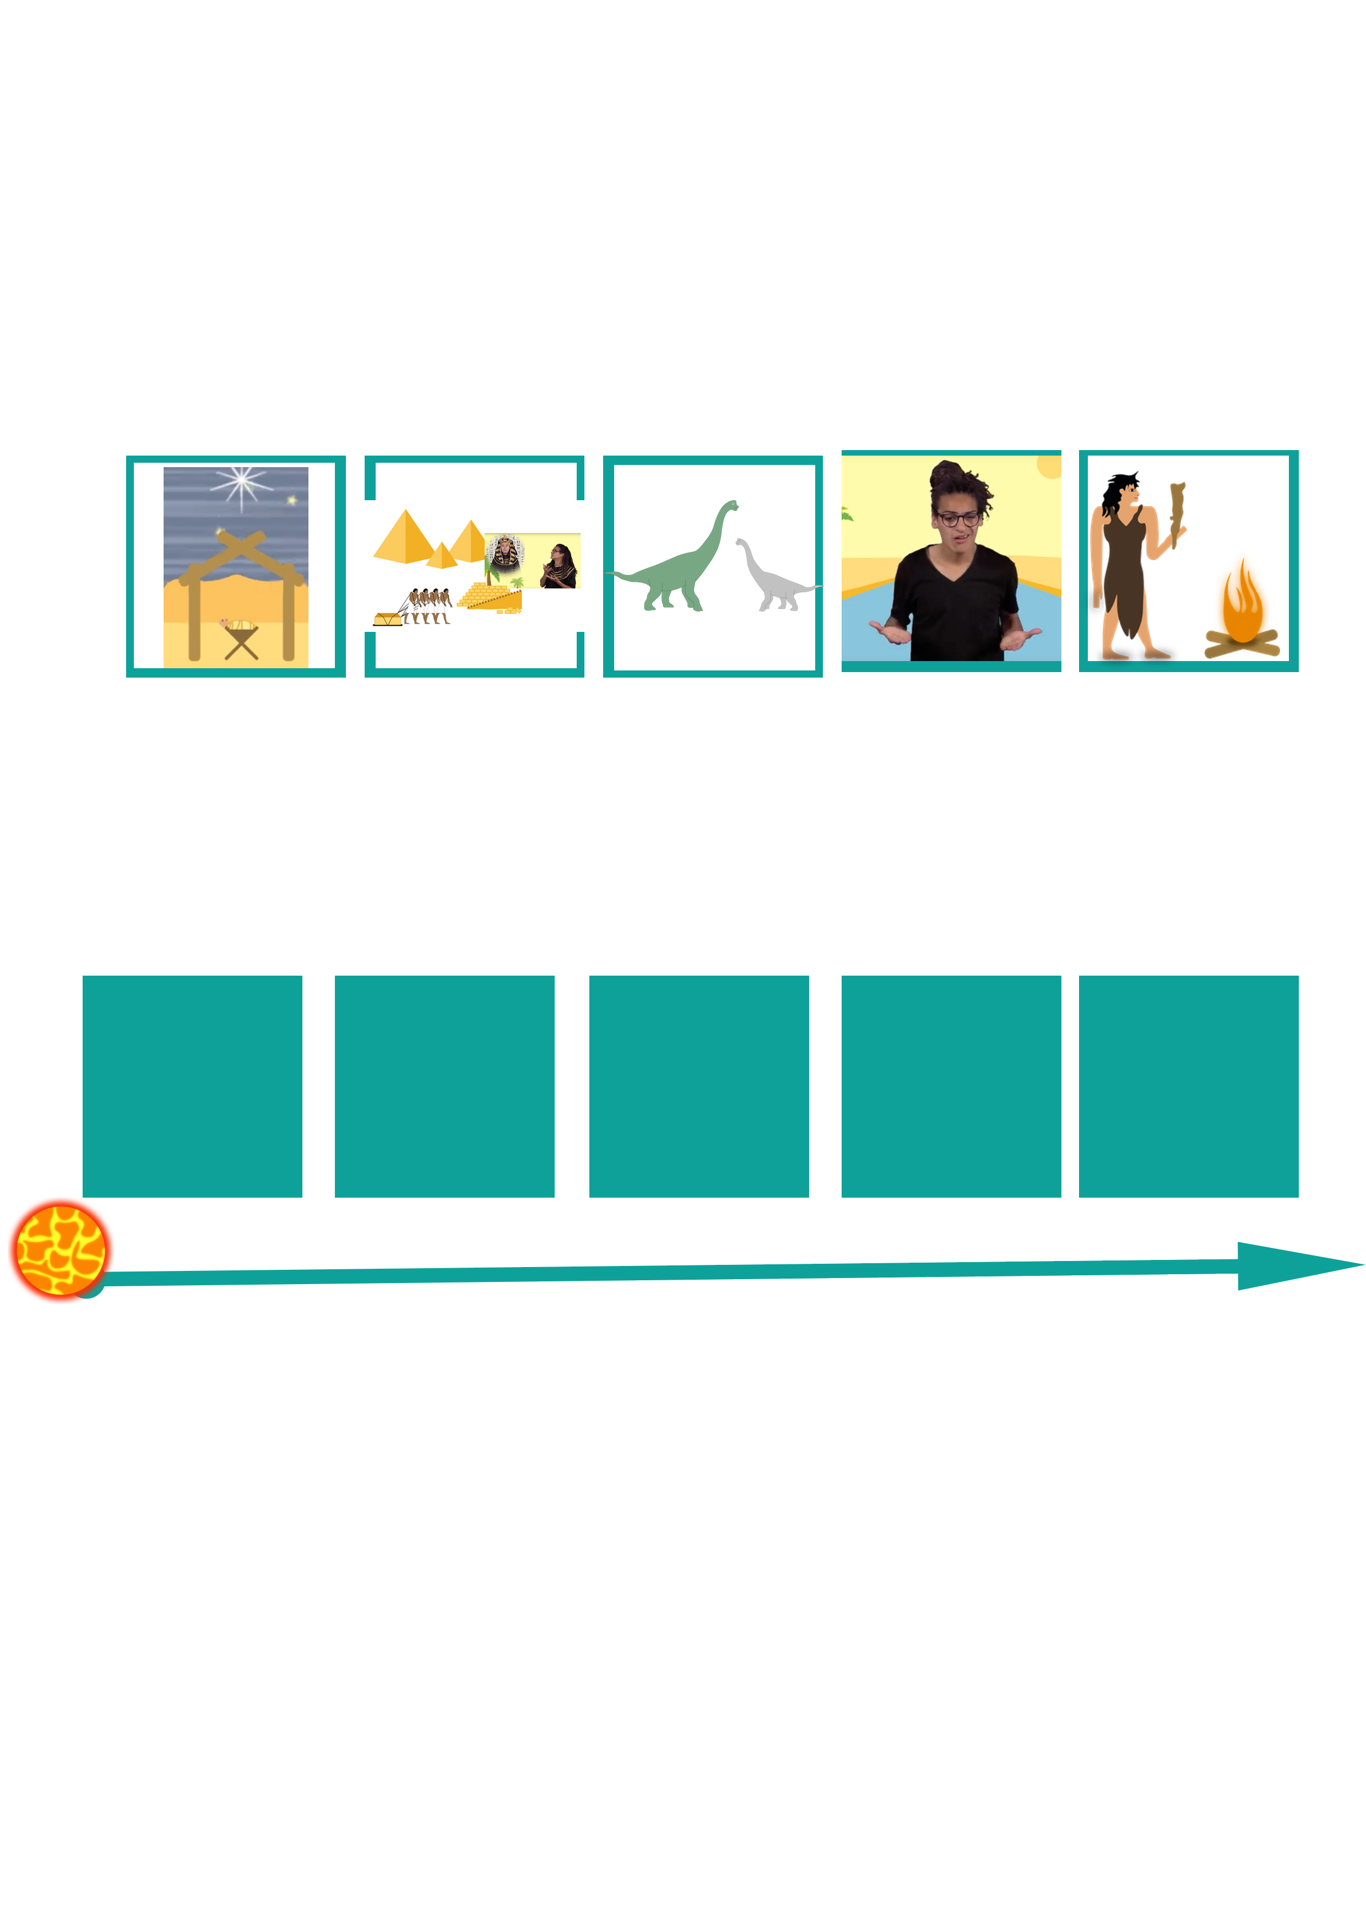
- Exercises, Games and Evaluation

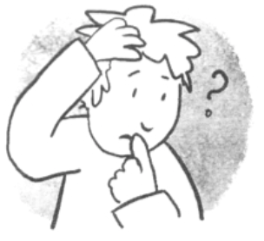
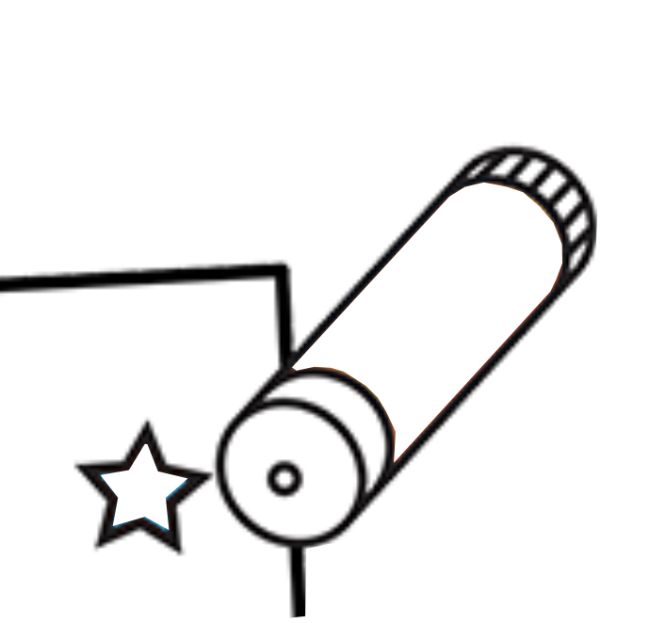
- Put in order the different periods mentioned in the video
http://opensign.eu/thematic_topics/57

2. What is an effective technique for pulling the pyramid blocks alongside the sand?
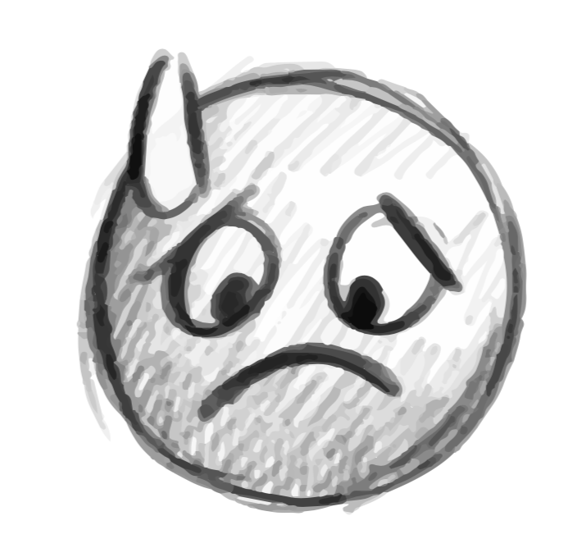
The answer can be found by playing the game here: http://opensign.eu/sequence/61

- Extend / Enrichment / Prolongation Web links with others digital tools :
- Ancient Egypt http://www.opensign.eu/thematic_topics/57
- The Egyptian Era: http://opensign.eu/memory_game/55
- Wheels in Egypt : http://opensign.eu/multiplechoice/60
- The Pyramid Blocks: http://www.opensign.eu/sequence/61
- DIY Open Sign: http://www.opensign.eu/manual_activities_videos

Ce projet n ° 2017-1-FR01-KA201-037433 a été financé avec le soutien de la Commission européenne. Cette publication n'engage que son auteur et la Commission ne peut être tenue responsable de l'usage qui pourrait être fait des informations qui y figurent.

