You can create your own resources, videos and games at:

http://www.opensign.eu

GAME : Life in Ancient Egypt

Age: 8 to 12 years
Creator : Média’Pi

Competences :
- Link an iconic/visual video description with objects used in Ancient Egypt

- Remember hidden memory cards and strategically choose your cards

- Be patient and perseverant

European Competences
https://eur-lex.europa.eu/legal-content/EN/TXT/?uri=uriserv%3AOJ.C_.2018.189.01.0001.01.ENG&toc=OJ%3AC%3A2018%3A189%3ATOC

Specific vocabulary / keywords :
Papyrus, crocodile, boat, hieroglyphics

Lesson outline:
Playing this game will allow the student to discover the context and understand the journey of the hero back to the time of the pharaohs.
http://opensign.eu/memory_game/54
You can view the video on « Ancient Egypt » after playing the game
http://opensign.eu/thematic_topics/57

Resources
A computer and an internet connection

Focus on sign language:
The student can identify the forms of objects and make distinctions between them. Work around handicape configurations to describe objects can be done.

Ce projet n ° 2017-1-FR01-KA201-037433 a été financé avec le soutien de la Commission européenne. Cette publication n'engage que son auteur et la Commission ne peut être tenue responsable de l'usage qui pourrait être fait des informations qui y figurent.

- Play the Game : Life in Ancient Egypt: http://opensign.eu/memory_game/54
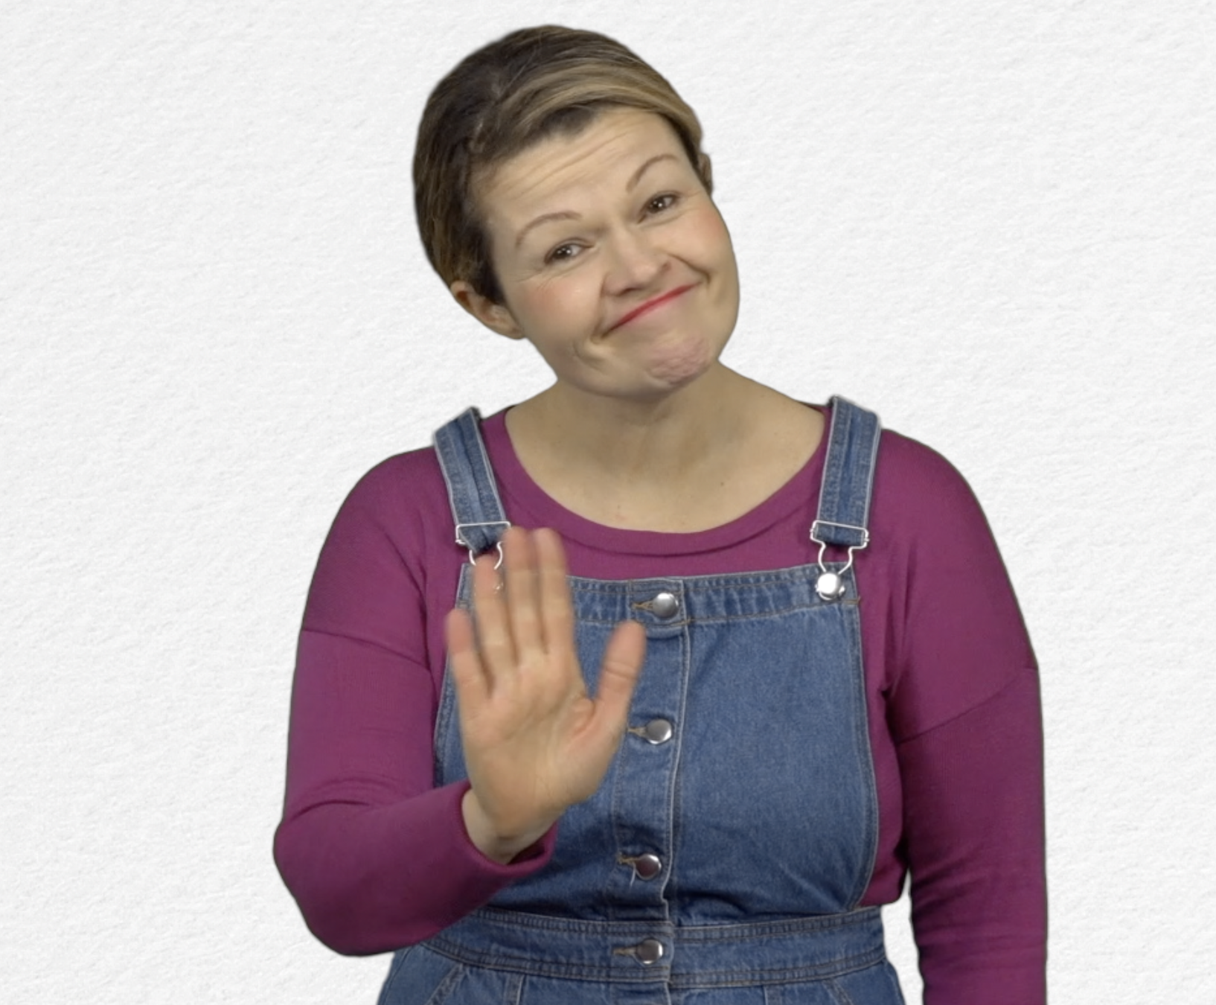
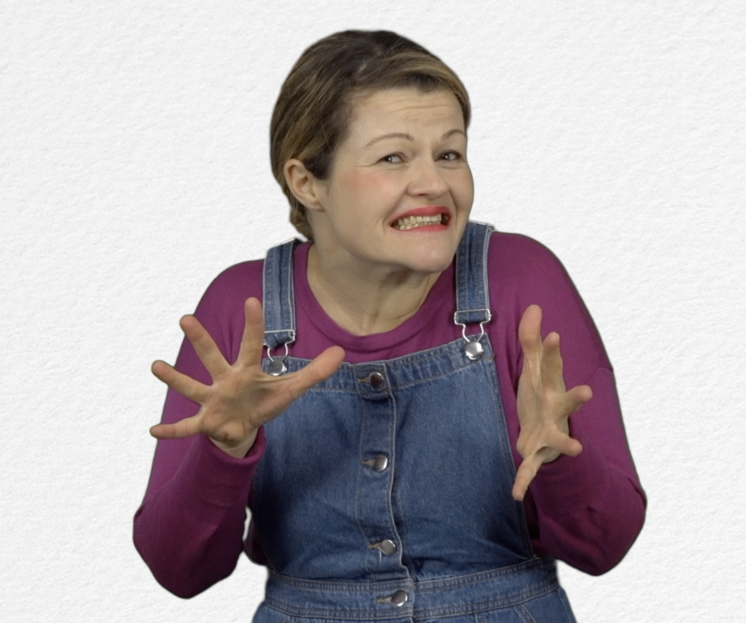
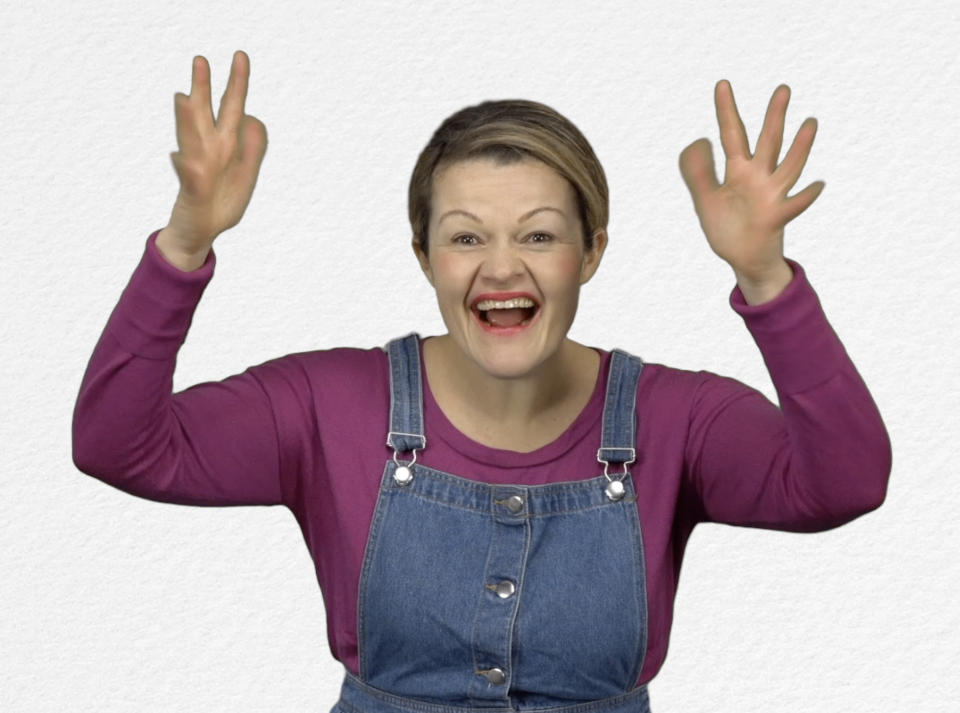
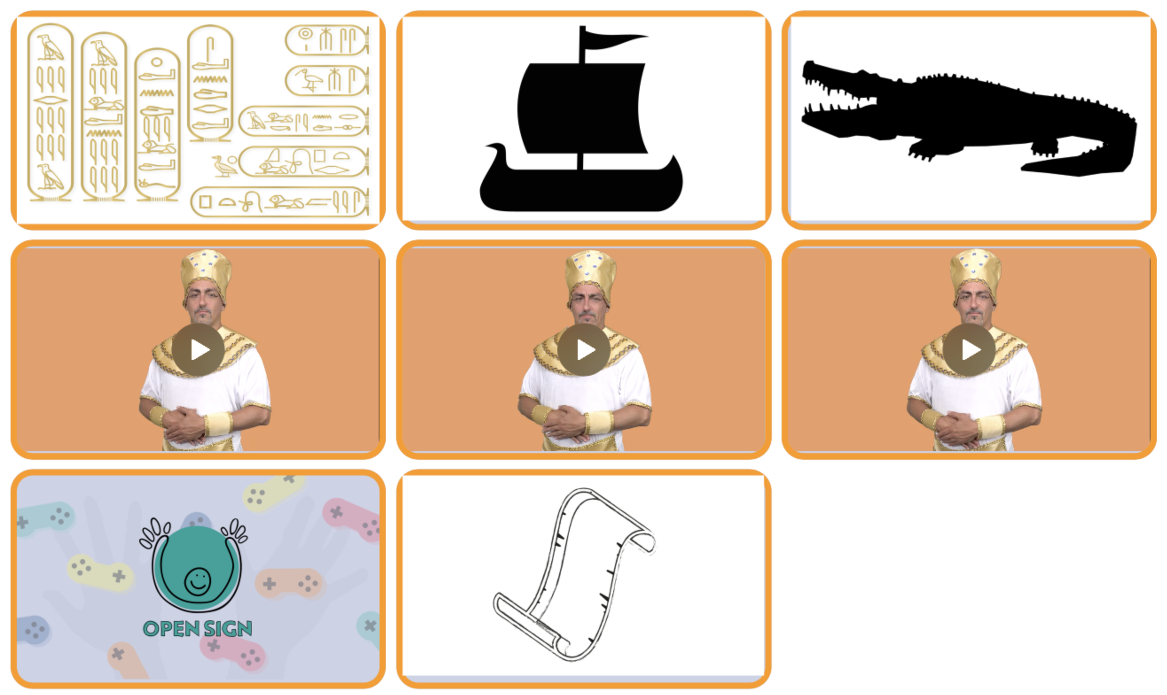
Tick the box if you have succeeded on the first try or note the number of tries.

- Extend / Enrichment / Prolongation Web links with others digital tools :
- Ancient Egypt: http://www.opensign.eu/thematic_topics/57
- The Egyptian Era : http://opensign.eu/memory_game/55
- Wheels in Egypt : http://opensign.eu/multiplechoice/60
- The Pyramid Blocks: http://www.opensign.eu/sequence/61
- DIY Open Sign: http://www.opensign.eu/manual_activities_videos

