You can create your own resources, videos and games at:

http://www.opensign.eu

GAME : Wheels in Egypt

Age: 8 to 12 years
Creator : Média’Pi

Competences:
- Explain why Egyptians did not use wheels in sand

- Choose the correct answer, making sure you know the correct answer

- Listen and decide on your answer after seeing the 3 proposals

European Competences
https://eur-lex.europa.eu/legal-content/EN/TXT/?uri=uriserv%3AOJ.C_.2018.189.01.0001.01.ENG&toc=OJ%3AC%3A2018%3A189%3ATOC

Specific vocabulary / keywords :
A boat, a wheel, an idea, an invention, sand, roll, getting bogged down.

Lesson outline:
After having seen the thematic video on «Ancient Egypt» at:
http://www.opensign.eu/thematic_topics/57
Find the game at: http://opensign.eu/multiplechoice/60
Present this game to the child alone, noting the number of errors the child makes

Resources:
A computer and an internet connection.

Focus on sign language:
Work on cause and consequence by introducing the logical connectors of the story in the country’s signed language. Suggest further questions around “Why? Because.”

Ce projet n ° 2017-1-FR01-KA201-037433 a été financé avec le soutien de la Commission européenne. Cette publication n'engage que son auteur et la Commission ne peut être tenue responsable de l'usage qui pourrait être fait des informations qui y figurent.

- Play the Game: Wheels in Egypt : http://opensign.eu/multiplechoice/60

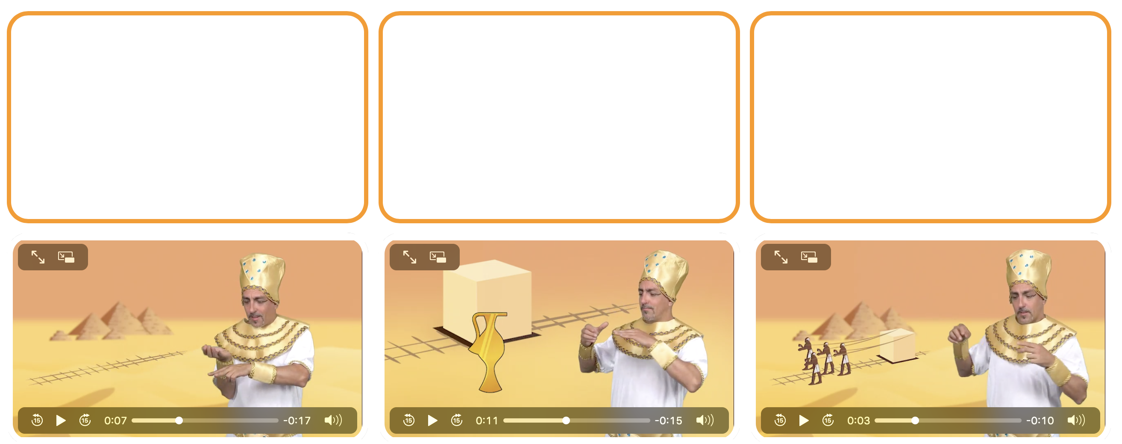
Tick the box if you have succeeded on the first try or note the number of tries.

- Extend / Enrichment / Prolongation Web links with others digital tools :

- Ancient Egypt :http://www.opensign.eu/thematic_topics/57
- The Egyptian Era: http://opensign.eu/memory_game/55
- Egyptian Life : http://opensign.eu/memory_game/54
- Wheels in Egypt : http://opensign.eu/multiplechoice/60
- DIY Open Sign: http://www.opensign.eu/manual_activities_videos

