MULTIPLYING BY 5

Age category: 9-12 years

Authors: Trâncă Ramona

Competences:
      - The students will learn to multiply by 5
- The students will know how to multiply by 5 in different contexts: real or abstract
- The students will gain self-confidence in their abilities for arithmetic

Competences according to European curriculum:
http://eur-lex.europa.eu/legal-content/EN/TXT/?uri=LEGISSUM%3Ac11090

Formative assessment:
- Making equal groups of 5 elements
- Using repeated addition of a number
- Transferring the sum of the repeated addition to the result of the multiplying operation to which it corresponds.

Summative Assessment:
- Learning multiplying by 5

Specific vocabulary list/Keywords:
- Equal groups
- Elements of an equal group
- Multiplying
- Repeated addition

Short description of the educational context/scenario:

The students will watch the video with the activity of multiplying by 5. Using sign language they will be asked to identify groups of 5 objects in their classroom. They will receive different toys, objects, sticks and they will be encouraged to count equal groups of 5 elements. All the plastic sticks will be tightened to get equal groups of 5. The activities will start from counting the elements, showing equals groups of 5, repeated addition of 5 elements. In the end the transfer will be shown – from repeated addition to multiplying operation.

Materials needed/Technical requirements:
- Plastic or wooden sticks, glasses of plastic/ card, tape, writing markers, scissors.

Focus on sign language:
- Indicating all the learning steps in sign language
- Using mathematic terminology in sign language

- Colour the 5th fruit .

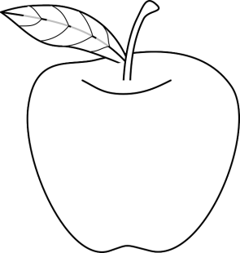

2. Circle the elements belonging to the same category.

Example:
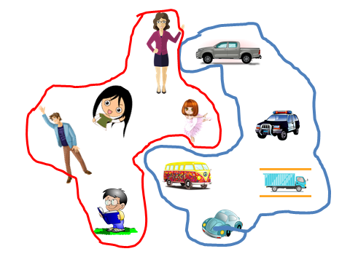

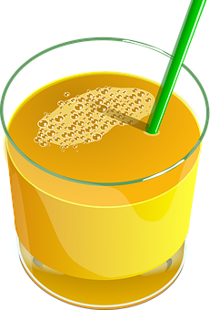

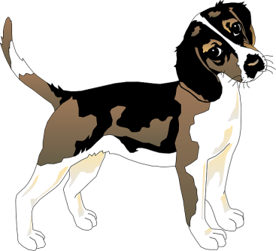

3. Fill in each group so they all have 5 elements each.

5
5
5

5
5
5

4. Fill in the rows.

- Ascending.

1 2 3 4 5

- 1 __ __ __ 5. b) 1 __ 3 __ 5.

- __ 2 __ 4 __. d) 1 __ __ 4 __.

e)1 __ __ 4 __. f) __ __ __ __ __ .

- Descending.

5 4 3 2 1

a) 5 __ __ __ 1. b) 5 __ 3 __ 1.

- __ 4 __ 2 __. d) __ 4 __ __ 1.

- 5 __ __ 2 __. f) __ __ __ __ __.

C. Fill in the missing numbers.

- 1 2 3 4 __ 6 7 8 9 ___ 11 12 13 14 ___ 16 17 18 19 ___ .

b) 33 34 __ 36 37 38 39 ___ 41 42 43 44 ___ 46 47 48 49 __ 51.

c) 18 19 __ 21 ___ ___ ___ ___ 26 27 28 ___ ___ 31 32 33 34.

- Fill in with the missing number by counting from 5 to 5.

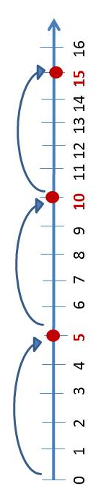

Exemple: 5, 10, 15, 20…………

- 5, 10, __ , __ , 25, __, 35 .

- 20, __, 30 , __, 40 , __, 50 .

- 10, __, 20 , __, __ , __, 40 .

- 50, 45 , __ , 35 , __ , __, 20 .

5.
- Count the animals from the two groups.

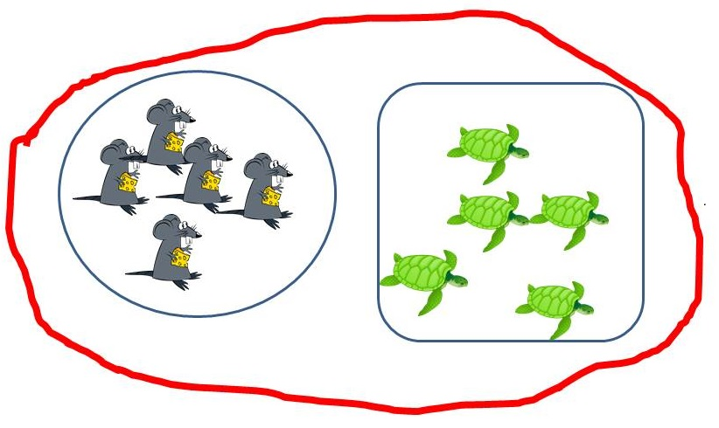

- Add the sticks and write the sum.

- Write the sum of the additions below:

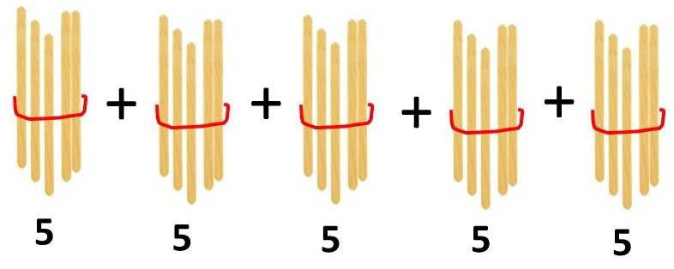
=

5+5+5 =

5+5+5+5+5+5 =

5+5+5+5 =

5+5+5+5+5+5+5+5+5 =

5+5=

5+5+5+5 +5 =

5+5+5+5+5 +5+5 =

5+5+5+5+5+5+5+5+5+5 =

5+5+5+5+5+5+5+5 =

7. Use the repeated addition and then write the multiplying operation.

Example: 5+5+5= 15 3 X 5 = 1 5

X
____ X ____ =_____

____ X ____ =_____

____ X ____ =_____

____ X ____ =_____

____ X ____ =_____

____ X ____ =_____

____ X ____ =_____

____ X ____ =_____

____ X ____ =_____

____ X ____ =_____

+
5

5+5=

5+5+5 =

5+5+5+5 =

5+5+5+5+5 =

5+5+5+5 +5 +5=

5+5+5+5 +5 +5+5=

5+5+5+5 +5 +5+5+5=

5+5+5+5 +5 +5+5+5+5=

5+5+5+5 +5 +5+5+5+5+5=

- Look at the images and then write the multiplying operation.

Example:

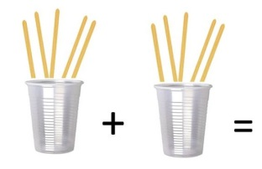
2 x 5

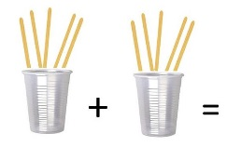
+

+
+

=
+

+
+
+
+

- Match the multiplying operation with its result.

5 x 5 10

9 x 5 20

2 x 5 5

7 x 5 45

4 x 5 25

8 x 5 15

1 x 5 50

3 x 5 35

10x 5 40

- Write the result of the next multiplying operations. = ?

1 X 5 =

2 X 5 =

3 X 5 =

4 X 5 =

5 X 5 =

6 X 5 =

7 X 5 =

8 X 5 =

9 X 5 =

10 X 5 =

Extend / Enrichment / Prolongations Web links with others digital tools:
www.freepik.com
www.pixabay.com

