MEMORY GAME

Age category : 6-12 years

Authors: Chira Dorina Elena, Radu Ofelia

Competences:
- The students will know to explain how some recyclable materials can be used to make a memory game
- The students will know to make a memory game
- The students will know to act properly in relation to the environment and to use some recyclable materials, instead of throwing them away

Competences according to European curriculum:
http://eur-lex.europa.eu/legal-content/EN/TXT/?uri=LEGISSUM%3Ac11090

Formative assessment:
- Explain the steps for making a memory game using recyclable materials
- Define the words: memory game , recyclable materials, caps, Egyptian symbols
- Identify the tools needed to make a memory game from recyclable materials

Summative Assessment:
- Make a memory game using recyclable materials

Specific vocabulary list/Keywords:
- Recycling, cartoon, plastic, bottle caps, Egypt, Egyptian symbols, recyclable materials

Short description of the educational context/scenario:
The teacher and the children will see the video ”Memory game” from the beginning till the end. The teacher will explain new vocabulary and the concepts. The children will sign the new vocabulary. They will see the movie again. One child can explain the steps for making a memory game using recyclable materials. The teacher will give the educational sheet to the children. The children will complete the educational sheet. The teacher will assist the students.

Materials needed/Technical requirements:
- plastic caps , images of Egyptian symbols , scissors, glue

Focus on sign language:
- Sign the new vocabulary, sign the materials needed to make a memory game using recyclable materials, sign the steps

1. Circle the plastic bottles with large caps: 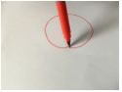

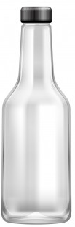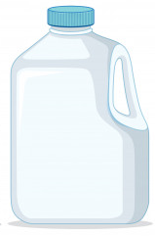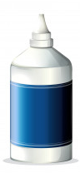

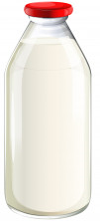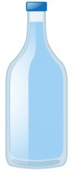

2. Find the right pairs. Match the images.
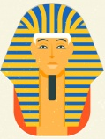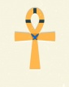

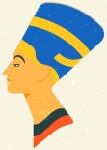

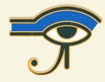

3. Circle the Egyptian symbols:

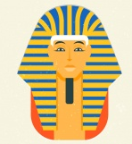

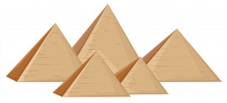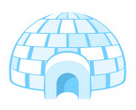

4. What do you need to make a recyclable memory game?
Match the images.

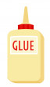
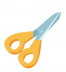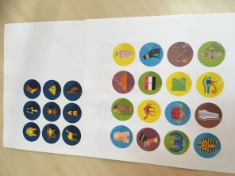

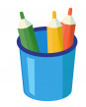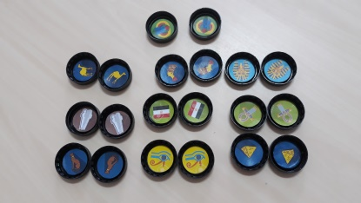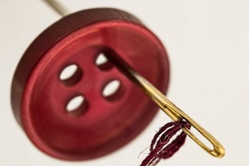

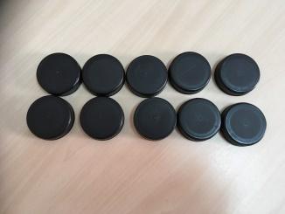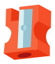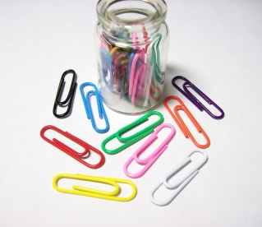

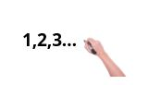
5. Number the images in the correct order.

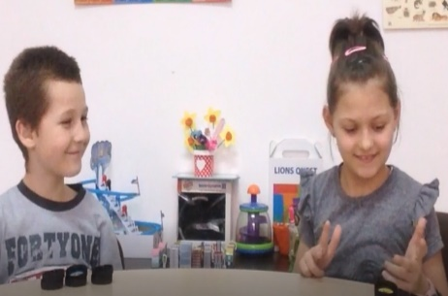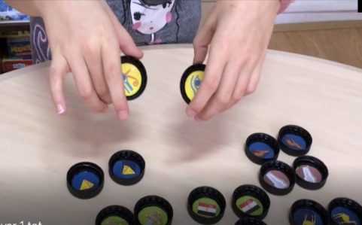

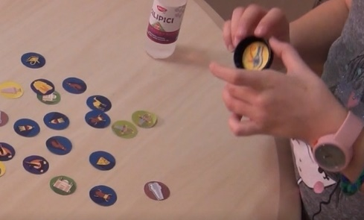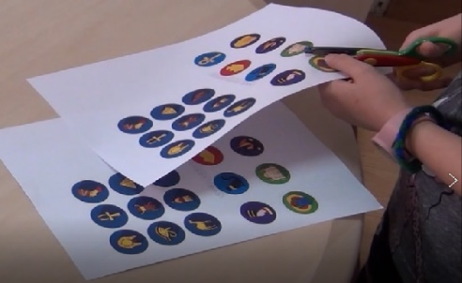

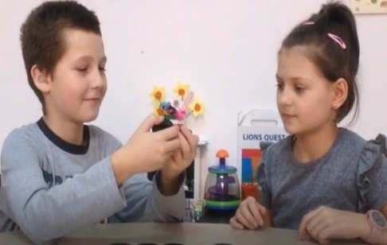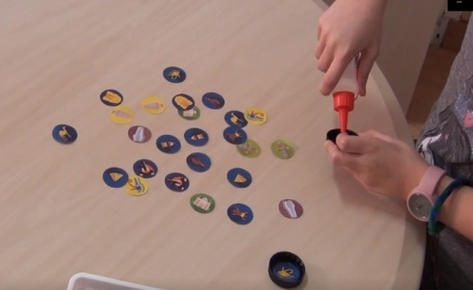

6. Cut the images and make the puzzle. 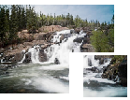

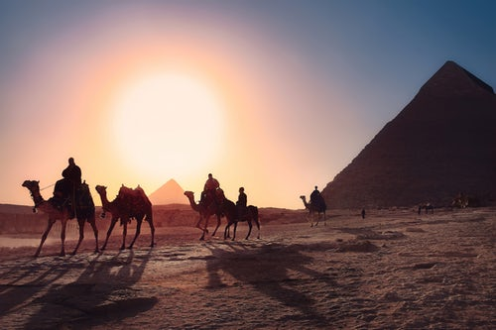

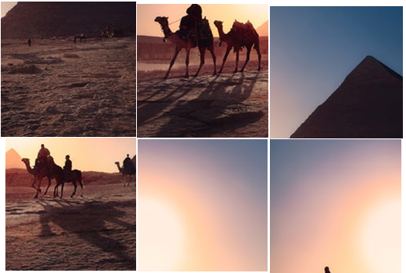

7. Match the image with the correct word.

Egypt

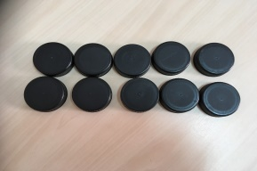
Caps

Memory game 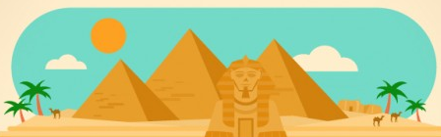

Bottle 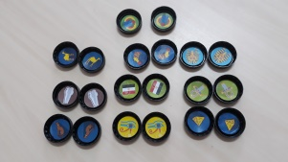

Scissors 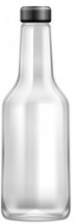

8. Circle the Egyptian symbols and flag:

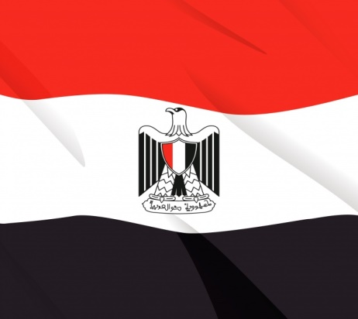
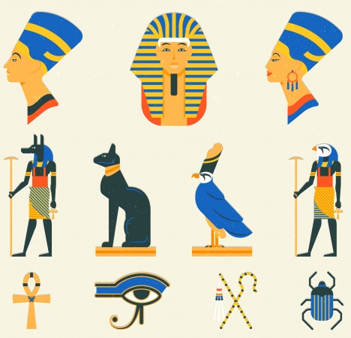

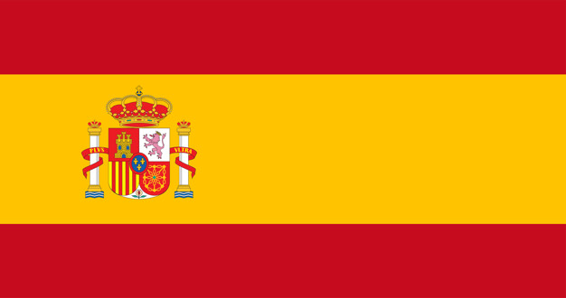
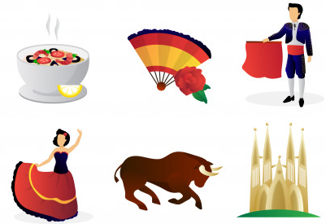

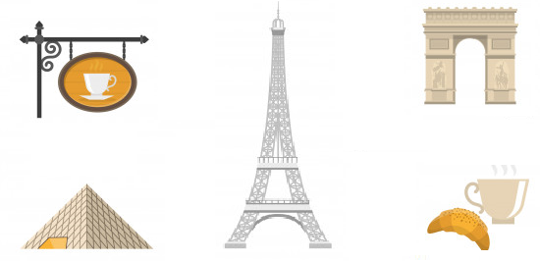

9. Draw your favorite Egyptian symbol 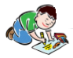

- Extend / Enrichment / Prolongations Web links with others digital tools:

- How to Make a Memory Card Game
https://www.youtube.com/watch?v=AvwTszkuw4s
- www.freepik.com
- www.pixabay.com

