Title: MANDALA

Age category: 6 -12 years old

Authors: Istituto dei Sordi di Torino www.istitutosorditorino.org

Competences :
- The students will stimulate their creativity and help express feelings, emotions and thoughts that would otherwise be difficult to tell.
- The shapes and the colors of mandalas are an invitation to play and allow the children to concentrate.
- The coloring of mandalas constitutes an occasion to experiment joy and to play one's own security, one's capacity for choice and observation, the awareness of one's own creative strength and one's critical sense.

Competences according to European curriculum:
http://eur-lex.europa.eu/legal-content/EN/TXT/?uri=LEGISSUM%3Ac11090

Formative assessment:
- Identify the tools
- Explain the actions to do on the materials: what to do first and the different phases and the freedom of choosing the colors.
- Define new terms and what do they mean: mandala, squares, circles, colors, traditions, spiritual cultures…

Summative Assessment:
- Stimulate in a simple way calm and quiet in children as well as fantasy.
- Explain important issues as spiritual traditions and intercultural topic.

Specific vocabulary list/Keywords:
- Mandala, colors, creativity, precision, geometry, meanings, traditions, fantasy.

Short description of the educational context/scenario:
This manual activity could be done both in a one by one relation with the educator or the teacher, and in group.
The teacher will collect the materials needed in order to colour a Mandala: papers, colours as pastels and markers. The teacher will ask to the children if they know what are the shapes on the papers and will discuss with them about their answers. The teacher will then ask them to choose one mandala and colour it.
After the activity of colouring the mandala, the teacher will ask the children to explain one by one to the group why they chose that specific mandala e those colours: what the colours mean for them, what the shape means for them…
At the end the teacher will explain what are mandalas, what they mean in spiritual traditions and the discussion can go further depending on the students.
The teacher will assist the children in each necessity.

Materials needed/Technical requirements:
- Papers with mandala drawn on it (you can download them from the net), pastels and/or markers.

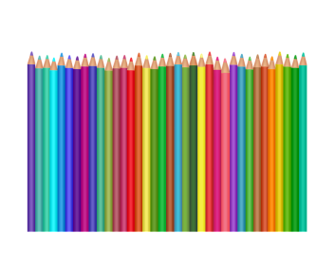
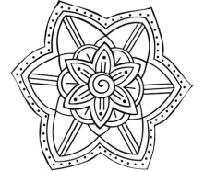

Focus on sign language:
- Sign the new vocabulary, sign the materials needed, sign the steps to take.

- Each colour its name!

GREEN

RED

PINK

ORANGE

YELLOW

LIGHT BLUE

BLACK

- Each shape, its colour! Colour the little mandala.

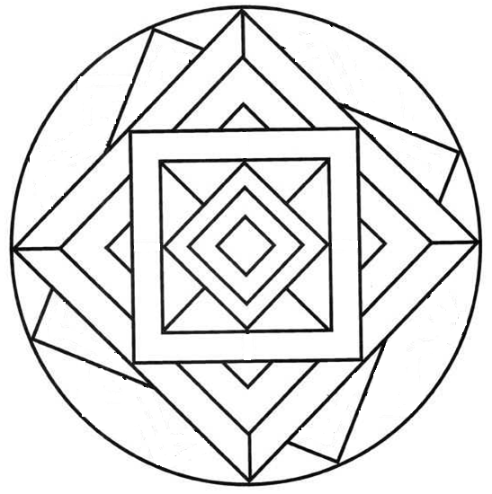
- Each shape its name. Write it!

These are …………………..
These are …………………..
This is a …………………..
- Colour the balloon with your favourite colour and explain why you like it!
My favourite colour is ____ __________________________________________________________________________________________________________________________________________________________________________________________________________________
- Colour the country from which mandala comes from:

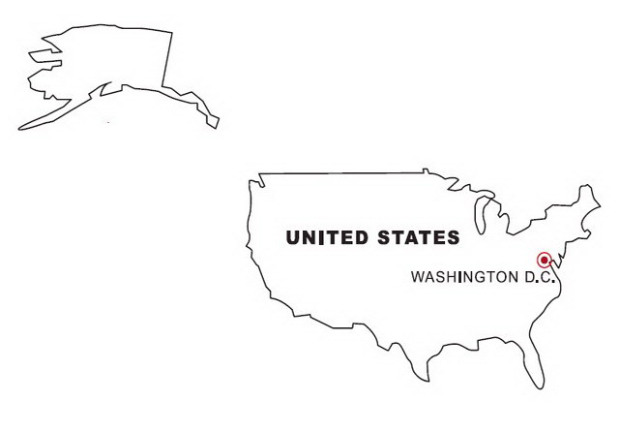

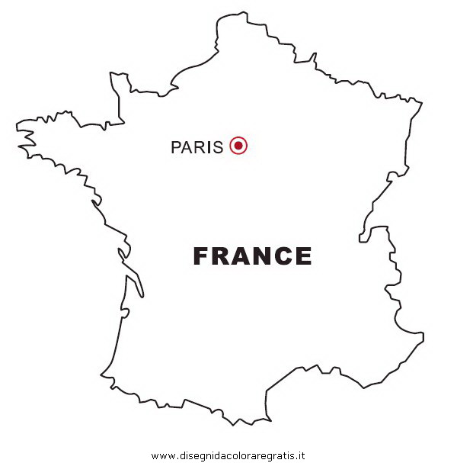
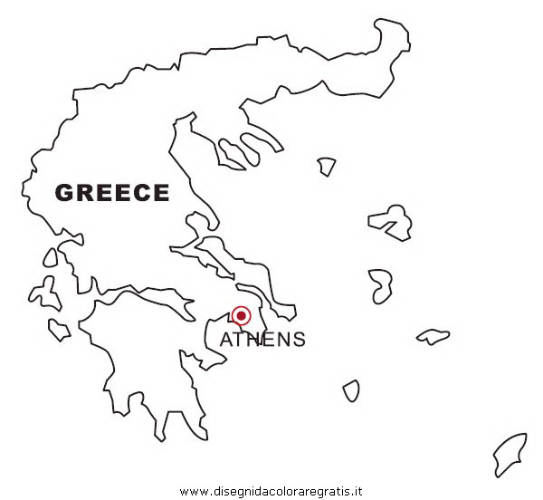
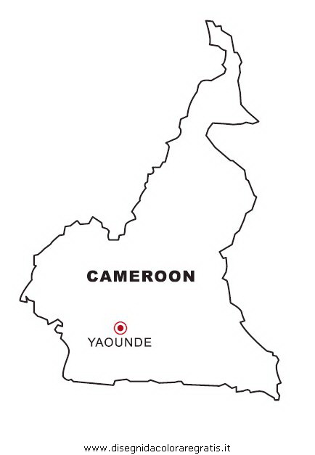
- Cut the images and make the puzzle.

- MANDALA 3D!
Watch out this video
https://www.youtube.com/watch?v=p5X6xkVCHUU
and choose what you need to make it.

Extend / Enrichment / Prolongations Web links with others digital tools:

- https://www.youtube.com/watch?v=8OFTl7jR1Pg
- https://www.youtube.com/watch?v=bwDYIRt2oO8
- https://www.youtube.com/watch?v=TWqwjeWCAZI

