THEMATIC TOPIC: Big fish and little fish
http://opensign.eu/thematic_topics/58

Age category: 6 à 10 ans

Author: Média’Pi! www.media-pi.fr

Competences:
- Know how to name the elements of meaning in sign language: in particular the handshapes , the face’s expressions and the movement of the hands in space.
- Know how to reproduce a story as it is or by adding elements of description.
- Experience songs in signs.
Competences according to European curriculum:
http://eur-lex.europa.eu/legal-content/EN/TXT/?uri=LEGISSUM%3Ac11090

Formative assessment:
- Identify the physical elements of an object that define its name.
- Identify the different handshapes.
- Give examples of other everyday objects that are using the same handshape.
- Specify the elements of meaning such as rhythm, speed, amplitude of the sign.
- Explain the different facial expressions during the different stories.
- Identify the different relationships between the fishes and the movements that illustrate these situations: swim with friends, chase, escape ...
- Reproduce rhythm changes: slow / fast, size: big / small.

Summative assessment:
Being able to imagine your own poem using a single handshape: for example, use your sign name.

Specific vocabulary list / keywords:
A fish, a swim, a boat, a hook, a walk, a run, to escape, handshape, facial expression, space, movement and rhythm.

Short description of the educational context/scenario:
Watch the video and identify the signs that pupils notice and repeat during the video. Ask questions about context, characters, situations and emotions that this story provides.
Watch the video a second time, and extract different small scenes. Invite children to reproduce the excerpt perfectly, then add descriptive or narrative elements, and invite them to imagine the end of the story with a configuration constraint.

Materials needed/Technical requirements:
A computer and internet access.

Focus on sign language:
The repetition of the stories and songs needs precision in the realization of the gestures and the looks which participate in the global expression. By varying the amplitude of motion, you realize that the whole sense of the story is changed.

I. Vocabulary, exercices :

1. Spot the differences between the singular and the plural.
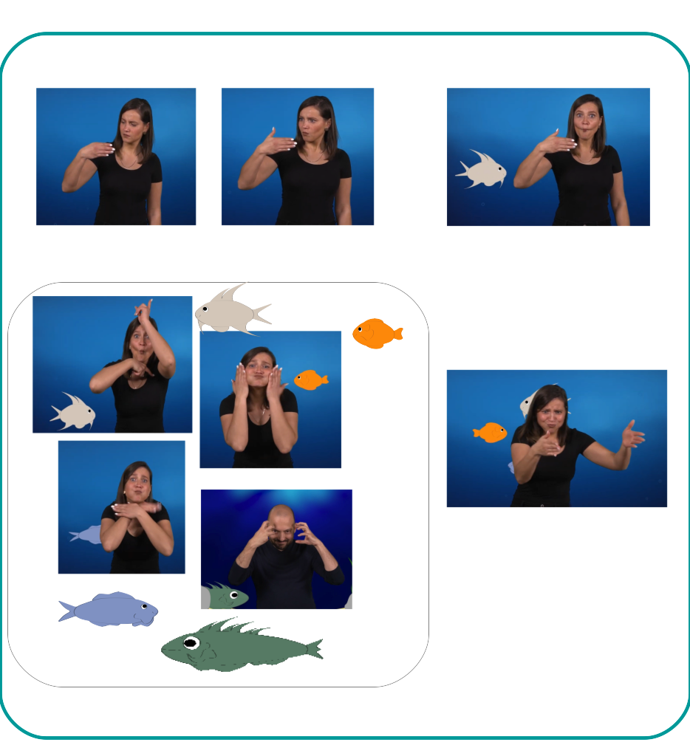

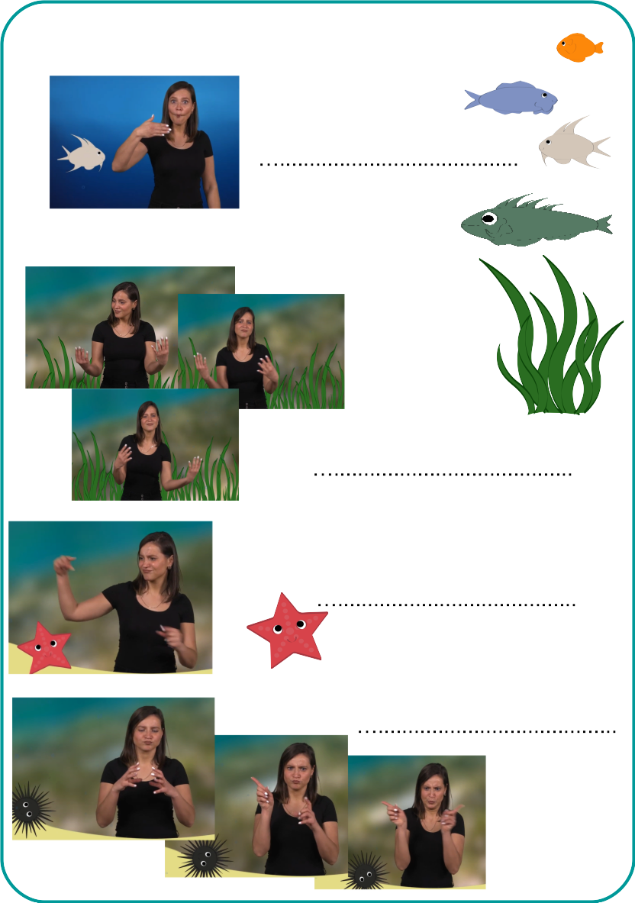
2. Write the name of the elements that appear in the video :

3. Associate each fish with its name-sign:

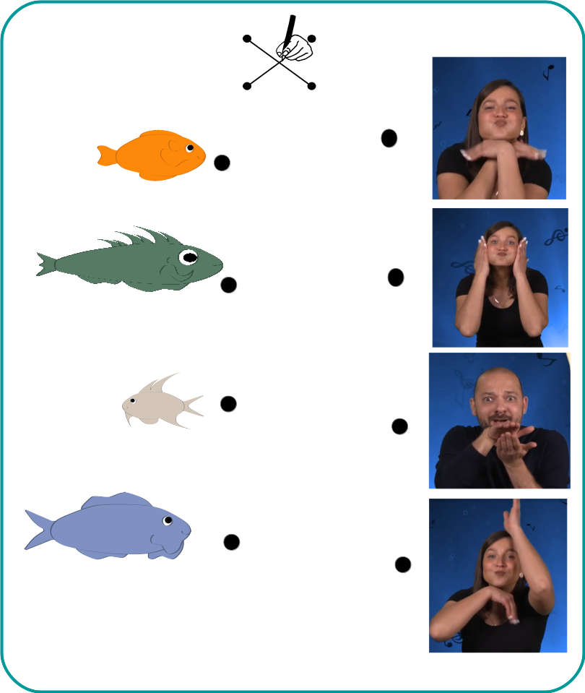

4. Tell the story your own way:
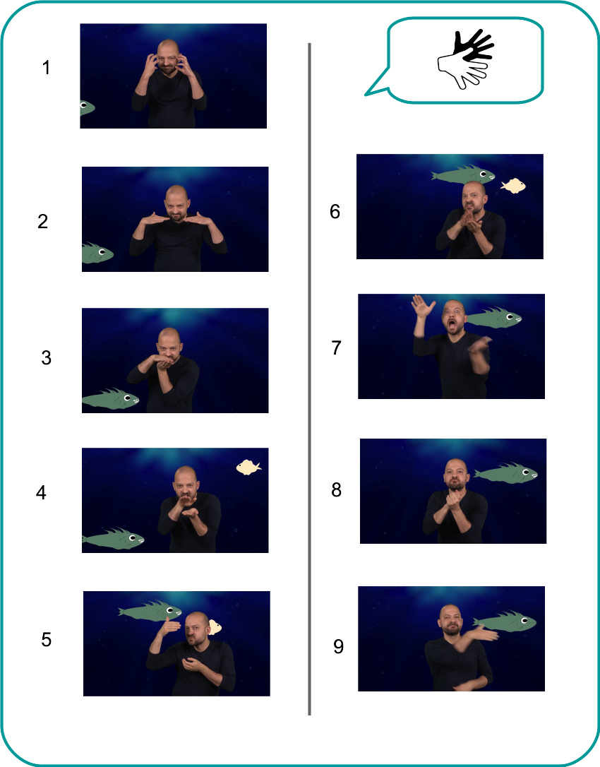

5. Re-order the sequences of this story:

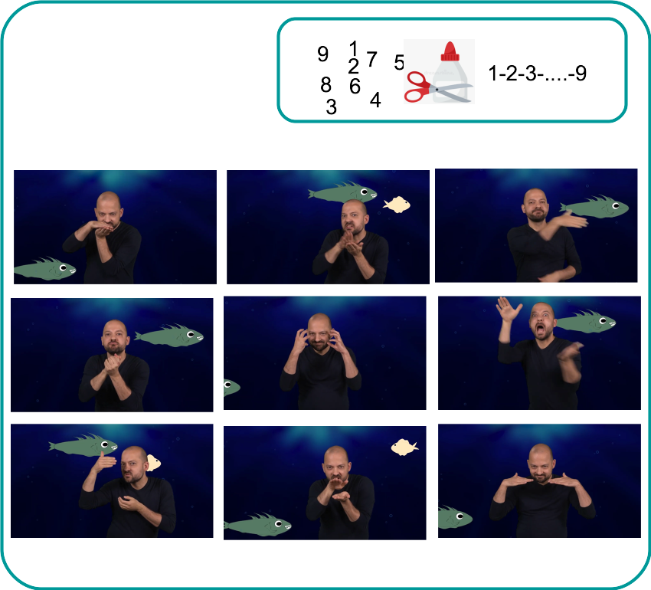

6 - Sing the fish song!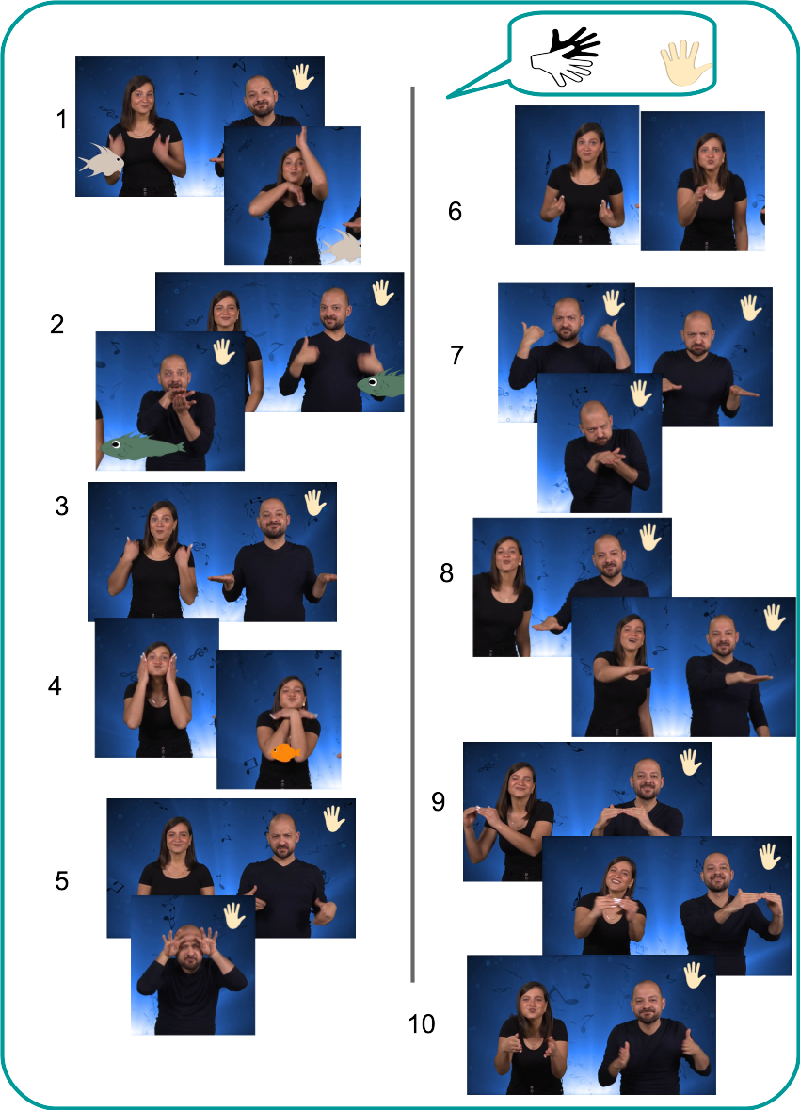

II- Extend / Enrichment / Prolongations Web links with others digital tools :
- DIY Open Sign : https://www.opensign.eu/en/manual_activities_video/96
- DIY Open Sign : https://www.opensign.eu/en/manual_activities_video/144

You too, you can create your own support : games :http://www.opensign.eu/gamescreator

