Title: SEASONS

Age category: 6 -12 years old

Authors: Istituto dei Sordi di Torino www.istitutosorditorino.org

Competences :
- The students will take advantage of nature changes in order to create a new artwork.
- The students will know to use their manual dexterity and use imagination with some material taken from nature.
- The students will learn seasons and their characteristics. Discussing with the teacher can be useful to learn the vegetables of each season.

Competences according to European curriculum:
http://eur-lex.europa.eu/legal-content/EN/TXT/?uri=LEGISSUM%3Ac11090

Formative assessment:
- Identify the tools
- Explain the actions to do on the materials: what to do first and the different phases
- Define new terms and what do they mean: seasons, weather changes, leaves and nature changes…

Summative Assessment:
- Look at the nature and understand the changes..

Specific vocabulary list/Keywords:
- Nature, leaves, weather, climate, seasons, natural products of each seasons, characteristics.

Short description of the educational context/scenario:
The teacher and the students will collect the materials needed to do the activity: this activity is possible to do both in spring, summer and autumn. The teacher will discuss with the students about the seasons, which are the characteristics pf each season, when the start and finish during the year, which is their favourite one…
After discussion with them, the teacher will propose to use some leaves in order to create a simple work of art (a face or flower) and will ask which other drawings or activity they can imagine.
The teacher can help the children each action, the imaginative one about the mental imagination and the practical one.
The teacher will assist the students.

Materials needed/Technical requirements:
- Scissors, colored papers, glue, leaves.

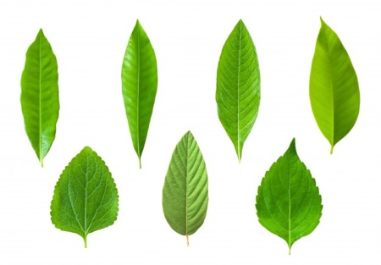

Focus on sign language:
- Sign the new vocabulary, sign the materials needed to make this activity, sign the steps to take.

- Circle only the leaves.

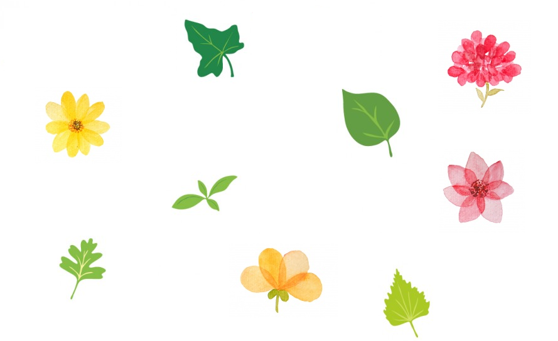

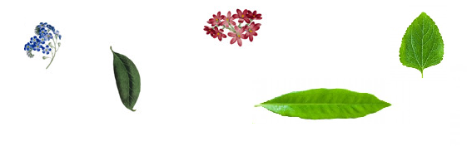

- Draw and paint with the right colours the leaves on each tree according to the seasons.

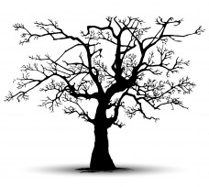

SUMMER
SPRING

WINTER
AUTUMN

- Match the leaves and flowers with the correct period of the year.

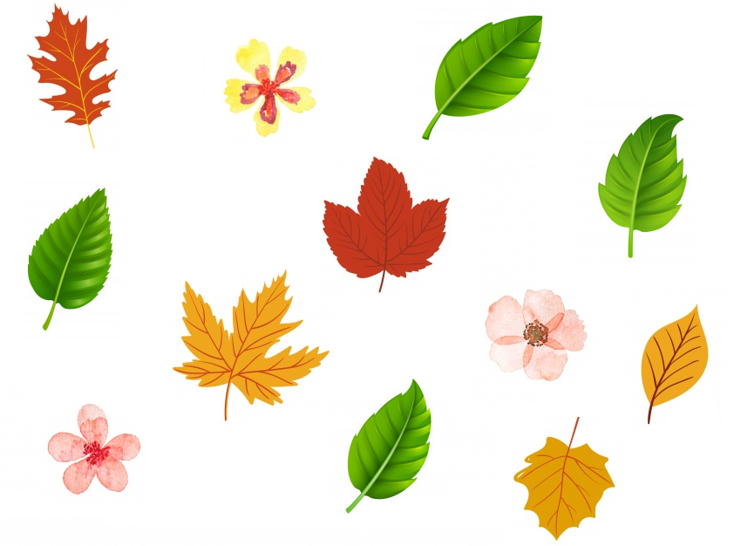

- Write the correct season in the boxes.

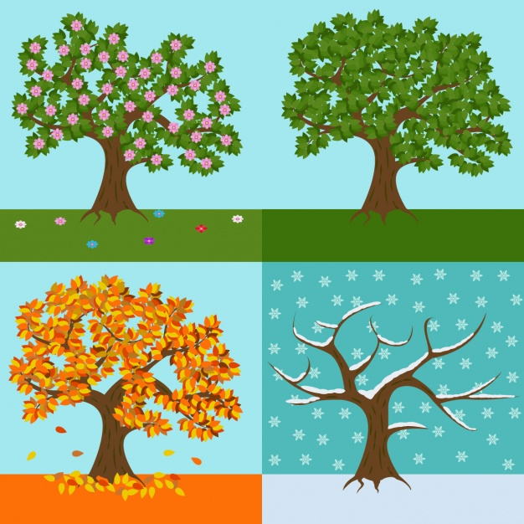

- Match the seasons with the months.

JANUARY

FEBRUARY

MARCH

APRIL

MAY

JUNE

JULY

AUGUST

SEPTEMBER

OCTOBER

NOVEMBER

DECEMBER

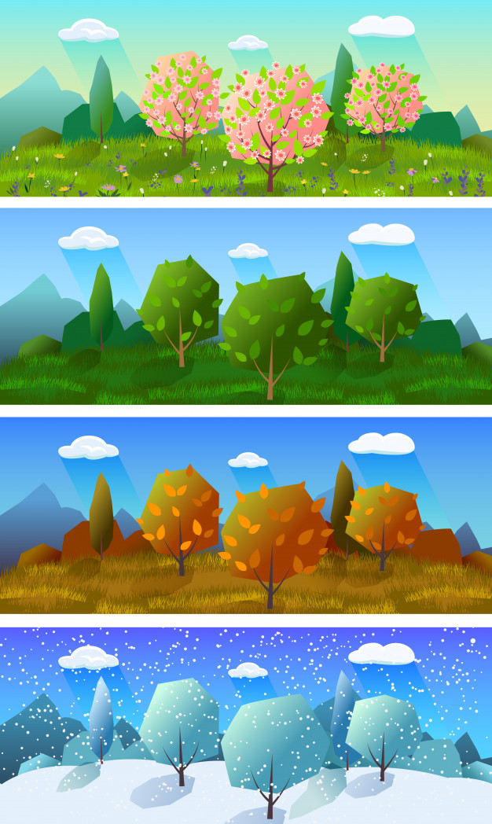

- Cut the images and make the puzzle.

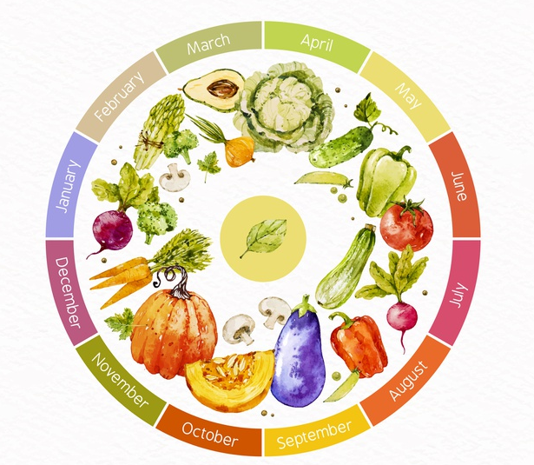
- Which is your favorite season? Draw it!

Extend / Enrichment / Prolongations Web links with others digital tools:

- https://www.youtube.com/watch?v=6tV_-CK3Hx8
- https://www.youtube.com/watch?v=L0D-Z0eFZjs

